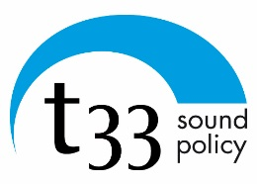

Managing Authority:
Regione Puglia

t33 srl - www.t33.it
via XXV Aprile, 28/b , 60125 Ancona (Italy)
Tel. - fax +39 071 898093, info@t33.it

Strategic Environmental Assessment of Italy – Albania - Montenegro
Cross-Border Cooperation Programme

Non-technical summary of the Environmental report

Scope of the document
The Strategic Environmental Assessment (SEA) aims at promoting sustainable development through evaluation to ensure that environmental issues are included in advance in plans or programmes.
This is a non-technical summary of the Environmental Report on the of the CBC (Cross Border Cooperation) Programme Italy-Albania-Montenegro 2014-2020, in compliance with Directive 42/2001/EC (the ‘SEA Directive’). It is designed to present the SEA findings in a clear and simple format that can be seen and understood by the widest possible audience.

Presentation of the 2 Seas Programme
The Italy – Albania - Montenegro Programme (‘the Programme’) is a cross border cooperation programme between Italy, Albania and Montenegro, co-financed by the European Regional Development Fund (ERDF) and IPA (Instrument for Pre-Accession Assistance). The Programme contributes to the European Cohesion Policy, which pursues harmonious development across the Union by strengthening economic, social and territorial cohesion in order to stimulate growth.
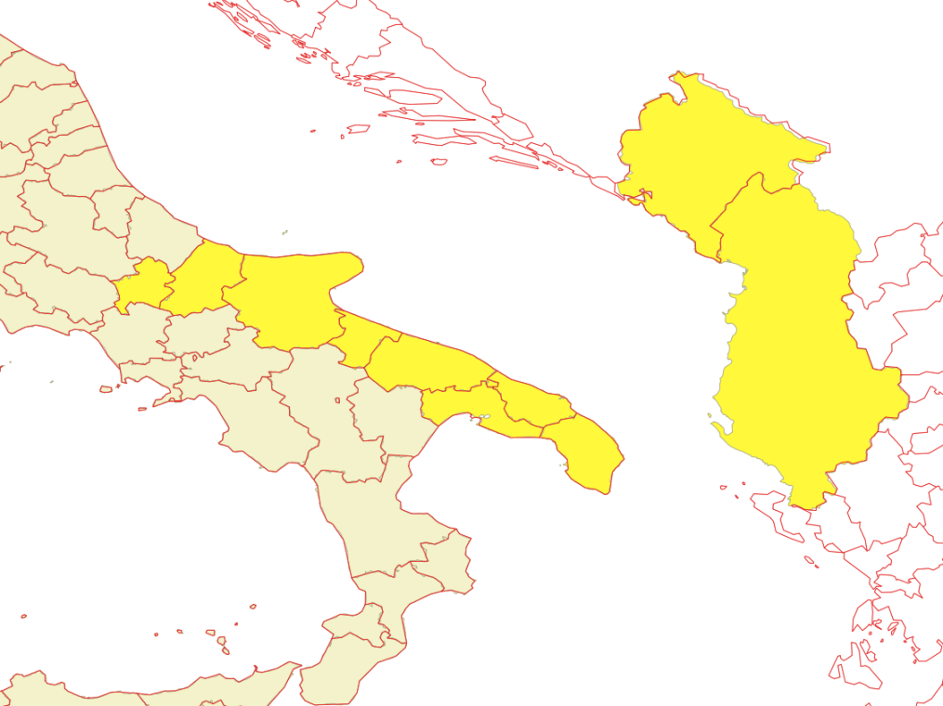
The focus of the Programme is the exchange of knowledge and experiences, to develop and implement pilot actions, to test the feasibility of new policies, products and services and to support investments.
The strategy of the programme addresses the following thematic priorities set by IPA regulations: enhancing competitiveness, encouraging sustainable tourism, promoting sustainable transports and improving public infrastructures; protecting the environment. The priority axes selected in this preliminary phase will concern the following topics:

- Entrepreneurships and innovation;
- Valorised Heritage;
- Environment protection and risk management;
- Integrating sustainable networks.
To address these objectives, the Programme has been structured into five Priority Axes and six Specific Objectives (SOs).
Axis 1 is dedicated to the cross-border cooperation and competitiveness of SMEs, Axis 2 to the cross border sustainable tourism, Axis 3 Environment protection, risk management and low carbon strategy, while Axis 4 promotes a sustainable transport. Finally, Axis 5 is entirely devoted to technical assistance, supporting implementation of the Programme. This latter, has not been considered in the evaluation of environmental effects.
Budget Allocation - from the ERDF and IPA for 2014-2020 is around €78.8 million. The budget allocation for each Priority Axis is divided as follow.
Axis 1 | Axis 2 | Axis 3 | Axis 4 | Axis 5
20% | 28% | 25% | 17% | 10%

Methodology of the assessment
The assessment follows the SEA Directive methodological prescriptions. First of all, the analyses are referred to the Italy-Albania-Montenegro Programme area. In the assessment procedure, the relevant environmental objectives and related indicators identified during a preliminary scoping phase have been used. They represent the basis for the description of the environment’s state and its development trends in the programme’s area as well as for the assessment of likely significant effects of the programme on the environment.
The Programme’s potential effects on the environment were assessed through a qualitative approach. Significant issues relate to climate change, inland and marine ecosystems, water, soil, landscape, air, health, and natural/cultural heritage, energy and waste have been addressed.
Eventually, cumulative effects between the environmental issues and cross-border effects are detailed, highlighting interdependencies and effect-chains.

Key environmental issues in the cooperation area
The cross border area has diverse marine, coastal and inland ecosystems. These provide a number of ecological benefits to local communities including fish resources, water quality and quantity, diverse plants and animals, as well as air quality. The quality on the different environmental primary components (air, water, soil) are in general good, with criticality lower than the European average. A synthesis of the state and trend of main environmental issues in the CBC area is presented in the following table.

Indicator | State | Trends | Synthetic description
Climate changes adaptation and risks
GHG emission |  |  | Emission of climate change gasses in the CBC area shows lower values in respect to European level. All the administrations involved in the Program are carrying out measure and strategy for additional reduction in strategic sector, so that an incremental trend is not apparent.
Coastal erosion |  |  | Coastal erosion represents a problem for all the CBC coastal area and it has increased in the last years, both for climate change causes (especially sea level rise) and human pressure.
Flood risks |  |  | Flood events are frequent in al the Country involved in the program but less than the European average; their number has increased in last years in consequences of climate changes.
Risk of desertification |  |  | Concerning the risk of desertification, the CBC area shows a low to medium sensitivity. As previous indicator, we observe an increasing trend for this risks, linked to ongoing climate changes
Biodiversity and ecosystem
Nationally designated protected areas |  |  | The CBC hosts a large number of natural protected areas, covering percentage an average of 10% of territory.
Natura 2000 network |  |  | Natura 2000 network is well defined in Apulia and Molise and has been introduced also in Albania and Montenegro.
Natural and semi natural ecosystem |  | ? | Natural and semi-natural ecosystems are dominant in CBC area, with a prevalence of agricultural system.
Species conservation |  | ? | The CBC area is interested by species richness usually greater than the European average but it hosts also the greatest concentration of threatened species, for amphibian and reptiles
Marine ecosystem and natural resources
Marine protected area |  |  | All the territory with the exception of Montenegro has Marine Protected area, finalized to the conservation of marine resources.
Marine water quality |  | ? | Marine water quality is not excellent in the CBC area, with frequent problem related to bathing water.
Air quality
Air Pollution |  |  | At a CBC level, Montenegro seems to have a better quality of the air than the Albanian and Italian part of the area. There are exceedances of the PM10 level in Albania and in Apulia. The trend of the pollutants considered seems to be stable.
Inland water quality and supply
Water bodies status |  |  | In the CBC area the water bodies status is generally categorized as sufficient, evidencing some problems such as pollution from urban water discharge (as in Albania), pollution from agriculture and livestock (as in Apulia Region) and decline in quality and quantity of ground water and the presence of some dangerous substances in marine water (as in Molise Region).
Water consumption |  | ? | The consumption of water in the CBC area is in line with the European average (150 l/inhabitant/day). The Italian and Albanian regions show level of consumption slightly high whereas in Montenegro the consumption is low in respect to the European average. Even if at European level it is possible to assess a reduction in water consumption, no data are available to assess the trend in the CBC area.
Soil use and landscape
Artificial Soils and Surfaces |  |  | The percentage of artificial soils in the CBC area is lower in respect to the EU average, but the trend of consumption of natural soil shows an increase in the last decade.
Contaminated sites |  | ? | All the administration involved host contaminated sites.
Cultural and Natural Heritage
Sites under the Unesco World Heritage Convention |  |  | The CBC area hosts 8 Unesco sites, seven of which belonging to the Cultural Heritage category and only one to the Natural Heritage category
Energy production and consumption
Energy Consumption |  |  | At a CBC level the energy consumption is lower than the EU average registering the highest consumption in Montenegro and the lowest in Albania.
Energy Production |  |  | Compared to EU 28 energy mix, in the CBC area there is no electricity production from nuclear power and on the other hand there is a remarkable increase in energy production from renewable sources in Apulia region and a slight increase as well in Molise region. On the Italian side, the two regions involved in the Programme have a surplus of the electricity produced over the electricity consumed.
Renewable Energy
Waste production and recycling
Waste Production |  | ? | It can be noticed that the waste generation in all the parts of the CBC area is lower than the EU average but the trend varies. In the Italian regions there is a decrease of waste production in the last years, in Albania and Montenegro instead there is an increase.
Recycling |  |  | The recycling waste in the CBC are is also lower than the EU average with Albania and Montenegro being at their beginnings but Apulia and Molise on the other hand having a constant increase of recycled waste year by year.

Main environmental effects and mitigation measures
Analysis of the environmental effects has three main steps. Firstly, environmental objectives in the area were matched with the proposed Specific Objectives (SOs) and actions planned by the Cross Border Cooperation (CBC) Programme. SOs with potential positive or negative effects on an environmental objective were then identified. Secondly, SEA experts estimated the effect’s intensity according to a scale of significance. Thirdly, the information was reorganised to assess the cumulative and cross-border effects of each action planned by the CBC Programme. Measures to mitigate possible negative effect or to orientate the Programme to sustainability have been proposed. A synthetic description of the assessed effects and of the proposed measure is presented below. The following table shows the impacts of SOs ranked by environmental theme.
Priority Axis 1 - Cross-border cooperation and competitiveness of SMEs. It includes only one OS, aimed at strengthening cross-border competitiveness, contributing to cross-border smart specialization strategies. Possible actions from the OS range from access to research results and technology transfer for SME’s, to networking of Intermediary Organizations (such as Chambers of Commerce), to feasibility studies and pilot actions for innovation. An environmental assessment of this OS is not straightforward. In general, innovation could imply a reduction of pressures on resources, but it is clearly true only in the case of the blue economy and green economy or for sustainable innovations. In the Programme, it is not clear how much these practices will be encouraged. As a consequence, possible positive effects on water and energy use, emissions and waste production would be no significant (because not certain, reversible and localized). Actions about networking and financing tools don’t have assessable effects on environment.
Mitigation and Orientation Measures for Axis 1. To enforce the non-significant positive effects assessed on the use of resources it is necessary to promote the blue and green economy using dedicated criteria in the project selection phase.

Priority Axis 2 - Cross-border sustainable tourism. The PA2 is devoted to the tourism and it contains two SO. The actions included in the SO1 consider the development of common ITC promotional tools in cultural/tourism sector, the creation of products for specific tourism categories and the development of new cross border cultural/tourist routes. Possible actions are also finalized to develop common models for the smart and sustainable tourism management. The expected increase of tourism could have negative effect on use of resources (energy, water and waste production) and on ecosystems (included marine ones). These effects are not significant because of their low probability of occurrence and reversibility. The creation of mountain and bike trail has not negative effect a-priori, but it is necessary to establish appropriate criteria for the project selection, particularly for those regarding peculiar natural and cultural sites. Here, negative effects are assessed following a preventive approach and to better set appropriate criteria for the realization of the actions. SO 2.2 concerns the promotion of cultural heritage through promotion and realization of cultural and creative activities, initiatives and events. Possible actions are mainly immaterial with, in general, not direct or significant effect on environment. The promotion of tourism, consequent to the implementation of the activities, has environmental consequences of unknown sign (positive or negative): an increase of tourism could have negative effects on use of resources and on ecosystems (as the previous OS) but the promotion of off-peak or a niche tourism could have positive effect on the same resources, so that the “real” environmental effect depend on the way of implementation of the OS.
Mitigation and Orientation Measures for Axis 2. Possible not significant negative effect on resource use (energy, water and waste production) and on ecosystems (included marine ones) could derive from tourist flows. The mitigation measure proposed is to make explicit in the Programme the instruments able to grant sustainable tourism. In addition, in project selection, it is recommended to specify criteria which explicit what sustainability of tourism means for the programme, especially for tourism in natural areas. To enforce positive effects on marine resources, the Programme should enhance its attention to the marine environment (with its natural and cultural assets), that is the principal resource in common in the CBC area.

Priority Axis 3 - Environment protection, risk management and low carbon strategy. The SO3.1 fis ocuses on cross-border cooperation strategies on water and landscapes as well. The objective is to strength the cooperation between partners in order to enhance the capacity of relevant actors to improve the water cycle management with attention to coastal and inland environmental risks prevention and biodiversity safeguard. The SO could have positive effects on climate change adaptation, supporting actions for risk management and prevention, cross-border early warning system and procedures for risk assessment. These effects, that are direct and involve a widespered spatial horizon, became significant considering the priority given to climate change adaptation issues in the Programme. In addition, positive indirect effect can be expected on inland biodiversity and ecosystem, as consequences of the improvement in coastal and natural area management. In reference to the effect on marine ecosystem and on landscape, networking and exchange of information could have positive consequences in term of a better management of coastal areas; on the other hand, actions aimed to contrast coastal erosion, can be translated in the realization of infrastructures of defense, with potential negative effects on conservation of natural marine environment and landscape. The reference to Natura 2000 Network and to Integrate Coastal Management in the description of the OS becomes more evident in the last version of the OP, in respect to the previous one. It should be note that adequate orientation measures could help to grant this orientation. Action on water management should produce positive effects on water use and water quality, but also in contrasting the trend toward desertification, for what concern the measures addressed to agriculture. The SO 3.2 is concerned by coordination in implementation of innovative practices and tools to reduce carbon emissions (also through the promotion of energy efficiency actions). Positive significant effects are expected in terms of reduction of GHG emissions, improvement of energy efficiency and increase in renewable energies.
Mitigation and Orientation Measures for Axis 3. To mitigate possible negative effect deriving from the realization of coastal defense interventions, it is proposed to include in the OP specific measures dedicated to landscape and marine ecosystem conservation.

Priority Axis 4 - Sustainable transport. Actions included in the Programme are wide spreading, ranging from the cooperation to improve multimodal connections, to the realization of small scale physical infrastructures, to coordination in order to intercept new traffic flows. The increment of transport flows should have negative effects (significant, because with a wide spatial diffusion and certain in respect to the action foresee) on air quality and on GHG emissions. Possible not significant effect is expected on human health, in term of exposition to pollutants. The realization of small physical infrastructures has negative effects on biodiversity: these effects are significant because, even if not certain (depending on the location and on project characteristics), they are likely to be not reversible. Effects of unknown sign have been associated to the pressure on marine ecosystem: the nature (positive or negative) of these effects will depend on how much the actions under this OP are concretely addressed to sustainability.
Mitigation and Orientation Measures for Axis 4. To mitigate possible negative effects from the increase of traffic flows, in term of air pollution, GHG emission and pressure on marine ecosystem, it is necessary to make explicit in the OP the list of instruments able to foster the sustainability of transport.

impacts and cross-border effects on the environment
Environmental issues | Environmental objectives | OS1.1 | OS2.1 | OS2.2 | OS3.1 | OS3.2 | OS4.1
Climate change and associate risks | Reduce GHG emissions |  |  |  |  | + | -
 | Reduce flooding risks |  |  |  | +
 | Reduce risks linked to coastal erosion |  |  |  | +
 | Reduce risks of desertification
Air quality | Improve air quality | n.s. |  |  |  |  | -
Water quality and supply | Improve or maintain underground, surface and bathing water quality |  |  |  | +
 | Reduce pressures on fresh water | n.s. | n.s. | ? | +
Biodiversity and ecosystem | Restore degraded ecosystems and their associated services |  | n.s. | ? | n.s. |  | -
 | Protect and preserve the diversity of species |  |  |  | n.s
Marine ecosystems and natural resources | Improve or maintain costal water quality |  |  |  | n.s
 | Protect and preserve the diversity of species |  |  |  | n.s
 | Reduce the pressures on natural resources |  | - | ? | n.s |  | ?
Soil quality and use | Remediate contaminated soils and lands
 | Improve efficiency in soil and land management
Technological risks | Prevent technological risks
Health and Sanitary risks and nuisances | Reduce chemical pollution and its effect on health |  |  |  |  |  | n.s.
Natural and cultural heritage and Landscape | Preserve landscape and cultural heritage |  |  |  | n.s
Energy | Promote renewable energies |  |  |  |  | +
 | Improve energy efficiency | n.s. | n.s. | ? |  | +
Waste management | Reduce the production of waste | n.s. | n.s. | ?
 | Promote recycling and reuse

Positive effects | Scale to measure the intensity of the effects | Negative effects
++ | Very significant effects | --
+ | Significant effects | -
? | Unknown effect | ?
n.s. | No significant effects | n.s.

Monitoring measures
A monitoring system is integral to the SEA procedure. A description of monitoring measures must be included in the environmental report and monitoring measures also have to be made available when the decision is publicised.
The proposed monitoring system takes into account the environmental context as well as result, output and performance indicators. These are all able to monitor unexpected environmental effects from the Programme intervention during its implementation phase. Most of these indicators will be based on information already available in the monitoring system. Few data will be directly collected by surveying beneficiaries of the Programme.
All information collected at different levels will be included and analysed in an environmental report, periodically drafted by the monitoring team and made available for decision making to the JTS and Managing Authorities. Such a report should be discussed in monitoring committees, especially during the Programme mid-term review and decisions made regarding re-Programmeming or adjustment of the Strategy in order to reach a more satisfactory sustainable development of the area under the cooperation objective.

Conclusion
The environmental assessment revealed that the Italy-Albania-Montenegro CBC Programme has overall positive effects on environmental issues. The few negative effects assessed can be avoided with the mitigation measure proposed.
During the SEA procedure, different alternative scenarios were considered. Analysis shows that the current strategy proposed for public consultation must be considered as a good alternative compared to other Programme options discussed during the preparation phase, because it represents a compromise between the needs of the CBC area and the environmental performance of the Programme.
Furthermore, SEA procedure includes a consultation phase for environmental issues in which stakeholders and the generic public will be involved. Suggestions collected during consultations will be taken into account in the final Programme version.

EU Regulation n.231/2014, Annex III “Thematic priorities for assistance for territorial cooperation”.
"?": some actions planned by the Programme could have indirect impacts difficult to estimate under the current methodologies of assessment. E.g. projects in the field of innovation or R&D could have environmental effects depending on many different factors, such as technology, market conditions or implementations factors, unknown at the beginning of the program.

