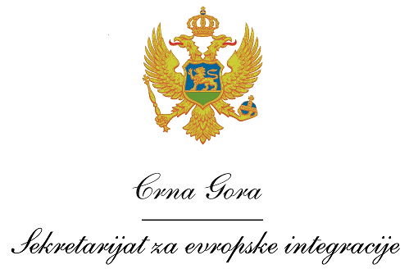
Montenegro
Ministry of Foreign Affairs and European Integration

Tasks of a Head of the Joint Technical Secretariat (JTS)

- The Team Leader will be based in the main JTS / project office to be established in the region, but will be expected to travel to the Antenna offices and project sites in the entire eligible territories, whenever required.
- The Team Leader will assist in all matters relating to the management and implementation of the project, including the coordination of the activities of all other experts.
- He will supervise the overall performance of the JTS staff (other experts), report to the Project Manager in the Ministry of Foreign Affairs and European Integration and provide suggestions regarding the improvement of both CBC Programmes design and implementation.

- Organize the daily operation of the programme management tasks
- Co-coordinate the development of strategic papers, analyses, reports, statistics for the Operating Structure (OS) and Joint Monitoring Committee (JMC)
- Ensuring the daily co-ordination of all tasks related to the core management of the JTS (including Antenna offices in Partner Countries)
- Keep contact and exchange of information with the National Coordinators of the Programmes in the OS
- Organize the secretarial work for the JMC and support the preparation for decision making (general issues)
- Co-ordinate and contribute to the drafting of the programmes annual implementation report to the EC, as well as all other required documents
- Ensure proper documentation flow, manage the system of archives, ensure that all of the relevant information is provided to all of the staff members of the OS and the JTS
- Co-ordinate the process for support and advice to potential applicants during the application phase (in co-operation with the OS)
- Co-ordinate the process for support to the project beneficiaries during the project implementation phase (in co-operation with the OS)
- Participate in the monitoring of implemented projects (in co-operation with the OS)
- All other tasks related to the implementation of the programmes, required by the OS

Tasks of a Financial and Procurement Officer

- Under the supervision of the Team Leader, and assisted by the other Project Officers, he or she will be responsible for contributing to the financial management of the project (technical assistance), including specific activities related to procurement, sub-contracting, budgeting, financial reporting, etc.
- He or she will play a fundamental role on contract reporting, administration of resources, as well as assistance in the launching of calls for proposals, support, if required, to field project monitoring and deliver specific trainings about financial and administrative project management for grantees.

- Ensure that the programmes are managed in accordance with the principle of sound financial management
- Participate in and contribute to project seminars and conferences as appropriate
- Ensure the proper administration of the TA resources related to the direct responsibility of the OS, in line with the Programme Document and related regulations, etc.
- All other tasks related to the implementation of the programmes, required by the OS

 | Project  An EU funded project managed by the Delegation of the European Union to Montenegro

