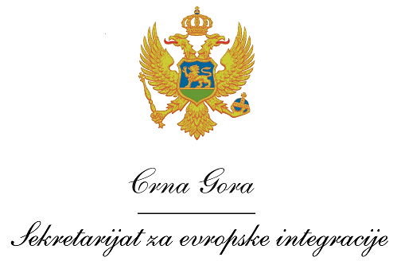
Montenegro
Ministry of Foreign Affairs and European Integration

Vacancy announcement

The Ministry of Foreign Affairs and European Integration (MFAEI) of Montenegro, as the national coordinator of the Cross-border Cooperation (CBC) Programme Montenegro – Kosovo 2007-2013 under the Component II of IPA (Instrument for Pre-accession Assistance), invites interested candidates to apply for the following positions:

- Administrative assistant for the Cross-border Programme Montenegro-Kosovo 2007-2013
- Location: Podgorica
- Duration: maximum 7 months

Requirements and qualifications of an Administrative assistant for the Cross-border Programme

Qualifications and skills
- University degree, and at least 3 years of professional experience
- Fluency in written and spoken English and the national language of Montenegro
General professional experience
- At least 2 years of general professional experience in assistance programmes/projects funded by the EU or other donors and
- At least 1 year in financial and administrative project management in the public or private sector
Specific professional experience
- At least 1 year of experience preferably in matters related to Cross-border Cooperation programmes
- Experience in financial and administrative project management, procurement, sub-contracting, budgeting, financial reporting, administration of resources
- Substantial experience in budget planning and reporting, as well as project monitoring
- Ability to work as member of a team, to maintain good inter-personal relations, and work promptly to deadlines

Application procedure

Interested candidates have to submit:
- • A curriculum vitae (CV) in Europass format;
- • A motivation letter in English.

Interested candidates should send their CV and motivation letter by 29 April 2016 until 17.00 to the following email address:

E-mail: gdkpp@mfa.gov.me
Subject: Administrative assistant for the CBC Programme Montenegro-Kosovo
The Terms of Reference is available on the MFAEI’s web-site: www.mvpei.gov.me and www.eu.me

Only short-listed candidates shall be contacted for an interview.

 | Project  An EU funded project managed by the Delegation of the European Union to Montenegro

