[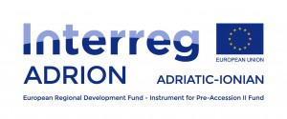](http://www.adrioninterreg.eu/) 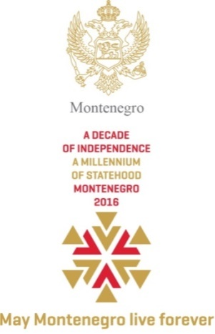 

**Montenegro**

**Ministry of Foreign Affairs and European Integration**

**Vacancy announcement**

The Ministry of Foreign Affairs and European Integration (MFAEI) of Montenegro, as the National Authority of the Interreg V-B Adriatic-Ionian cooperation programme 2014-2020(ADRION) andDanube Transnational Programme 2014-2020, invites interested candidates to apply for the following position:

**National Contact Point for the Interreg V-B Adriatic-Ionian cooperation programme 2014- 2020 (ADRION) and Danube Transnational Programme 2014-2020**

**Requirements and qualifications:**

* University degree in social sciences
* Relevant professional experience in management of programmes or projects funded by the EU or other donors;
* Fluency in both written and spoken English and Montenegrin;
* Knowledge of EU policies, European Territorial Cooperation, European Union Strategy for Adriatic and Ionian Region (EUSAIR), EU Strategy for the Danube Region (EUSDR) will be an asset;
* Knowledge of PRAG rules will be considered as advantage;
* Advanced computer literacy;
* Communication skills;

**Application procedure**

Interested candidates have to submit following application documents:

* A curriculum vitae (CV) in Europass format;
* A motivation letter in English;
* Photocopy of University degree.

The Terms of Reference is available on the MFAEI’s web-site: http://www.eu.me.

Interested candidates should send application documents by **6 June 2016 until 16.00h** to the following email address: [gdkpp@mfa.gov.me](mailto:gdkpp@mfa.gov.me), specifying in the **Subject**: National Contact Point for the Interreg V-B Adriatic-Ionian cooperation programme 2014- 2020 (ADRION) and Danube Transnational Programme

Only short-listed candidates shall be contacted for an interview.

|  |
| --- |
|  |