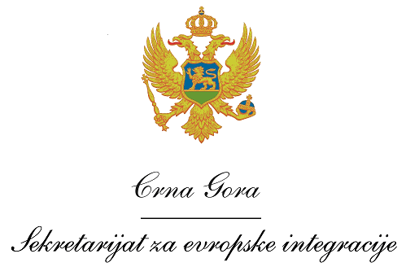
Montenegro
Ministry of European Affairs

Vacancy announcement

The Ministry of European Affairs (MEA) of Montenegro, as the National Authority of the Interreg IPA Cross-border Cooperation Programme Italy-Albania-Montenegro 2014-2020 in cooperation with the Programme Managing Authority, invites interested candidates to apply for the following position:

the Financial Assistant located in Podgorica

Requirements and qualifications:

- University degree in Human or Social sciences;
- At least 3 years of work experience in relevant field;
- Ability and readiness to work independently and to fit in with the international team;
- Fluency in both written and spoken English and Montenegrin;
- Advanced computer literacy;
- Good communication skills;
- Team work, capability and creativity in solving problems;

Application procedure

Interested candidates have to submit following application documents:
- A curriculum vitae (CV) in Europass format (in English);
- A motivation letter in English;
- Photocopy of University degree;
- Photocopy of valid driving licence.

Interested candidates should send application documents by 3 February 2017 until 16.00h to the following email address: nina.dakic@mfa.gov.me, specifying in the Subject: the Financial Assistant of the Interreg IPA Cross-border Cooperation Programme Italy-Albania-Montenegro 2014-2020

Only short-listed candidates shall be contacted for an interview.
Project

Terms of Reference – Financial Assistant

Position: Financial Assistant for the Interreg IPA Cross-border Cooperation Programme Italy-Albania-Montenegro 2014-2020

Location: Podgorica

Overall objective

Main tasks of the Financial Assistant will be to ensure proper administration of the financial resources related to the direct responsibility of the National Authority (Ministry of European Affairs), in line with the Programme Documents and related regulations.

Selected Financial Assistant will perform following duties:

- Preparing a procurement documentation related to Technical Assistant Project;

- Immediate reporting of any signal of irregularities identified;

- Keep relevant up-to-date financial project information in electronic form.

- Providing any relevant financial information to the National Authority in the participating country as required;

- Drafting and/or amending relevant Programme documents and relevant procedures as required;

- Advising project partners in questions related to the eligibility of expenditures;

- Supporting national controllers and members of the group of auditors in fulfilling their functions;

- Other tasks ordered by the superiors.

