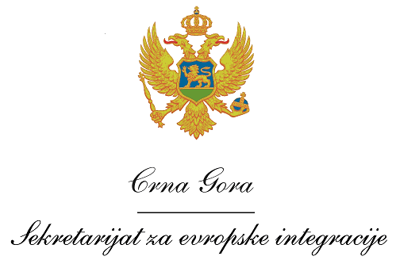
Montenegro
Ministry of European Affairs

Vacancy announcement

The Ministry of European Affairs (MEA) of Montenegro, as the National Authority of the Interreg IPA Cross-border Cooperation Programme Italy-Albania-Montenegro 2014-2020 in cooperation with the Programme Managing Authority, invites interested candidates to apply for the following position:

the National Info Point located in Podgorica

Requirements and qualifications:

- University degree in Human and Social sciences or other relevant field;
- Relevant professional experience in an international environment and on EU funded projects/programmes;
- At least 3 years of work experience;
- Work experience in organising public events, as well as publicity measures for initiatives in the public sector would be an asset;
- Accuracy, experience and knowledge related to management techniques and consultation methods, in particular project cycle management, preparation of reports and presentations;
- Ability and readiness to work independently and to fit in with the international team;
- Fluency in both written and spoken English and Montenegrin;
- Advanced computer literacy;
- Good communication skills;
- Team work, capability and creativity in solving problems;
- Driving license.

Application procedure

Interested candidates have to submit following application documents:
- A curriculum vitae (CV) in Europass format (in English);
- A motivation letter in English;
- Photocopy of University degree;
- Photocopy of valid driving licence.

Interested candidates should send application documents by 3 February 2017 until 16.00h to the following email address: nina.dakic@mfa.gov.me, specifying in the Subject: the National Info Point of the Interreg IPA Cross-border Cooperation Programme Italy-Albania-Montenegro 2014-2020

Only short-listed candidates shall be contacted for an interview.
Project
Terms of Reference – National Info Point

Position: National Info Point for the Interreg IPA Cross-border Cooperation Programme Italy-Albania-Montenegro 2014-2020 located in Podgorica

Location: Podgorica

Overall objective

Main tasks of the National Info Point (NIP) are to translate the goals of the Cooperation Programme to potential beneficiaries in Montenegro and serve as national information points for the projects’ preparation and submission phase, and implementation. The National Info Points are synergic with the activities of the Joint Secretariat and the NIP may carry out, in cooperation with the National Authority (Ministry of European Affairs) and the Joint Secretariat (JS) in Bari in charge of the Cooperation Programme, other specific activities.

Selected National Info Point will perform following duties:

- Acting as an information point for potential project applicants and beneficiaries at national level;
- Contributing to maximize information and publicity actions within the respective Country;
- Acting as link among beneficiaries and bodies in charge, at national level, of the implementation of the Cooperation Programme;
- Supporting, at national level, the JS and Programme controllers for the implementation of projects-monitoring activities;
- Supporting national bodies with information required for fulfilling their tasks;

- Participating in preparation and organization of events and participating in development other tools such handbooks, manuals, for applicants;

- Participating in organisation and preparation of JMC meetings and provide support to JMC in its functions;

- Participating in preparation of reports on Programme implementation;

- Participating in programme documents evaluation and amendments;

- Supporting the implementation of the technical assistance for the implementation of the Programme;

- Participating in preparation of reports on Programme implementation;

- Participating in activities regarding use of eMS system;

- Other tasks ordered by the superiors.

