International Consulting Expertise EEIG (ICE) in consortium with Eurecna, European profiles, Naxta, Consulgal and Ervet

is seeking to engage

3 Junior Non-Key Experts to support the EU negotiation process

International Consulting Expertise EEIG (ICE) is currently implementing the EU funded technical assistance project Strengthening the Capacities of the Montenegrin Authorities for the EU Accession Process and IPA II Instrument, managed by the Delegation of the European Union to Montenegro.

The duration of the project is 18 months from the 1st December 2016 until end of May 2018.
The project focuses on technical and operational support to the Ministry for European Affairs of Montenegro to strengthen the capacity of governmental institutions for EU accession process and to strengthen the capacity and accountability of the Ministry for European Affairs and other stakeholders for overall coordination of the EU accession process; with the specific focus on accession negotiations and management of IPA II funds.

Due to the lack of interest to the Call as of 27 December 2016, the consortium is prolonging time for application until Friday, 20th January for the following vacancies:

1. Junior Non-Key Expert Lawyer linguist (1 position for total of 300 working days)
2. Junior Non-Key Expert for legal alignment /harmonisation (2 positions for total of 300 working days each)

The successful candidates will fit the following profile:

1.LAWYER LINGUIST

Qualifications and skills:
- University degree, preferably in Law (at least 4 years of completed university studies attested by a diploma);
- Excellent knowledge of English language (equivalent to CEFR C1 level);
- Computer literacy, knowledge of Microsoft Office package: Word, Excel, Power Point, the Internet;
- Excellent knowledge of Montenegrin language and Montenegrin Orthography;
- Knowledge of the legal system of Montenegro, as well as of the national legal technical rules.
General professional experience:
- Minimum 3 years of professional experience in drafting legislation, preferably the legislation which is harmonised with the EU Acquis
- Experience in working in/with the public administration bodies, judiciary or similar public bodies, preferably within the frame of Montenegrin institutions, will be an asset.
Specific professional experience:
- Minimum 1 year of professional experience in EU accession process and harmonisation of the Montenegrin national legislation with the EU Aquis, especially related to legislation drafting and coordination of harmonisation.

2. EXPERT FOR LEGAL ALLIGNMENT

Qualifications and skills:
- University degree preferably in Law (at least 4 years of completed university studies attested by a diploma);
- Very good knowledge of the English language (equivalent to CEFR B2 level);
- Excellent knowledge of the Montenegrin language;
- Computer literacy (command of Microsoft Office (Word, Excel, Power Point, etc.) and the Internet).
General professional experience:
- Minimum 1 year, but preferably 2 years, of general professional experience in legislation drafting;
- Professional experience of at least 1 year in Montenegrin public administration bodies in the field of approximation of national legislation with the EU Acquis will be an advantage.
Specific professional experience:
- Knowledge of the legal system of Montenegro, as well as of the national legal-technical rules.

Note that traineeship shall be taken as a relevant general working experience for non-key junior experts.

Please apply by e-mail only to IPAjobs@ice-org.eu on or before 20th January 2017, submitting CV in English language and a brief note outlining suitability for the position in question.
Only shortlisted candidates will be contacted for Interviews.

The post is not available to civil servants or other officials of the public administration in the beneficiary country (Montenegro).

The Project is an equal opportunities employer and welcomes applications from women and minorities.

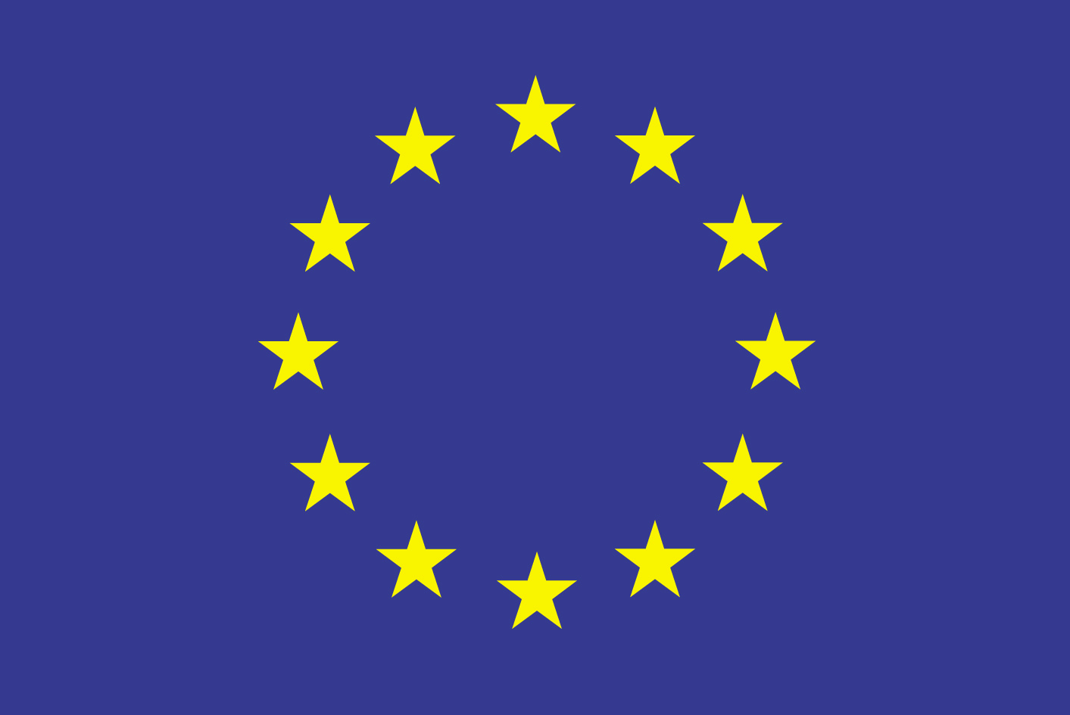

Strengthening the Capacities of the Montenegrin Authorities for the EU Accession Process and IPA II Instrument
EuropeAid/137894/DH/SER/ME

