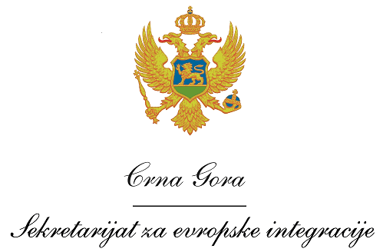
Montenegro
Ministry of European Affairs

VACANCY ANNOUNCEMENT

Ministry of European Affairs (MEA) of Montenegro, as the Operating Structure of the IPA Cross-border Programme Bosnia and Herzegovina and Montenegro 2014-2020, in cooperation with the Directorate for European Integration of Bosnia and Herzegovina, invites the interested candidates to apply for the following position:

Project Officer in the Antenna Office of the Joint Technical Secretariat, located in Nikšić

Professional requirements
Qualifications and skills
- University degree;
- Fluency in both written and spoken English and the official languages in Bosnia and Herzegovina and in Montenegro;
- Good communication, organizational and presentation skills;
- Computer literacy;
- Driving license.
General professional experience
- At least 6 years of professional experience following the University degree.

Specific professional experience
- At least 2 years of experience in programme/project management;
- Experience related to project monitoring, preferably of EU-funded grant contracts;
- Experience in at least one EU-funded project in the last 3 years and knowledge about IPA CBC Programmes in the Western Balkan countries would be considered an asset.

Application procedure

Interested candidates have to submit the following application documents:
- A curriculum vitae (CV) in Europass format (in English);
- A motivation letter in English;
- Photocopy of the University degree;
- Photocopy of a valid driving licence.

In order for your application to be processed, all required documents must be submitted.

Interested candidates must send the application documents by Friday, 9 February 2018 by 15.00h to the following email address: def@mep.gov.me, specifying in the Subject: Project Officer in the JTS Antenna Office in Nikšić / IPA Cross-border Programme Bosnia and Herzegovina and Montenegro 2014-2020.

Only the short-listed candidates shall be contacted for an interview.

