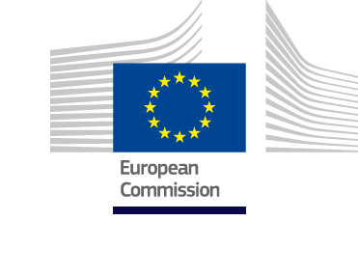

IPA III
Cross Border Cooperation Programme
2021-2027

Montenegro - Kosovo
ADOPTED ON DD/MM/YYYY

TABLE OF CONTENTS
Programme synopsis 3
List of acronyms 4
Section 1: Programme summary 6
1.1 Summary of the programme 6
1.2 Preparation of the programme and involvement of the partners 7
Section 2: Programme area 9
2.1 Situation Analysis 9
2.2 Main findings 18
Section 3: Programme strategy 24
3.1 Rationale - Justification for the selected intervention strategy 24
3.2 Description of programme priorities 27
3.3 Horizontal and cross-cutting issues 39
3.4 Coherence with other programmes and microregional strategies 41
Section 4: Financial plan 42
Section 5: Implementing provisions 43
5.1 Financing agreement 43
5.2 Indicative implementation period 43
5.3 Implementation method 43
5.4 Programme management structure 45
5.5 Project development and selection and implementation 45
5.6 Payments and financial control 45
5.7 Reporting, monitoring and evaluation 45
5.8 Information and visibility 46
LIST OF ANNEXES 47
ANNEX 1: Description and analyses of the programme area 47
ANNEX 2: SWOT 79
ANNEX 3: Key lessons learned from the current period 92
ANNEX 4: Questionnaires - Main findings 93
ANNEX 5: Political maps 100
ANNEX 6: Bilateral agreements between Montenegro – Kosovo 102
ANNEX 7: Local and national strategies 103
ANNEX 8: References 119

Programme synopsis
Programme title | IPA-III Cross Border Cooperation Programme between Montenegro and Kosovo for the period 2021-2027
Programme area | Montenegro: The municipalities of Andrijevica, Bar, Berane, Bijelo Polje, Gusinje, Kolašin, Mojkovac, Petnjica, Plav, Podgorica, Rožaje, Tuzi and Ulcinj  Kosovo: The municipalities of Pejë/Peć, Istog/Istok, Junik, Deçan/Dečani, Klinë/Klina, Gjakovë/Đakovica
Programme overall objective | Promoting and strengthening good neighbourly relations and socio-economic development of the cross-border region through the valorisation of its potentials in sustainable tourism and employment.
Programme thematic clusters, thematic priorities and specific objectives per thematic priority | TP 0: Technical Assistance  TC 1: Improved employment opportunities and social rights  TP 1: Employment, labour mobility and social and cultural inclusion  across the border  Specific objective 1.i. To enhance the access of youth and vulnerable groups to the labour market  TC 4: Improved business environment and competitiveness  TP5: Tourism and cultural and natural heritage  Specific objective 5.i. To boost sustainable tourism in the Programme area  TP7: Governance, planning and administrative capacity building of local and regional authorities (mainstream priority)
Total EU financial allocation 2021-2027
Management implementation mode | Indirect management mode
Contracting authority | Directorate for Financing and Contracting of EU Funds  Ministry of Finance of Montenegro  Arsenija Boljevića 2A  81000 Podgorica
Relevant authorities in the participating beneficiaries [operating structures] | European Integration Office of the Government of Montenegro  Department for European Territorial Cooperation,  Bulevar revolucije br. 15, 81000 Podgorica  Ministry of Local Government, Kosovo
Offices of the joint technical secretariat (JTS) | Joint Technical Secretariat of the Cross-border Cooperation Programmes Montenegro - Albania and Montenegro - Kosovo  A: Beogradska 17  81 000 Podgorica  Montenegro  B: Antenna Office in Pristina, Kosovo  XXXXX

List of acronyms
CANU Montenegrin Academy of Sciences and Arts
CBC Cross Border Cooperation
CEFTA Central European Free Trade Agreement
CERN European Organisation for Nuclear Research
CLP EU Regulation on the Classification, Labelling and Packaging of Substances and Mixtures
COSME EU programme for the Competitiveness of Small and Medium-sized Enterprises
COST European Cooperation in Science and Technology
COVID-19 Coronavirus Disease 2019
CSO Civil Society Organizations
EC European Commission
ERASMUS EU's programme to support education, training, youth and sport in Europe
ETS Emissions Trading System
EU European Union
EUREKA Publicly funded, intergovernmental network, involving over 40 countries
EUSAIR EU Strategy for the Adriatic and Ionian Region
EUSDR European Union macro-regional Strategies for the Danube Region
FDI Foreign Direct Investments
GDP Gross Domestic Product
GEANT Europe’s leading collaboration on network and e-infrastructure services
GVA Gross Value Added
IAEA International Atomic Energy Agency
ICT Information and Communication Technology
IPA Instrument for Pre-accession Assistance
IPARD Instrument for Pre-accession Assistance for Rural Development
JTS Joint Technical Secretariat
KAS Kosovo Agency of Statistics
KBRA Kosovo Business Registration Agency
KS Kosovo
ME Montenegro
MMR Monitoring and Reporting Mechanism
MoM Minutes of Meeting
MONSTAT Statistical Office of Montenegro
NA Not Available
NDS National Development Strategy 2016-2021
NERP National Emission Reduction Plan
NGO Non-Governmental Organisation
NSSD National Strategy for Sustainable Development
OS Operating Structures
PPS Purchasing Power Standard
PESTLE Political, Economic, Social, Technological, Legal, Environmental
R&D Research and Development
REACH Registration, Evaluation, Authorisation and Restriction of Chemicals
RLAH Roam like at Home
RYCO Regional Youth Cooperation Office
SAA Stabilisation and Association Agreement
SEECP South East Europe Cooperation Process
SME Small and medium Sized Enterprises
SWOT Strengths, Weaknesses, Opportunities, Threats
TGD Podgorica airport
TPP Thermal Power Plant
UN United Nation
UNESCO United Nations Educational, Scientific and Cultural Organization
UNFCCC UN Framework Convention on Climate Change
VET Vocational Education Training
WTO World Trade Organization

Section 1: Programme summary
The cross-border cooperation programme between Montenegro and Kosovo will be implemented under the framework of the EU Instrument for Pre-accession Assistance (IPA III) for the funding period 2021 - 2027. IPA III supports cross-border cooperation with a view to promoting good neighbourly relations, fostering Union integration and promoting socio-economic development through joint local and regional initiatives.
The legal provisions for its implementation are stipulated in the following pieces of legislation:
- TBC
The document has been designed and drafted by the European Integration Office of the Government of Montenegro and the Ministry of Local Government of Kosovo, with support of Cross-border Institution Building Project (CBIB+3), in accordance with the provisions of the framework for IPA III.

1.1 Summary of the programme

Main findings
IPA III CBC ME-KS programme is based on the findings of the situation analysis and SWOT. The needs stemming from the analysis were scrutinised in the light of the cross-border relevance and the possibilities the programme enables to address those needs.
The situation and SWOT analysis revealed that there are numerous issues which are of common need however only a small part of it can be addressed via the CBC programme. The CBC area is dominated by rural areas and mountains. The rich biodiversity provides manifold possibilities to jointly utilise the asset. However, it is important to jointly protect the environment and be prepared towards various different impacts based on climate change.
Those aspects reach in all social and labour market sectors and thus should be tackled in an integrated manner.
The richness of the environment allows for joint tourism development and reveals the need for a better promotion of the area internationally. Joint tourism activities as well as adequate skill development is needed to improve the service and offers in the region. Labour market, business development, vulnerable groups and social inclusion in the CBC area need to be jointly addressed with involving those sectors most active in the CBC region, namely forestry, agriculture and food processing. In order to support the labour market in the region there is a need to improve public and private capacity as well as a better understanding of each other.
The region suffers from lack of CBC accessibility virtual and actually by road, thus skills to improve the virtual exchange and take up of the possibilities of ICT can help to improve the prosperity in the region.
The involvement of local and regional authorities in all projects should ensure cooperation between administrations across the border and enhance sustainability of project results.
Main areas of intervention
The selection of thematic priorities acknowledges the possibilities of a cross border programme with a comparably lower budget than national infrastructure programmes usually provide.
The following thematic clusters were chosen with possible types of activities:
TC I. Improved employment opportunities and social rights
Involvement of vulnerable groups in the labour market in the cross-border region
TC IV. Improved business environment and competitiveness
Enhance joint tourism promotion and activities;
The implementation of the IPA III ME-KS programme assures that the main needs such as unemployment, lack of skills and capacities as well as the lack of cooperation among public authorities will be addressed in each project regardless of which Thematic clusters (TC) and priorities (TP) are selected.
By doing so the programme contributes to the economic, social and territorial development of the cross-border region at the best possible rate. With the horizontal involvement of public authorities in all projects, their capacity will be strengthened and they will be empowered to play an active role in supporting the above.
The programme structure follows the logic of the EU structural funds and the implementation of particular TC and TP will give local and regional authorities the understanding of the aim and objective of the EU structural funds for territorial cooperation. The assurance of implementing horizontal principles and cross cutting issues should increase the understanding of territorial cooperation goal, namely promoting reconciliation and confidence building among the local communities in the border region, through good neighbouring relations, creating sustainable partnerships for socio-economic development and/or the removal of obstacles to this development.

1.2 Preparation of the programme and involvement of the partners
The actual programming process spanned a period of xxxx months, from mid-September 2020 to xxxx. However, preparations involving both Operating Structures started in May 2020 and continued until xxxx during which the programme document has been revised xxxx times.
The document at hand is the result of close and intensive cooperation between Montenegro and Kosovo in this period. In order to be able to get this document produced and endorsed, stakeholders were frequently consulted and asked to provide information (e.g. municipal and regional statistics and strategies, national and domestic statistics, policy documents and strategies, donor publications and initiatives, etc.). The communication process was hampered by the COVID 19 crisis and mainly conducted online.
The following initiatives and events were organised during the programming process:
Table 1.1: Table of meetings, important milestones and consultations
Date and place | Activities and Scope
22 April 2020 | A letter from the European Commission (EC) regarding IPA III and starting of programming process received by the NIPAC Office
05 May 2020 | Kick off meeting between MNE OS and CBIB+3 on the IPA III CBC programming process (required steps and draft working plan)
06 May 2020 | Kick off meeting between KS OS and CBIB+3 on the IPA III CBC programming process (required steps and draft working plan)
End July to end September | The process for the establishment of the Joint Task Force (JTF) was completed, consisting of a representation of stakeholders from Montenegro and Kosovo for the preparation of the CBC programme 2021 – 2027
30 July – 07 August 2020 | JTS MNE-AL-KS dispatched the questionnaires to the relevant CBC stakeholders
01 September 2020 | Mobilisation of the programming expert for the programme MNE-KS
06 October 2020 | The aggregated answers from the collected questionnaires were delivered to the programming expert for further elaboration and analysis
13 October 2020  Online | Workshops on strategy development and formulation for the members of the JTF, and OS, JTS (in ME and KS)
28 October 2020  Online | 1st JTF meeting on the draft Situation Analysis
02 – 05 November 2020 | Consultation with CBC stakeholders from Montenegro and Kosovo (Collection of comments on the draft Situation Analysis)
09 November 2020  Online via MS Teams platform | 2nd JTF meeting on the Situation Analysis and preliminary discussion on selection of TCs/TPs
15 – 19 November 2020 | Consultation with CBC stakeholders from Montenegro and Kosovo (Collection of comments on the Situation Analysis and preliminary discussion on selection of TCs/TPs )
20 November 2020  Online | Consultative meeting between two OSs on the selection of TCs/TPs
20 November 2020  Online | 3rd JTF meeting on the draft Programme Strategy
25 November – 02 December | Consultation with CBC stakeholders from Montenegro and Kosovo (Collection of comments on the draft Programme Strategy)
03 December 2020  Online | 4th JTF meeting on the 1st draft Programme Strategy
XX December 2020 | Submission of the first draft of the Programming Document to the European Commission
XX December 2020 | Public Consultation
 | 5th JTF meeting on the 2nd draft Programme Strategy
 | Submission of the 2nd draft version to the European Commission
 | Submission of the final version to the European Commission

Section 2: Programme area

2.1 Situation Analysis
The situation analysis aims to explore the regional specificities of the programme area that will help to identify the most relevant thematic clusters, priorities, areas of intervention and actions. This section is an extract of the analysis in Annex 1 of this document, focusing on the main characteristics and challenges of the cross-border area that should be addressed during the 2021 – 2027 programming period. It summarizes key data and findings of the analysis, including updated data at local wherever it was available. Additional information, statistics, maps and information sources are presented in the Annexes.

Programme area
The programme area for the cross - border programme between Montenegro and Kosovo covers a territory of around 8,725 km² with a total population of about 716,488 inhabitants. The territory of the programme area in Montenegro accounts for 73% (6,400 km²) as against 27% (2,324.4 km²) in Kosovo. The total borderline length is 75.6 km.
There are two border-crossing points along this borderline, with only one being currently in function and serves as a customs point in Kulla/Kula (on the road between Rožaje and Pejë/Peć); and the other one in Qakor/Čakor (on the road from Murino linking Plav and Pejë/Peć municipalities) which has been closed to traffic for nearly two decades.
Figure 2.1: Map of the Programme Area
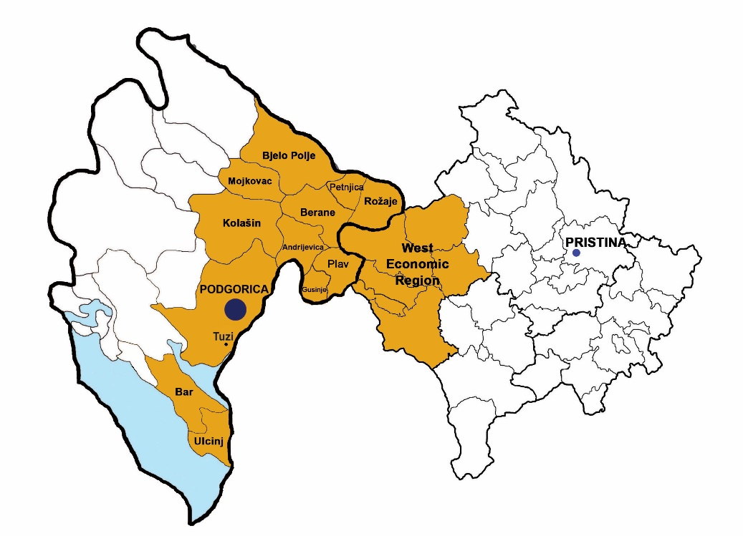
Source: JTS of the programme
The programme area in Montenegro consists of 13 municipalities including the capital city Podgorica and 12 main towns. There are no administrative regions in Montenegro and the municipalities represented in the programme area are: Andrijevica, Bar, Berane, Bijelo Polje, Gusinje, Kolašin, Mojkovac, Petnjica, Plav, Podgorica, Rožaje, Tuzi and Ulcinj.
Kosovo has 38 municipalities, six of which are part of the programme area. The eligible area includes the West Region, which is composed of the municipalities of Deçan/Dečani Gjakova/Đakovica, Istog/Istok, Junik, Klinë/Klina and Pejë/Peć.

Table 2.1: The Programme Area
 |  | Area (km2) | % of the total territory
Country | Montenegro (ME) | 13,812 | 100%
Programme  area | Municipalities of Andrijevica, Bar, Berane, Bijelo Polje, Gusinje, Kolašin, Mojkovac, Petnjica, Plav, Podgorica, Rožaje, Tuzi and Ulcinj | 6,400 | 46%
Country | Kosovo (KS) | 10,905 | 100%
Programme area | Municipalities of Deçan/Dečani Gjakova/Đakovica, Istog/Istok, Junik, Klina and Pejë/Peć. | 2,324.4 | 21%
Total programme area |  | 8,724.4 | ME: 73%  KS: 27%
Source: IPA II CBC 2014 – 2020, KAS

Figure 2.2: Schematic presentation of the programme area characteristics
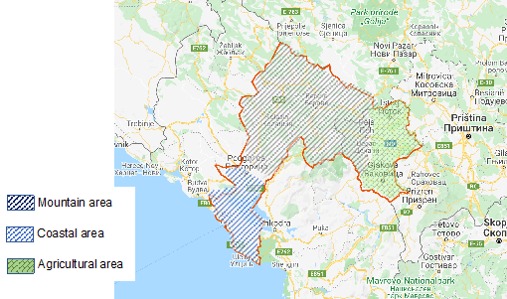Source: Google maps
In the programme area, six municipalities are directly on the relevant border including Berane, Rožaje and Plav in Montenegro and Peja/Peć, Istog/Istok and Deçan/Dečani in Kosovo. The border line passes through the high mountain ranges of Bjeshkët e Nemuna/Prokletije (Accursed Mountains) and Hajla, also known as the Albanian Alps.

The eligible area in Montenegro covers two coastal municipalities Bar and Ulcinj in the southern part of the country, the capital city Podgorica, municipality of Tuzi, and the north-eastern region, a mountainous area bordering with Kosovo, Serbia and Albania. In the east, the region is dominated by Prokletije and Hajla mountains adjacent to Albania and Kosovo. Mountain peaks reach up to 2,500 m and the territory is crossed by rivers Lim, Morača and Tara. Another mountain range, Bjelasica forms the centre of the northern part of the eligible area.
The capital city Podgorica is located in the central part of Montenegro, where the population and economic activities of the country are mainly concentrated. Podgorica, together with Tuzi municipality, stretch to the northern shore of Skadar Lake, the largest lake in the Balkans. The coastal municipality of Bar, with the largest port in the country, is an important transport connection which serves as a key entry and exit point for large amounts of goods for Montenegro and its neighbouring countries.
The programme area in Kosovo borders Montenegro to the northwest, Albania to the southwest and Serbia to the north. The region covers six municipalities and 314 settlements, including the municipalities of Deçan/Dečani, Gjakovë/Đakovica, Istog/ Istok, Junik, Klinë/Klina and the municipality of Peja/Peć, which represents the centre of the region.
Municipalities with the largest surface areas in the region are Peja/Peć and Gjakova/Đakovica. The area is covered largely by the Dukagjini Plain that borders the Albanian Alps. The highest peak is Gjeravica Mountain (2,656 m) which is also the highest peak in Kosovo.

Governance

Policy reforms and EU integration process
Montenegro and Kosovo are committed to become members of the European Union. Montenegro has obtained the candidate status and has opened 33 negotiating chapters, three of which have been provisionally closed. Kosovo has signed the EU-Kosovo Stabilisation and Association Agreement and is waiting to complete its visa liberalisation process.
Ratification of the border demarcation agreement between Montenegro and Kosovo in 2018 was a key milestone with regard to good neighbourly relations and regional cooperation, followed by a bilateral agreement on international transport of passengers and cargo to facilitate cross-border movement of freight and passengers.
Both countries participate in various regional initiatives to enhance regional cooperation. However, further efforts are needed with regard to improved procedures at border crossings, the regional trade agenda and the creation of a regional electricity market.
Montenegro´s National Strategy for Sustainable Development (NSSD) is one of the main strategic documents aiming to achieve sustainable development by 2030. In addition, the country has adopted its Smart Specialisation Strategy 2019 – 2024 which aims to increase the competitiveness of the economy by concentrating and linking research and innovation resources to a limited number of priority economic areas.
Kosovo´s National Development Strategy 2016-2021 serves as a multi sectoral strategy focused on addressing key obstacles to national development and coordinating development policies and institutional processes. A Strategy for Local Economic Development 2019 – 2023 is adopted, which defines the way municipalities can reach their objectives with better governance, attractive business environment, quality education, health and social welfare, developed agriculture and clean environment.

Legal framework
In Montenegro, the local self-government legislative framework is in place and needs to be implemented through capacity strengthening and harmonisation of functions at local level. A new Law on the financing of local self-government has been adopted, aiming at consolidating local public finances.
Kosovo is working on a new Law on local finances to address issues related to budget allocations, arrangements for local capital investments and financial sustainability. While municipalities have been given more powers, their human and financial resources are insufficient and capacities in enforcing laws, policies, and procedures are limited. In addition, there is a lack of harmonisation between local strategies and central level policies.

Economy

Economic overview
Montenegro and Kosovo represent the smallest economies in the Western Balkans in terms of GDP. While both countries have reported positive GDP growth rate over the last years, the unemployment rate remains high, especially in Kosovo, which points to a misalignment between education outcomes and labour market needs.
In Montenegro, the programme area is characterized by regional differences in terms of economic and social development. The capital city Podgorica is the economic and social centre of the area, followed by the coastal municipalities of Bar and Ulcinj, which on the other hand rely heavily on tourism and seasonality. The northern region is the least developed area, with an unemployment rate up to nine times higher than in the coastal region.
In Kosovo, Peja/Peć municipality represents the economic centre of the region, being one of the richest cities of Kosovo. Gjakova/Đakovica is the second most important economic centre of the programme area.

Sectoral and enterprise structure
Services, and tourism in particular, agriculture and manufacturing remain the main economic industries in Montenegro. Likewise, services continue to be the main sector of Kosovo´s economy in terms of GDP and employment, and account for the biggest group of registered enterprises. Small and medium-sized enterprises (SMEs) remain the backbone of the economy of the cross-border area. However, local SMEs development plans are still missing for the majority of municipalities.
In the programme area in Montenegro, more than 99% of active businesses are SMEs and nearly 94% of them micro-enterprises. The country has developed some support mechanisms to increase the competitiveness of SMEs, including programmes for cluster development, business zones in some municipalities and a strategy to improve SME innovation and competitiveness. However, the private sector development remains constrained by weaknesses in the business environment, limited access to finance for small companies, red tape and a high prevalence of informality.
In Kosovo, as in Montenegro SMEs represent over 99% of registered enterprises and almost all of them are micro-firms (1-9 employees). The majority of businesses operate in the areas of wholesale and retail trade, manufacturing, tourism, and construction. Other sectors of high potential are food processing industry from agricultural and meat processing industries. Municipalities have established economic zones such as an industrial park and economic zone in Gjakova/Đakovica, while one economic zone is foreseen to be established in Peja/Peć. Cumbersome administrative procedure, corruption, informality, limited access to finance and an unreliable supply of energy continue to hamper the business environment at local and national level.

Tourism
Tourism represents an important sector of the programme area, serving as a significant driver of investment and overall economic development.
In Montenegro, the tourist services account for nearly 80% of total exports and foreign tourists generate over 20% of GDP. The programme area contributed to around 34% of tourist arrivals and 32% of overnight stays in 2019. The two coastal municipalities and Podgorica welcome the highest number of tourists in the programme area, in particular foreign tourists. On the other hand, the northern region reports a small number of tourists.
Similarly, Kosovo´s service exports are also dominated by tourism services, mainly offered to the diaspora. The programme area accounted for nearly 25% of tourist arrivals and around 33% of overnight stays in the country in 2019. Municipalities of Peja/Peć and Gjakova/Đakovica remain the most visited municipalities in the region.
Table 2.3: Tourism
Country/ Programme area | Tourist arrivals | Overnight stays
Montenegro (total) | 2,645,217 | 14,455,920
Montenegro Programme area | 901,872 | 4,658,135
i) Coastal area (Bar and Ulcinj) | 636,597 | 4,166,910
ii) Podgorica | 186,207 | 310,593
iii) Other municipalities in the programme area | 79,068 | 180,632
Kosovo (total) | 287,083 | 490, 401
Programme area (region of Gjakova/Đakovica, region of Peja/Peć) | 73,094 | 163,226
Source: MONSTAT 2020, KAS 2020
Considering its natural and cultural assets and some world-famous cultural and historic sites, the programme area has the potential to offer different types of tourism such as mountain, cultural, winter, youth, agro- and ecotourism. However, low number of tourists particularly in mountain regions, stresses the need for improvement and diversification of the tourism offer and products.

Agriculture and rural development
Characterised by a high level of population living in rural areas, agriculture and rural development remain key for the economy of the cross - border area.
In Montenegro, agricultural production remains fragmented and characterised by small, family-run parcels with high production costs, limited organization, outdated equipment, lack of diversified production, limited skills and poor access to credit and markets.
In Kosovo, farmers are faced with similar obstacles. Land consolidation, measures against transformation and degradation of agricultural land, organisation of the markets and an integrated information system on agriculture are needed to enhance the competitiveness of this sector.
The programme area on both sides of the border has great potential for organic production. There is a need to build on the strengths the region has in the farming sector, which include available land, good conditions, and potential to add value to traditional products; and to exploit opportunities for increased exports of agricultural products and for strengthening the links between the farming and food industries and the tourism industry. Strengthening the capacities of farmers and supporting SMEs in the field of organic farming and processing of agricultural products is necessary to increase the competitiveness of the programme area and create new jobs.
Considering the structure of agricultural land in the area, numerous pastures and meadows can also be best valorized through the development of sheep and cattle breeding, which remain the most important sector of livestock production.

Forestry and wood processing
In Montenegro, forests cover more than 67% of the territory (942 thousand ha), being considered as among the finest in Europe. In the northern region big areas of municipalities are coved by forests, which is an excellent basis for the development and valorisation of forest resources. The wood processing industry is one of the oldest sectors in the country, mainly focused on primary and secondary production.
The majority of companies are located in the north and north-east part of the country including the municipalities of Mojkovac, Andrevica and Kolašin, among others. Companies mostly focused on selling wood raw materials without processing remain vulnerable compared to other companies, with the latter being a much more solid base for further development of the industry and generating new jobs. As in other sectors, the trend of migration, especially youth, can affect the perspective of this sector in the coming years.
In Kosovo, the forest area is estimated at approximately 481 thousand ha (45% of total area), which a large area located in southwestern Kosovo in the municipalities of Peja/Peć, Deçan, Istog/Istok, Junik and Gjakova/Dakovica. However, the wood industry is not as developed as in Montenegro.
Together with agriculture, forestry and wood industry remain among the most vulnerable sectors in terms of the impact of climate change. Actions will be needed to not only protect the natural resources and related economic sectors but to also adjust to the anticipated effects of climate change. Better management and a more balanced use of forest resources are needed and illegal logging shall be stopped. Afforestation and reforestation activities shall be supported, as well as better and improved forest monitoring and protecting tools should be introduced and applied.

Labour market and education
The unemployment rate in Montenegro stood at the level of 15 % in 2019, with still existing gap in the employment of women, youth and vulnerable groups. As regards youth employment the situation has improved but remains challenging at the level 29.4% in 2018. This points to a skills mismatch and difficulties with entering in the labour market.
The unemployment rate in Kosovo stood at 25.7% in 2019. Gender gaps in access to economic opportunities remains a challenge. Youth unemployment is very high (2019: 49.4%), revealing the difficulty of the education system and its outcomes to cope with the labour market needs. In the programme area, the ratio between market supply and demand is quite large due to the lack of access to and registration of jobseekers in employment offices. Labour market policies, pre-qualification schemes and vocational training programmes remain inadequate and still to be developed. The outflow of educated and skilled workforce and youth; poses serious challenges that widen the existing skills gaps and hampers local development.
Concerning education, despite some good measures implemented in Montenegro such as the on - the - job learning, more efforts are needed to enhance tracer studies and address the discrepancy between education outcomes and skills. As regards vocational education, new educational programmes were included focused on the use of ICT. In addition, an analysis of existing mechanisms for the participation of relevant partners in the decision-making process is planned to be conducted. Based on these findings, recommendations will be made to strengthen cooperation among partners. further analyses are planned in 2021 with respect to financing of vocational education. By 2024, employers are expected to take over the financing of second-grade dual education fees (now they only finance third-grade fees). Considering the COVID-19 pandemic impact, the country took some measures to adapt to the restrictions imposed. However, additional efforts are needed to ensure that the teaching process and practical classes either at school or with the employer are not interrupted and they are effectively implemented.
On the other hand, the vocational education reform in Kosovo is still at an early stage, focusing mainly on analysing the situation in vocational education training (VET) schools. Further efforts should be made to establish and strengthen linkages between education and businesses.

Social

Population
The population living in the programme area accounts for almost 18% of the total population of Kosovo (KAS 2019: 321,488 inhabitants) and 63% of Montenegro.
In the programme area in Montenegro, the population is relatively young and mostly living in urban areas, with a large number of people living in Podgorica. In the northern region, the majority of the population is still residing in rural areas. In the programme area in Kosovo, the population is young and is composed of various ethnicities. There is a low urbanisation level with most of the population living in rural areas.

However, in both territories potential changes are expected in the urban-rural and age distribution of the population compared to the 2011 census, due to internal and outward migration, which negatively affects the growth and structure of the population mainly in the programme area in Kosovo and in the northern region in Montenegro.

Social issues
In Montenegro, the at-risk-of-poverty rate remained at 23.8% in 2018, with the northern region reporting the highest rate (40%). The at-risk-of-poverty rate is the lowest for employed people in the country while almost half of the poor are unemployed (47.5%).
As regards social assistance, the northern region reported the highest number of families (60%) that received material support in the programme area in 2018 and up to half of the family members at national level (48%). Day care centres for elderly and centres to protect children with disorders and difficulties in development have been opened in several municipalities such as in Podgorica, Bijelo Polje, Plav, Berane Mojkovac, among others. In addition, the 2017-2020 social housing programme is being implemented in several municipalities, addressing the housing needs of socially disadvantaged or socially excluded groups, including also projects on housing cooperative of health and education sectors employees (especially in the northern region of Montenegro). Montenegro has also adopted a Strategy for integration of persons with disabilities 2016-2020 aiming at improving the situation of persons with disabilities and with the need to involve them in all fields of society on an equal basis. Also, a national strategy for social inclusion of Roma and Egyptians 2016 – 2020 is being implemented, which aims to address issues related to: housing, education, health care, employment, etc. Few municipalities, including the capital city Podgorica, Bar and Ulcinj have drafted local plans on Roma. Despite various types of programmes, financing remains one of the main challenges and other forms of support are needed.
In Kosovo, the proportion of population living below the poverty line has been decreasing, but it is still high (18% in 2017), with inhabitants of rural areas and female-led households disproportionately affected. This category has little to no access to health services. As regards vulnerable groups, the high level of out-of-pocket expenditures for health care remain one of the main concerns due to their poor economic conditions.
Referring to the poverty rate based on the level of education, people with tertiary education have lower chance to live in poverty compared to those with primary and secondary education. High levels of poverty among unemployed and uneducated people highlights the importance of education and employment as the best exit out of poverty. Activation and employment support actions as well as inclusion of vulnerable groups that are in a disadvantaged position or marginalized are vital in improving the social situation in the programme area.

Health
In Montenegro, the health care is provided in three levels. The first level is the primary health care level that provides around 80-85% of health care needs. The secondary health care level is provided through specialist clinics and hospital wards, as well as tertiary level of health care with the development of sub-specialist clinics
A unit in the Ministry of Health was established to manage the new integral health information system which shall cover all state-owned medical institutions. However, the unit currently has only two staff members, which is insufficient for managing such a complex system. In addition, the system needs to be further improved in order to enable effective provision of quality health services to all patients, better management of the health system and the collection of data necessary for advanced public health reporting.
In addition, special attention should be paid to the health of elderly, especially in relation to the quality of life and demographic changes considering the expected aging of population. Also, health of disabled persons requires a special approach in terms of relations between the health workers and the readiness of the system to support the exercising of rights in the area of health care. Furthermore, health of socially endangered and marginalized population groups is also associated with many aspects of health care problems. Their core problem is ignorance of their rights and methods for exercising health care, for example in Roma population group.
In Kosovo, the health care is also provided in three levels, with the public network of primary healthcare institutions covering all municipalities. The secondary health care is provided in two regional hospitals in the programme area: one in Gjakova/Đakovica and one in Peja/Pec. The tertiary health care, as the highest specialized medical level, is provided in the capital city Prishtina/Pristina.
The country faces several challenges including a non-functional public health information system and health workers brain drain which is negatively impacting the health system. Kosovo has yet to introduce a universal health coverage scheme and amend the Law on health insurance. Also, little progress has been made on the health sector strategy.
On access to health services, around 18% of the population do not seek medical services in the event of illness due to economic reasons. The high level of private (out-of-pocket) expenditures - estimated at 40 % of total medical costs has been disproportionately affecting the most vulnerable groups. Roma and Ashkali communities have low immunisation levels and limited access to healthcare due to economic reasons. In addition, the distribution of information on public services and the incidence of discrimination requires improvement.
Regarding the response to COVID-19 outbreak, five provisional hospitals for medical treatment of persons suffering from COVID-19 were prepared and equipped in Montenegro. Kosovo adopted a new Law on prevention and fight against the COVID-19 pandemic in August 2020, in order to provide a solid legal framework for the required public health measures. Both countries received materials to control COVID tests and EU funding to enabling them to buy urgently needed medical equipment and supplies.

Civil society
Civil society has an important role to play, especially in the EU accession process of both countries. Montenegro has adopted a new NGO strategy and action plan. The rules for public funding of civil society organisations (CSOs) are in place, with a 0.5% minimum percentage of the state budget to be allocated to civil society. However, the inclusion of civil society organisations in the policy-making process is yet to be ensured in practice.
Kosovo has also adopted the Government Strategy for Cooperation with Civil Society 2019-2023, which aims to improve the enabling environment for development of civil society and increase its participation in policy making.

Infrastructure

Transport
Poor infrastructure continues to hamper the economic and social development, especially in remote areas.
In Montenegro, the construction of the priority section of the Bar-Boljare highway suffered delays and cost overruns. Meanwhile, preliminary studies are underway for building the Adriatic-Ionian highway, which would set a second highway parallel to the coast and which will improve connectivity not only in the programme area but in the whole Western Balkans.
In Kosovo, some progress has been made in improving roads, including the highway to Peja / Peć and construction of local roads. However, there are gaps in railway and road infrastructure and inadequate road maintenance, especially in rural areas.
On air and water transport, the largest port in Montenegro (Port of Bar) and Podgorica international airport are located in Montenegro as important transport connections within the programme area.

Energy supply
In Montenegro, energy supply capacities have been enhanced with the launch of a windmill farm at Možura with 46MW of installed capacity which was put into operation in November 2019, the issuing of licences for solar power plants and the interconnection of the electricity network with Italy. In 2018, 38.8% of the country’s electricity production came from renewable sources, mostly hydropower and biomass. However, the reliability of the electric power supply in rural areas still needs to be improved.
In Kosovo, unreliable energy supply and high losses in the electricity sector remain key obstacles for economic development. The outdated power system, which relies on old, inefficient, and highly polluting lignite thermal power plants causes critical air pollution. Electricity produced from renewables accounted for only 3.2% of total production in 2018.

Digitalisation
In Montenegro, the implementation of the strategy for developing the information society is delayed. 25% of households had no internet access in 2019, increasing up to 37% in rural areas. The process of mapping existing telecommunication infrastructure is ongoing and expected to be completed in 2020. In 2018, 99.2% of enterprises (with 10+ employees) had access to internet. While 80% of companies with internet access have a website, only 8% of SMEs sold online in 2018, compared to the EU average (17%).
As regards the digitalisation of the economy in Kosovo, the country achieved the mid-term targets in its 2013 - 2020 digital agenda by mid-2018, as penetration of fixed broadband internet reached 91% and the number of mobile phone users stood at 103% of the population. Access to internet at home was 93.2% in 2019.

Innovation and research
Investment in research and development (R&D) in Montenegro amounted to 0.5% of GDP in 2018, which is below its 2020 target of 0.6% and EU average (2.11%). Most of the investment comes from the public sector, while only 2.2% of SMEs invest in R&D.
Montenegro is the first country in the region to adopt the Smart Specialisation Strategy (S3) 2019-2024, which is an important step towards developing an innovation ecosystem by concentrating and linking research and innovation resources to key priority areas (agriculture, energy, health, tourism and ICT). Work is continuing on the innovation and the science and technological park in Podgorica, while two new centres of excellence on food science and biomedical science started operating in 2020.

In Kosovo, R&D spending amounted to only 0.1% of GDP, despite a 0.7% target mandated by law. The public funding and efforts are mostly focused on providing scholarships for students to study abroad and very few opportunities for PhD/postgraduate research. The development of a Smart Specialisation Strategy is at an early drafting stage. In 2018, a new Ministry of Innovation was established and funds were allocated for specific labs and equipment at two regional innovation centres. In the programme area, Jakova Innovation Centre has been established in Gjakova/Đakovica to promote and support entrepreneurship.

Environment

Environmental protection
Considering the environmental resources and biodiversity that the programme area possesses, environmental protection and preservation is key for its sustainable development. Further efforts are needed to ensure better water and sewage management especially in rural areas, as well as to address issues related to uncontrolled waste disposal, illegal landfills, poor industrial and urban waste management and industrial pollution.
As regards industrial pollution and risk management, Montenegro is partially aligned with the EU acquis while no progress is noted in Kosovo. In Montenegro, the Industrial Waste Management and Clean-up Project (IWMCP) has been implemented to remediate 5 selected industrial waste disposal sites and to manage the ongoing disposal of industrial hazardous waste. In Kosovo, the insufficient enforcement of legislation and polluter accountability continues to hamper the setting-up of a system for preventing industrial and chemical accidents. Also, hazardous mine waste, as well as industrial waste are discharged into rivers and industrial dumpsites continue to pose serious threats to soil and water.
Also, there is a risk of deforestation due to uncontrolled logging in the programme area. Importantly, potential or existing investments in infrastructure and in renewable energy, as well as touristic developments need to comply with nature protection and water management requirements.

Climate change
Both countries do have a climate change strategy/plan in place but not always consistent with the requirements at EU level. The implementation of climate change mitigation and adaptation measures is substantially lacking behind. Various challenges should be addressed such as the lack of financial resources and capacity as well as the lack of public awareness. Progress is needed in aligning the legislation and mainstreaming climate action and in public awareness.

2.2 Main findings
Some of the key findings stemming from the situation analysis (annex 1) and the SWOT analysis (annex 2) of the programme area Montenegro – Kosovo and the screening of the available projects reports of the current programming period 2014-2020 may be summarized as follows:

Economy
The economic development in both countries relies significantly on foreign investments and trade. Services, and tourism in particular, agriculture and manufacturing remain the main economic industries. Private sector development is constrained by weaknesses in the business environment, limited access to finance for small companies, human capital development, a mismatch between education and labour market needs and a high prevalence of informality (estimated at around 30% of GDP). Informality is particularly perceived by SMEs as one of the costliest obstacles for doing business.
Relevance for the CBC programme: Economic development and trade investments are key elements in creating an inclusive society, new jobs, as well as balancing regional differences in the region. While they represent very broad areas to be addressed by a CBC programme, the programme will contribute to the economic development of the area by supporting actions in key economic sectors such as tourism, forestry and agriculture.

Unemployment
The unemployment rate remains high, especially in Kosovo and in the northern region of Montenegro. In particular, the high level of unemployment among young people reveals the difficulty of the education system and its outcomes to cope with the labour market needs. The predominantly rural area of the cross-border region has limited employment options, requiring realistic and relevant support in specific fields.
Relevance for the CBC programme: Unemployment is strongly related to national and international interventions and covers a broad field of thematic areas. Therefore, there it is necessary to focus on those sectors and fields of interventions with the highest impact at regional and local level. Topics such as tourism, forestry and agriculture, environmental protection, climate change mitigation and adaptation have a high relevance in the CBC region and can create new jobs.

Skill mismatch in the labour market
In both countries there is a misalignment between education outcomes and labour market needs which limits access to economic opportunities for young people. Among others, the development of IT skills and increased business use of ICT could boost the competitiveness of businesses in both areas and facilitate their access to international markets. Taking into consideration the current pandemic, it is vital to identify and encourage emerging opportunities and move away from business as usual practices through digitalization, innovation and with better and upgraded skills.
Relevance for the CBC programme: Employment skill development in the labour market is a broad field and should be narrowed down to CBC relevant thematic areas. Consequently, skill development should be focused for example on environmental protection, natural heritage, tourism, disaster management and administrative aspects supporting those thematic areas (e.g. improvement of digital exchange and public procurement).

Lack of cooperation between educational institutions and businesses
Efforts are needed to establish closer links between educational institutions and businesses in both countries, mostly in urban areas. This will help to provide high-quality vocational education, facilitate school-to-work transition and increase employment.
Relevance for the CBC programme: Considering the characteristics of the programme area, where there is a large proportion of micro-enterprises and a predominantly rural area the potential for the CBC programme is lower. Nevertheless, joint actions can be successfully implemented in larger urban areas in those fields which are of higher importance in the CBC and provide better opportunities for collaboration.

Social inclusion
With minorities settled on both sides of the border as well as other vulnerable groups, social inclusion remains a common need in the programme area. The at-risk-of-poverty rate remains high among minorities (e.g. Roma), especially in rural areas where there is a lack of employment opportunities and lack of understanding on how to respond to future challenges (demographic change, climate change impacts, etc).
Relevance for the CBC programme: In the context of this CBC programme, minorities can for example be involved in environmental protection, climate change projects as well as for example waste management and tourism. There is also a need for awareness raising in the population as well as a supporting local and regional communities in implementing supporting interventions for vulnerable groups. Type of actions possible are know how exchange as well as pilot actions related to integration of vulnerable groups.

Health services
In Montenegro, the access to healthcare is relatively high. However limited resources to finance programmes focused on elderly and vulnerable groups remain a concern and other forms of funding are needed. In Kosovo, a universal health coverage system is yet to be implemented, with high levels of out-of-pocket expenditures for health care remaining one of the main concerns for vulnerable groups due to their poor economic conditions.
Relevance for the CBC programme: The relevance for the CBC programme is low considering that the healthcare system requires substantial investments in both countries. The CBC programme does not have the financial capacity to largely contribute to improving health services and access to health care. Potential for joint projects are limited to know-how exchange and capacity building activities.

Informality
Shrinking the size of the informal sector remains a key priority for both countries as it continues to cause significant fiscal losses and hampers competitiveness and growth of businesses. In addition, their limited access to finance, red tape and an insufficiently skilled workforce remain other challenges for the development of the private sector in the cross-border area.
Relevance for the CBC programme: Informality is a common challenge that requires the involvement of various institutions at national level as well as the development and implementation of complex measures in both countries. Therefore, it cannot be substantially tackled under an IPA CBC programme. However, it has to be assured that informalities do not occur when actions are implemented in the frame of IPA III ME-KS programme.

Internal and external migration and brain drain
There is a tendency of internal and outward migration in the last years, particularly in rural areas, which negatively affects the growth and structure of the population. In addition, both countries shall take measures and introduce incentives to stop the “brain drain”, especially in sectors that are key for their economic and social development.
Relevance for the CBC programme: Migration is a common concern, which can be mainly addressed by creating job and educational opportunities in different fields, especially in rural and small urban areas. While the programme may contribute to a certain extent to reduce migration in the cross-border area, other substantial actions and incentives are needed to improve the economic situation in both countries, especially in the northern region of Montenegro and in the programme area in Kosovo.

SME development and cooperation
Small and medium-sized enterprises (SMEs) are the backbone of the economy in both countries. Some support mechanisms to increase the competitiveness of SMEs have been developed (mainly in Montenegro), including programmes for cluster development, business zones and business support organisations such as business incubators. However, local SMEs development plans are still missing for the majority of local authorities in the programme area.
Relevance for the CBC programme: Business development, cooperation and networking can be important drivers to address the micro size of businesses in the cross-border area, in particular in sectors of common interest and potential such as in tourism and agriculture.

Agriculture and forestry
Agricultural production in the programme area is fragmented and characterised by small, family-run parcels with high production costs, outdated technologies, limited skills of farmers and poor access to credit and markets. Land consolidation, measures against transformation and degradation of agricultural land, organisation of the markets and an integrated information system on agriculture are needed. Supporting SMEs in the field of organic farming, processing, standardisation and certification of agricultural products are necessary to increase the competitiveness of the programme area and create new jobs. In addition, forestry and wood processing are important economic activities taking into consideration the big areas of municipalities coved by forests. Actions are needed to protect the natural resources and to adjust to the anticipated effects of climate change. Better management, monitoring and a more balanced use of forest resources are needed and illegal logging shall be stopped.
Relevance for the CBC programme: The programme should focus on agriculture and forestry in terms of environmental protection and risk management and should aim to reduce pollution in agriculture and illegal deforestation. These aspects have high potential to create new jobs but also require skill and capacity development. Furthermore, agricultural organisations could be better integrated into the tourism interventions due to the influence in the programme area in terms of natural heritage and development of potential tourism services.

Climate change and risk management
Climate change adaptation and mitigation is still underdeveloped in both countries. The economic situation, mismanagement, lack of public awareness as well as a lack of data remain key issues in the region. Progress is needed in aligning the legislation and mainstreaming climate action. Key sectors such as agriculture, forestry and wood industry, tourism remain among the most vulnerable sectors in terms of the impact of climate change.
Relevance for the CBC programme: This issue is of high relevance for the programme area and enables the development and implementation of a wide variety of potential cross border projects. For example, the administrative capacity needs to be strengthened at all levels; cross-border data exchange as well as a substantial improvement of data monitoring systems could be of benefit for the programme area; Risk prevention especially in the mountain area is of high cross-border relevance.

Environmental protection
Considering the environmental resources and biodiversity that the programme area offers, environmental protection and preservation is key for a sustainable development. Further efforts are needed to ensure better water and sewage management especially in rural areas, as well as to address issues related to uncontrolled waste disposal, illegal landfills, poor industrial and waste management and industrial pollution. Natural protection requires adequate technical and staff capacity which appears to be insufficient in the programme area. There is a risk of deforestation due to uncontrolled logging. Importantly, potential or existing investments in infrastructure and in renewable energy, as well as touristic developments need to comply with nature protection requirements.
Relevance for the CBC programme: Environmental protection is of high relevance in the programme area and should be continued in the programme area. There is a high potential for CBC projects which could not only address environmental protection but also the inclusion of vulnerable groups, increasing youth employment in rural areas and supporting business development in the mountain area. The fight against illegal landfilling, illegal settlement as well as illegal deforestation can create new jobs opportunities.

Waste management
Waste management remains a problem on both sides of the border due to a lack of infrastructure for treatment, disposal and storage of waste, and high number of illegal or unregulated landfills. Development of waste management systems shall contribute to a higher share of recycling in the future. Waste management is strongly related to environmental protection and should be integrated in such projects. Currently waste collection is only a subject in urban areas and does not cover rural areas. However, to protect and enhance the cross-border area it should be implemented in the context of environmental protection.
Relevance for the CBC programme: As already stated above waste management has a high potential in the programme area. Current projects should be taken up and should be continued. Potential enhancement should be made in terms of recycling and even circular economy.

Infrastructure
The most important cross-border traffic routes within the programme area include roads. However, road infrastructure is still in poor state and insufficiently equipped to allow for optimal transport services. In particular the rural areas have the least developed road infrastructure. Despite ongoing investment, there are numerous challenges in this sector such as road safety, inadequate maintenance, and weak administrative capacity of regulatory institutions. Also, the existence of more than one functional cross-border point between the two countries could facilitate the cross-border mobility and cooperation. In addition, a proper environment and social impact assessment and a sound cost-benefit analysis should be ensured when making infrastructure investment.
Relevance for the CBC programme: The cross-border relevance is only given in relation to investments in cross-border points. However, the IPA III CBC ME-KS programme does not have the financial capacity to be able to substantially contribute to the realisation of such projects. Therefore, it is not recommendable to address thematic cluster III under the IPA III CBC ME-KS programme.

Research and Innovation
While Montenegro has increased investment and activities in research and innovation, Kosovo has still substantial gaps in this area. Although strategies and development plans foresee research and innovation the lack of financial resources and adequate research facilities as well as ongoing brain drain are still the biggest concerns.
Relevance for the CBC programme: Considering various challenges the programme area has, research and innovation are less important for CBC region. The region is dominated by rural areas and lack the existence of research organisations. With the limited budget of the CBC programme for the funding period 2021 – 2027, it is advisable to rather support the existing strengths in the region.

Tourism and cultural heritage
Tourism remains an important sector in the programme area. Considering its natural and cultural assets and some famous cultural and historic sites, the area has the potential to offer different types of tourism such as mountain, cultural, winter, agro- and ecotourism. Differences in tourist distribution and low number of tourists especially in the mountain area, stress the need for improvement and diversification of the tourism offer. The programme area has a high potential of being a magnet of natural and recreational tourism in Europe. However, this potential is not adequately utilized for tourism. The mountain area as well as the cultural heritage available in other parts of both countries allow for a high-quality tourism portfolio which needs to be better promoted and protected.
Relevance for the CBC programme: The subject is of high relevance for the programme. Both countries can benefit from the cross-border cooperation to diversify and add value to their tourism offer and products and increase the number of tourists and their overnight stays. Tourism can subsequently contribute to other sectors such as agriculture, handicrafts and construction. There is a need for better promoting the area internationally. There are already some projects in the state of implementation on which future actions can build on.

Cooperation of local and regional public authorities
Cross border cooperation among public authorities has a high potential for improvement.
Relevance for the CBC programme: Cooperation of local and regional public authorities is a horizontal topic and must be integrated in all thematic priorities. Cross-border actions should involve local and public authorities to assure better sustainability and take up of results after the projects are completed. It is foreseen that each project involves relevant public authorities to assure better implementation and sustainability of project results.

Lessons learned from the current programming period
The COVID-19 pandemic is expected to have severe impact for the economy of the programme area. The importance of tourism makes the area highly vulnerable to the impact of the crisis. In addition, changes in the global supply chains and demand will affect manufacturing, the level of exports, as well as employment. Unregistered workers and vulnerable groups remain at most risk. Young people will be also affected as the school-to-work transition is expected to be prolonged and more difficult, considering challenges in the labour market and disruption of seasonal jobs.
Relevance for the CBC programme: Under these circumstances, cross-border cooperation will be important in supporting the economic and social development of the programme area under the relevant thematic areas in the CBC region.
The current programming period 2014-2020 showed that the cross-border dimension should be better ensured when designing and implementing projects under the IPA CBC programme. Future projects should have a clear cross-border relevance and more cross border activities. CBC projects can contribute to exchange knowledge and experience by intensifying for example cross-border exchanges and study visits between various stakeholders in both countries. The joint promotion of the region to improve the image and better position products and services is another approach which can be addressed in the CBC programme with clear cross-border value.

Section 3: Programme strategy

3.1 Rationale - Justification for the selected intervention strategy
The situational analysis and SWOT show a number of different challenges that need to be tackled by both countries. Only a minor part of them can be addressed in the CBC programme. However, the CBC programme can contribute to improving the socio-economic situation, especially in the predominantly rural area of the programme, by strengthening the strengths while taking up the opportunities available. The main strength of the CBC region lies in its rich natural resources and cultural heritage. The region is predominantly rural and mountainous. Opportunities consist of increasing interest of international investments as well tourists from other parts of Europe and beyond.
In particular, the capitalisation of its rich natural resources and cultural and natural heritage and consequently the preservation of the richness of the area are needed. As a result, sustainable jobs can be created in sectors such as tourism, environmental management, climate change adaptation and mitigation, risk management, sustainable forestry and agriculture. In order to assure a possible take up of its assets, the region needs to fight high unemployment especially among young people as well as among vulnerable groups. Currently the labour market in the area does not match the needs of the business sectors, which again accelerates outmigration and poverty.
The main character of the Programme is that it addresses people rather than large infrastructure investments. The programme should improve cooperation among public authorities as well as among other organisations and people to jointly tackle common challenges. The programme mainly supports joint capacity building and training activities as well as strategy development and pilot projects.
The programme area needs and obstacles shall be better tackled with a clear focus on those thematic areas which can be addressed at the level of CBC programmes and have a clear cross-border relevance. Applying those criteria to the situation analysis, the following needs can be addressed by the programme during the funding period 2021 - 2027:
Enhancing cooperation among public authorities as well as other organisations across the border to establish joint actions addressing common challenges;
Adapting skills and capacities to the labour market of youth and vulnerable groups in the cross-border area;
Creating job opportunities, especially in rural areas (e.g. in the fields of tourism, sustainable forestry, food processing, sustainable agriculture);
Better promoting the mountain area internationally as a tourism attraction;
Improving tourism products and services with a joint strategy and joint understanding;
Building on existing projects and combining results of different projects to assure alignment among activities in the programme area;
Raising awareness in terms of environmental protection for sustainable tourism

Based on the situation analysis and the needs listed above the following thematic priorities have been identified.
Figure 3.1: Synthetic overview of the justification for selection of thematic priorities
Selected thematic priorities | Justification for selection
TP 1: Employment, labour mobility and social and cultural inclusion | The selection of thematic priority 1 is justified by high unemployment rates and high out-migration rates which hinder the economic development of the region. The unemployment rate is especially high in rural areas and among youth and vulnerable groups. In particular, the high level of unemployment among young people reveals the difficulty of the education system and its outcomes to cope with the labour market needs. The predominantly rural area of the cross-border region has limited employment options, requiring realistic and relevant support in specific fields  Kosovo has developed the Strategy for Local Economic Development 2019 – 2023, which aims at strengthening the local economy by investing in human capital (as one of its key pillars). The country has also adopted and is implementing a sector strategy 2018 – 2022, which identifies the need for increasing employment, developing market relevant skills and improving labour market administration. In addition, the national youth employment plan 2018 – 2020 aims to guide the government´s work in relation to youth employment and education policies.  Apart from the National Strategy for Sustainable Development which covers improvement of the state of human resources and strengthening of social inclusion, Montenegro adopted a new Law on Youth in 2019, prescribing new solutions to improve the creation and implementation of youth policy at national and local level in order to improve among others the employment situation of young people in the country. In addition, municipalities in Montenegro have local plans covering different areas such as youth, sustainable development, environment, waste management, among others. Likewise, some municipalities in Kosovo have also drafted action plans on specific fields, but there is a lack of mid-term and long-term strategies at local level.  In 2019, the unemployment rate stood at the level of 15% in Montenegro and 25.7% in Kosovo, with an existing gap in the employment of women, youth and vulnerable groups. In both countries, the integration of vulnerable groups in the labour market is still to be accelerated.  Gender gaps in access to economic opportunities remains a challenge in both countries. While in Montenegro the youth employment increased, in Kosovo it remains at a very high level (2019: 49.4%), revealing the difficulty of the education system and its outcomes to cope with the labour market needs. In the programme area, the ratio between labour supply and demand is quite large due to the lack of access to and registration of jobseekers in employment offices.  Montenegro has adopted a Strategy for integration of persons with disabilities 2016-2020 aiming at improving the situation of persons with disabilities and with the need to involve them in all fields of society on an equal basis. In addition, a national strategy for social inclusion of Roma and Egyptians 2016 – 2020 is adopted and is being implemented, which among others aims to address issues related to education and employment. Few municipalities, including Podgorica, Bar and Ulcinj have drafted local plans on Roma.  Kosovo has also developed some national strategies and action plans (mostly at national level) including the National Strategy for Inclusion of Roma and Ashkali Communities in the Kosovo Society 2017-2021, which focuses on education, employment and social welfare, health, and housing. The high level of out-of-pocket expenditures for health care remain one of the main concerns due to their poor economic conditions. Roma and Ashkali communities have low immunisation levels and limited access to healthcare. As regards employment, the situation with employment of these communities is also worse than that of other communities.
TP5: Tourism and cultural and natural heritage | The richness of the region in terms of biodiversity and natural areas gives the region the opportunity to utilize this asset in terms of sustainable tourism. Tourism is one of the most promising sectors in the region and especially in the mountain area across the border. Considering its natural and cultural assets and some famous cultural and historic sites, the programme area has the potential to offer different types of tourism.  Differences in tourist distribution and low number of tourists especially in the mountain area, stress the need for improvement and diversification of the tourism offer. The area has a high potential of being a magnet of natural and recreational tourism in Europe. However, this potential is not adequately utilized. The mountain area as well as the cultural heritage available in other parts of both countries allow for a high-quality tourism portfolio, which needs to be better promoted and protected.  Both countries can benefit from the cross-border cooperation to diversify and add value to their tourism offer and products and increase the number of tourists and their overnight stays. Tourism can subsequently contribute to other sectors such as for example agriculture, handicrafts and construction, among others. There is a need for better promoting the area internationally.  Under the IPA II ME - KS some projects have been implemented or are in the state of implementation on which future actions can be built.
TP7: Promoting local and regional governance | Cross border cooperation of public authorities has a high potential for improvement. Cooperation of local and regional public authorities is a horizontal topic and must be integrated in all thematic priorities. Projects should involve local and public authorities to assure better sustainability and take up of results after the end of the project.

The financial allocation of the programme funds is as follows:
- Approximately 45% shall be allocated to thematic priority 1 - It is expected that this thematic priority to contribute to enhancing employment opportunities and entrepreneurship in the cross – border area. This thematic priority should address young people and vulnerable groups such as disabled people, unemployment women and minorities.
- Approximately 45% shall be allocated to thematic priority 5 - It is expected that this thematic priority contributes to a joint development and promotion of sustainable tourism in the cross-border area by supporting new and improved products and services as well as by better integrating cultural and natural heritage in sustainable tourism.
- A maximum of 10% of the programme allocation shall be used for technical assistance.

3.2 Description of programme priorities

Thematic cluster I - Improved employment opportunities and social rights

Thematic priority 1: Employment, labour mobility and social and cultural inclusion

Specific objective 1.i. To enhance employment and the access to the labour market of youth and vulnerable groups
Specific objective 1.i. should focus on enhancing employment opportunities and entrepreneurship in the cross – border area. This specific objective should address young people and vulnerable groups such as disabled people, unemployment women and minorities, as most affected.In both countries there is a misalignment between education outcomes and labour market, which raises the need to address those limitations in order to improve the economic opportunities for young people as well as for vulnerable groups Furthermore, brain drain of educated and young people is becoming a huge challenge in the programme area.
Active labour market policies and vocational training programmes as well as employment services are still to be improved to ensure matching workers with vacant jobs and thus to achieve the implementation of labour market policies. These policies include among others upskilling and on-the-job training to increase employment of young people and vulnerable groups and to improve the transition from informal to formal work.
Taking into consideration the current pandemic, it is vital to identify and encourage emerging opportunities and move away from business as usual practices through digitalization, innovation and with better and upgraded skills. Among others, the development of IT skills and increased business use of ICT could boost the competitiveness of businesses in both areas and facilitate their access to international markets.
The specific objective addresses on the one hand specifically young people which are either unemployed or still attending educational programmes with the need for better job opportunities and integration in the labour market and on the other side vulnerable groups such as long-term unemployed, minorities, disabled people etc with the need to get better access to the labour market.

Results
Result 1.1.1: The conditions for increased employability and self-employability of youth are improved.
Result 1.1.2: The conditions for increased employability and self-employability of vulnerable groups (other than youth) are improved.

Target groups
Result 1.1.1
  - young people living in the Programme area
Results 1.1.2
  - long-term unemployed,
  - people with disabilities,
  - marginalized ethnic minorities,
  - unemployed women.

Beneficiaries
Institutions in charge for employment policies
Social welfare institutions
Civil society organisations
Organisations responsible for providing social services
Local self-governments
Local and regional development organisations/agencies
Youth organisations
Organisations supporting different vulnerable groups (women, minorities, etc.)
Educational and research institutions and organisations
National authorities and institutions overseeing social welfare policies
Professionals working in local institutions,
Business support organisations, employment promotion institutions

Thematic cluster I - Improved employment opportunities and social rights
Thematic priority 1: Employment, labour mobility and social and cultural inclusion |  |  | Indicators | Baseline  value (year) | Target value (year) | Data source
Specific objective(s) | Results | Types of activities  (examples) | Impact
 |  |  | Number of participants managing to find employment thanks to new skills and competences acquired and/or as a consequence of development of new programmes and services (including self-employment programmes) | 0 | <…> | monitoring, evaluation
SO 1.1.  To enhance employment and the access to the labour market of youth and vulnerable groups | 1.1.1. The conditions for increased employability and self-employability of youth are improved | - Joint training plans for skill development on employability and entrepreneurship among the youth;  - Improvement of the cross-border educational offer of secondary schools  - Development of curricula addressing language barriers;  - Cooperation between educational institutions and business entities to promote employability and entrepreneurship among youth,  - Joint actions to introduce innovative workshops in vocational schools tailored to market needs;  - Know-how exchange and joint actions addressing similar problems in terms of youth unemployment;  - Exchange of experiences in skill development for example in ICT literacy, language etc.  - Development of clusters;  - Investment in equipment to support entrepreneurship and business development;  - Joint initiatives to enhance the possibilities of internships;  - Investments for public employment services;  - Development of mentoring programmes supporting new business opportunities of youth;  - Engagement of SMEs to work with students/unemployed youth;  - Joint organization of events to support matching between youth and business sectors;  - Cross-border partnership between labour promotion institutions formalized | Outcome
 |  |  | - No of young participants with increased employability and employment competences | 0 |  | survey
 |  |  | - No of business initiatives/start-ups created by young entrepreneurs
 |  |  | Output
 |  |  | - No of young participants trained through training schemes/ educational programs | 0 |  | project report
 |  |  | - No of young participants trained for establishing their own business | 0 |  | project report
 |  |  | - Number of employment and self-employment supportive measures (other than capacity building) carried out | 0 |  | project report
 | 1.1.2. The conditions for increased employability and self-employability of vulnerable groups (other than youth) are improved | - Joint training plans for skill development of vulnerable groups;  - Joint public activities to raise awareness about the vulnerable groups;  - Exchange of experience to develop adequate strategies to support employability and skill development for vulnerable groups  - Cooperation between educational institutions and business entities to promote employability and entrepreneurship among vulnerable groups,  - Know-how exchange and joint actions addressing similar problems in terms of unemployment among vulnerable groups;  - Exchange of experience in skill development for example in ICT literacy, language etc.  - Joint actions to connect people, clusters, business support organisations to enable joint business development.  - Investment in equipment to support entrepreneurship and business development for vulnerable groups;  - Joint initiatives to enhance the possibilities of internships;  - Investments for public employment services;  - Development of mentoring programmes supporting new business opportunities  - Engagement of SMEs to work with unemployed vulnerable groups;  - Joint organization of events to support matching between vulnerable groups and business sectors;  - Cross-border partnership between labour promotion institutions | Outcome
 |  |  | - No of participants for vulnerable groups with increased employability and employment competences | 0 |  | monitoring
 |  |  | - No of business initiatives/start-ups created by entrepreneurs from vulnerable groups | 0 |  | monitoring
 |  |  | Output
 |  |  | - No of participants from vulnerable groups trained through training schemes/ educational programs | 0 |  | project report
 |  |  | - No of participants from vulnerable groups trained for establishing their own business | 0 |  | project report
 |  |  | - Number of employment and self-employment supportive measures (other than capacity building) carried out | 0 |  | project report

Thematic cluster IV - Improved business environment and competitiveness

TP5: Tourism and cultural and natural heritage

Specific objective 5.i. To boost sustainable tourism in the Programme area
Specific objective 5.i should focus on the joint development and promotion of sustainable tourism in the cross-border area by supporting new and improved products and services as well as by better integrating cultural and natural heritage in sustainable tourism.
The Programme region has a rich potential to attract national and international tourism. Especially the mountain and rural area has high potential for outdoor and adventure tourism. Services and products need to be improved and coordinated between both countries in order to offer joint tourism packages to national and international visitors. Public administrations as well as service providers need to better coordinate with each other and build their tourism services and offers.
In addition, better preservation of cultural and natural heritage should be ensured by interventions on sites and creating awareness among the population on the importance of cultural and natural assets for the economic development of the area as well as by increasing the know how to professionally preserve these assets.

Results
- Result 5.1.1: Business competitiveness (products and services) in tourism related sectors is strengthened
- Result 5.1.2: Cultural and natural heritage integration in tourism is enhanced

Target groups
- people living in the border region, mostly in rural areas
- development agencies
- professionals working in tourism organizations
- people working in agriculture and other sectors related to tourism

Beneficiaries
- Tourism organisations at national/local level
- Development organisations/agencies
- Local self-governments
- Chamber of commerce, crafts, business associations, clusters, cooperatives
- Association of farmers
- Nature/environment protection institutions
- Institutions in the field of cultural heritage
- CSOs active in the field
- Educational, science and research institutions and organisations

Thematic cluster IV - Improved business environment and competitiveness
TP5: Tourism and cultural and natural heritage |  |  | Indicators | Baseline  value (year) | Target value (year) | Data source
Specific objective(s) | Results | Types of activities  (examples) | Impact
 |  |  | Increase in the number of visitors to the cross-border area | monitoring | <…> | monitoring
 |  |  | Number of new jobs created in tourism and related sectors | monitoring | <…> | monitoring
5.1. To boost sustainable tourism in the Programme area | 5.1.1. Business competitiveness (products and services) in tourism related sectors is strengthened | - Coordination among relevant organizations across the border to improve the planning and strategy development in this field;  - Joint projects enabling promotion of sustainable tourism with focus on developing skills, know-how exchange and joint actions addressing this matter  - Joint national and international promotional activities in order to improve visibility of the new developed products;  - Organization of CBC partnership events for tourism service providers;  - Development of new models for tourism actors/SMEs promoting local products;  - Development of new innovative and qualitative services;  - Joint capacity building activities to improve skills of relevant stakeholders (variety of needed skills including digital skills).  - Curricula and training material for VET programmes for tourism enterprises in the programme area  - Joint actions to involve local businesses and farmers in tourism services (e.g. organic food as new touristic products, wood products/tourist souvenirs);  - Development of local bio/products contributing to sustainable tourism;  - Joint marketing solutions for local bio/products and services contributing to sustainable tourism;  - Preparation of analysis and feasibility study for all covered area in order to identify type (s) of tourism offer and products that should be developed, based on the joint comparative advantages;  - Small scale investments in order to help local service providers to upgrade their offer;  - Joint workshops in order to identify priority actions and activities for development projects;  - Support for business start-ups (mentoring, facilities, equipment for small business clusters) in most relevant topics of the region which also contribute to sustainable tourism (i.e. farming, forestry, wood and food processing);  - Joint actions in ICT related business, food or wood processing and packaging, joint market access, organic food production, women in business, joint producers' fairs, etc.  - Joint actions to connect people, clusters, business support organisations to enable joint business development | Outcome
 |  |  | - No of new / improved joint tourism products commercialised | 0 |  | monitoring  project report
 |  |  | - No of people with increased capacity to create complementary tourism products and services | 0 |  | project report
 |  |  | Output | 0
 |  |  | - Number of new joint tourism products developed/ introduced in the programme area | 0 |  | project report
 |  |  | - Number of joint networking events in the border region among tourism service providers and relevant stakeholders | 0 |  | monitoring, study  project report
 |  |  | - No of people with increased capacities | 0 |  | project report
 | 5.1.2. Cultural and natural heritage integration in tourism is enhanced | - Upgrading and investment in natural sites;  - Promotion of natural and cultural heritage sites;  - Support and promotion of intangible cultural heritage (history, tradition, recipes, etc)  - Improvement and investment in cultural heritage sites  - Development of innovative solutions (digital tours online, mapping, etc)  - Joint studies on cultural and heritage sites to be improved;  - Monitoring of heritage site management; improvement of the monitoring systems;  - Development and implementation of joint programmes for protection, promotion and management of cultural heritage | Outcome
 |  |  | - No of new tourism offers that include natural and/or cultural heritage elements (to be disaggregated) | 0 |  | project report
 |  |  | - No of visitors visiting supported (or newly opened for the public) natural and cultural heritage sites | 0 |  | project report
 |  |  | Output
 |  |  | - No of improved/upgraded natural heritage sites (including small infrastructure investments) | 0 |  | project report
 |  |  | - No of improved/upgraded assets of the cultural heritage (including small infrastructure investments) | 0 |  | project report
 |  |  | - No of natural heritage sites and cultural assets publicized | 0 |  | project report

Technical assistance
The specific objective of the technical assistance is to ensure the efficient, effective, transparent and timely implementation of the IPA III Cross-border Cooperation Programme 2021 – 2027 as well as to raise awareness of the programme amongst central and local authorities and relevant organisations. It also supports awareness-raising activities in order to inform citizens in both IPA III beneficiaries.
This priority aims to also reinforce the administrative capacity of the authorities and beneficiaries implementing the programme with the aim of improving ownership and sustainability of the programme and projects’ results. The technical assistance allocation will be used to support the work of the Operating Structures (OS) and of the Joint Monitoring Committee (JMC) in ensuring the efficient set-up, implementation, monitoring and evaluation of the programmes as well as an optimal use of resources. This will be achieved through the establishment and operation of a Joint Technical Secretariat (JTS) based on the territory Montenegro (Podgorica) and an Antenna Office on Kosovo (Pristina). The JTS will be in charge of the day-to-day management of the programme and will be reporting to the OS and JMC

Expected results:
Enhanced administrative support to the Operating Structures and the Joint Monitoring Committee;
Increased technical and administrative capacity for programme management and implementation;
Visibility and publicity of the CBC programmes and their outcomes

Main target groups:
- Operating Structures
- Joint Monitoring Committee

Main beneficiaries:
- Programme Structures
- Potential Applicants
- Grant Beneficiaries
- Final Beneficiaries
- General Public

Technical assistance |  |  | Indicators | Baseline  value (year) | Target value (year) | Data source
Specific objective(s) | Results | Types of activities  (examples) | Impact
 |  |  | Percentage of funds available under the programme that are contracted | 0 | 100 | AIR, Monitoring system
0.1. To ensure the efficient, effective, transparent and timely implementation of the cross-border cooperation programme as well as to raise awareness of the programme amongst national, regional and local communities and, in general, the population in the eligible programme area | 0.1.1 The administrative capacity for CBC reinforced | - Establishment and functioning of the Joint Technical Secretariat and its Antenna  - Organisation of JMS and OS meetings  - Support to the work of the Joint Task Force in charge of preparing the programme cycle 2028-2034  - Monitoring of project and programme implementation, including the establishment of a monitoring system and related reporting  - Organisation of evaluation activities, analyses, surveys and/or background studies | Outcome
 |  |  | Percentage of JMC and OSs decisions implemented in a timely manner (as prescribed in the minutes of meetings) | 0 | 90 | AIR, MoM, Monitoring system
 |  |  | Percentage of projects covered by monitoring missions |  |  | AIR, project reports Monitoring system
 |  |  | Output
 |  |  | Number of JTS/antenna offices newly equipped and functional | 0 | 2 | AIR
 |  |  | Number of events organized in relation to programme management | 0 | …. | AIR, Monitoring system
 |  |  | Number of project monitoring missions implemented |  |  | AIR, project reports, Monitoring system
 | 0.1.2. Potential applicants and grant beneficiaries supported | - Organisation of events, meetings, training sessions, study tours or exchange visits to learn from best practice of other territorial development initiatives  - Preparation of internal and/or external manuals/handbooks  - Assistance to potential applicants in partnership and project development (partners search forums etc.)  - Advice to grant beneficiaries on project implementation issues | Outcome
 |  |  | Average share of potential applicants, applicants, grant beneficiaries and other target groups satisfied with programme implementation support | 0 | 60% | AIR, project reports, monitoring system
 |  |  | Output
 |  |  | Number of capacity building events for potential applicants, grant beneficiaries and programme structures’ employees | 0 | …. | AIR, project reports Monitoring system
 |  |  | Number of internal/external manuals or handbooks prepared | 0 | … | AIR and other reports
 |  |  | Number of queries of grant beneficiaries resolved | 0 | … | AIR and other reports R
 | 0.1.3 The visibility of the programme and its outcomes is guaranteed | - Information and publicity, including the preparation, adoption and regular revision of a visibility and communication plan, dissemination (info-days, lessons learnt, best case studies, press articles and releases), promotional events and printed items, development of communication tools, maintenance, updating and upgrading of the programme website, etc. | Outcome
 |  |  | Number of people reached by information/promotion campaigns | 0 | … | AIR and other reports
 |  |  | Output
 |  |  | Number of information/promotion campaigns implemented | 0 | …. | AIR and other reports
 |  |  | Number of promotional and visibility events organized | 0 | …. | AIR and other reports
 |  |  | Number of publications produced and disseminated | 0 | … | AIR and other reports

3.3 Horizontal and cross-cutting issues

Horizontal principles
The IPA III CBC programme Montenegro - Kosovo addresses the horizontal and cross cutting issues as follows:

Environmental protection, resource efficiency and risk management
With the selection of thematic cluster and priority 2: “Environment protection, climate change adaptation and mitigation, risk prevention and management” the programme directly addresses some key horizontal issues. The activities foreseen are specifically addressing environmental protection, climate change adaptation and risk management.
In other thematic clusters the programme puts emphasis on environmentally friendly projects with specific selection criteria in the application form and specific focus during the assessment process when assessing the impact of projects on environmental protection.

Equal opportunities and non-discrimination
Non-discrimination covers not only gender issues, but any discrimination based on racial or ethnic origin, religion or belief, disability, age or sexual orientation. The IPA III ME-KS programme emphasises the importance of sharing knowledge, good practices and the principle of equal access to information.
The programme puts emphasis on supporting vulnerable groups in rural areas with skill development and creating new job opportunities in all thematic clusters and priorities.
Furthermore, the selection process of projects will assess how far the principle of equal opportunity and non-discrimination is anchored in the organisations participating in cross-border projects.

Gender equality
The IPA III ME-KS programme puts emphasis on gender equality with specific selection criteria in the application form and assessment focusing on how and where the project involves women and whether they are equally treated as men.

Good governance
The principle of good governance is assured with integrating the thematic cluster V) “Improved capacity of local and regional authorities to tackle local challenges” in all specific objectives. This should assure that in all projects local and regional authorities are involved in the implementation and take up of project results.

Cross cutting issues
In addition to horizontal principles, the IPA III ME-KS places special attention on cross-cutting themes in different thematic clusters, which can significantly contribute to its overall objectives.

Data and knowledge management
Due to general objectives of transnational cooperation, project partners are obliged to make the data used or generated by the projects available to the public to ensure the promotion and visibility of project results to the largest extent possible. It is suggested that projects deliver datasets in line with the ‘open data by default’ principle to improve the dissemination and reuse of data between public institutions, partners and public in general.

Language barriers
Language barriers will be addressed directly in the programme with specific activities in TC.

TP7: Governance, planning and administrative capacity building of local and regional authorities;
Local and regional authorities are important stakeholders of cross-border cooperation programmes. Their administrative capacity is a key element for the successful implementation of projects necessary for achieving the objectives of the next programming period 2021- 2027. Therefore, this specific thematic priority stresses the significant relevance of strengthening administrative capacity of local and regional authorities to tackle local challenges in the programme area including inter alia employment, labour mobility and social inclusion, tourism and cultural and natural heritage, as well as protection of the natural and cultural heritage.

3.4 Coherence with other programmes and microregional strategies
For the IPA III CBC ME-KS the following macroregional strategies are relevant:
- EU Strategy for the Adriatic and Ionian Region (only for Montenegro)
- EU Strategy for the Danube Region (only for Montenegro)

EU Strategy for the Adriatic and Ionian Region
Pillars of the Adriatic and Ionian region | Specific objectives of IPA III CBCB ME-KS
Pillar 4 – sustainable tourism
Improving the quality and innovation of tourism offer
and enhancing the sustainable and responsible tourism capacities of the tourism actors across the macro-region. | 5.1. To boost sustainable tourism in the cross-border region

EU Strategy for the Danube Region
Pillars of the Danube region (action plan) | Specific objectives of IPA III CBC ME-KS
Policy area 3 – Culture & Tourism
ACTION 1: Promote sustainable tourism in the Danube Region and capitalise on EUSDR projects in the areas of culture, nature and tourism | 5.1. To boost sustainable tourism in the cross-border area
ACTION 3: Invest in sustainable quality products, services, innovative forms and infrastructure in the fields of tourism and culture, promote skills, education and creating jobs in the related areas
ACTION 5: Promote and encourage the development of the cultural activities and creative sectors
Policy area 9 – People and skills
ACTION 3: Integration of Vulnerable Groups into the Labour Market | 1.1 To enhance the access of youth and vulnerable groups to the labour market
ACTION 4: Fighting Poverty and Promoting Social Inclusion for All

Section 4: Financial plan
<A table specifying programme allocations in maximum figures and percentages per year by thematic priority for the entire period. A single 7-year Commission financing decision with a suspensive clause will be adopted.>

Figure 4: Indicative financial allocations per year for the period 2021-2027

Year | IPA II CBC PROGRAMME BENEFICIARY X- BENEFICIARY Z |  |  |  |  |  |  | Total (EUR)
 | 2021 | 2022 | 2023 | 2024 | 2025 | 2026 | 2027 | 2021-2017
CBC operations (all thematic priorities)
Technical assistance
Total (EUR)

Figure 5: Indicative financial allocation per priority and rate of Union contribution

Clusters | Priorities | IPA II CBC PROGRAMME BENEFICIARY X- BENEFICIARY Z
 |  | European Union funding | Co-financing | Total funding | Rate of Community contribution
 |  | (a) | (b) | (c)=(a)+(b) | (d)=(a)/(c)
Thematic cluster X | 1 Thematic priority X
Thematic cluster Y | 2 Thematic priority Y
Thematic cluster Z | 3. Thematic priority Z
4. Technical assistance
GRAND TOTAL

The European Union contribution has been calculated in relation to the eligible expenditure, which is based on the total expenditure, as agreed by the participating beneficiaries and laid down in the cross–border programme. The European Union contribution at the level of [thematic priority shall not exceed the ceiling of 85%] of the eligible expenditure. The co-financing under thematic priorities 1-4 will be provided by the final grant beneficiaries and it can be from public and private funds. Final grant beneficiaries should contribute with a minimum of 15% of the total eligible cost of the project, both for investment and institution building projects. The co-financing under the priority ‘technical assistance’ will be provided by the national authorities.

Section 5: Implementing provisions
This section will be updated following the discussions on the implementation provisions for CBC under IPA III. The implementing provisions should provide only the information on the method for the selection of operations (e.g. call for proposals vs strategic projects). All other issues such as programme management structures, payment and controls, reporting, monitoring and evaluation, as well as information and publicity have been presented under Framework and/or Financing Agreements. .

5.1 Financing agreement
In order to implement this programme, it is foreseen to conclude a financing agreement between the European Commission, [beneficiary X and beneficiary Z].

5.2 Indicative implementation period
The indicative operational implementation period of this action, during which the activities described in section 3 will be carried out and the corresponding contracts and agreements implemented, is <number> months from the date of entry into force of the financing agreement.
Extensions of the implementation period may be agreed by the Commission’s responsible authorising officer by amending this Decision and the relevant contracts and agreements.

5.3 Implementation method
Choose between a) or b)
(a) Indirect management with <Beneficiary X>
(b) Direct management
See responsibilities and tasks under section 5.4 below
Delivery methods
[Grey shading indicates an option, blue is guidance and yellow needs to be filled in.]
[Procurement[ (where relevant only in case of Strategic Projects)
Specify which objective/result in section 3 the procurement will contribute to achieving. Do not mention the procurement procedure; its choice is the responsibility of the authorising officer, not the College.
<…>
In case it is necessary to launch a call for tenders with a suspension clause before the adoption of this financing decision, the launch date must be mentioned and the nature of the exceptional circumstances hindering the possibility to launch the call after the financing decision is adopted must be explained. Moreover, the internal NEAR prior approval procedure must be followed [This call has been launched on <date> under a suspensive clause prior to the adoption of this decision. This is justified because <explain the exceptional circumstances> .]
The global budgetary envelope reserved for procurement: EUR <…>
Give the total envelope available for procurement out of the overall Union contribution to the programme. Do not specify any amount per contract or amount per type of contract.
[Grants]
It is not necessary to specify the award procedure (call for proposals or direct award), unless the situation is as described in point c) below. Note that a direct award is always possible if the reasons for the exception from a call are applicable (Article 195 FR).
- Purpose of the grants: Specify which objective/result in section 3 the call will contribute to achieving. <…>
In case it is necessary to launch a call for proposals with a suspension clause before the adoption of this financing decision, the launch date must be mentioned and the nature of the exceptional circumstances hindering the possibility to launch the call after the financing decision is adopted must be explained. Moreover, the internal NEAR prior approval procedure must be followed [This call has been launched on <date> under a suspensive clause prior to the adoption of this decision. This is justified because <explain the exceptional circumstances> .]
- Type of applicants targeted:
Define the type of eligible applicant with regard to their type – for example: legal entities, natural persons or groupings without legal personality, local authorities, public bodies, international organisations, NGOs, economic actors such as SMEs, profit, or non profit organisations. See section 2.1.1. of the PRAG guidelines for grant applicants (annex E3a). In the case of Twinning grants, applicants must be EU Member State administrations or their mandated bodies.
The beneficiaries shall be legal entities and be established in an IPA II beneficiary participating in the CBC programme.
Potential beneficiaries could be: local authorities, legal entities managed by local authorities, associations of municipalities, development agencies, local business support organisations, economic factors such as SMEs, tourism and cultural organisations, NGOs, public and private bodies supporting the workforce, vocational and technical training institutions, bodies and organisation for nature protection, public bodies responsible for water management, fire/emergency services, schools, colleges, universities and research canters including vocations and technical training institutions.
Other essential characteristics of the potential applicants, such as their place of establishment shall be specified in the guidelines for applicants of the call for proposals. The default scope of potential beneficiaries given above may be narrowed down in terms of nationality, geographical location or nature of the applicant where it is required because of the specific nature and the objectives of the action and where it is necessary for its effective implementation.
- Direct grant award: (where relevant, i.e. in the case of technical assistance)
Direct grant award for technical assistance to the Operating Structure:
A grant will be awarded for the implementation of the thematic priority technical assistance under this programme. Under the responsibility of the Commission’s authorising officer responsible, this grant may be awarded without a call for proposals to <name of the direct grant beneficiary, i.e. the name of the operating structure in the beneficiary where the contracting authority of the programme for operations is located>.
The recourse to the award of this grant without a call for proposals is justified to bodies with de jure or de facto monopoly in managing this cross-border cooperation programme, pursuant to Article 195(c) of Regulation (EU, Euratom) 2018/1046. As stipulated under the Section VIII ‘Provisions on cross-border cooperation programmes’, Title V ‘Programme structures and authorities and their responsibilities’ of the Framework Agreement for the IPA III programme, operating structures are the bodies that enjoy this monopoly.
- Other direct grant award: (where relevant)
If you are 100% certain of the grant beneficiary then you may specify it here and delete point (b) above, or you could have points (a) and (b). Moreover, specify the relevant provision of Article 195 FR providing the basis for the direct award and outline briefly the actual circumstances which explain why this entity is best placed to be awarded the grant.
[Under the responsibility of the Commission’s authorising officer responsible, the grant may be awarded without a call for proposals to <name of the direct grant beneficiary>]. Where this is filled in, you have to submit the direct award for a prior approval in parallel.
[The recourse to an award of a grant without a call for proposals is justified because <provide factual circumstances justifying any of the circumstances listed in Article 195 FR>.]
- Exception to the non-retroactivity of costs:
If it is required to accept costs made before the adoption of this financing decision, add: [The Commission authorises that the costs incurred may be recognised as eligible as of <a date prior to the adoption of this Financing Decision> because <add justification>.] If this phrase is not included, the costs incurred shall be eligible as of the date of entry into force of the grant agreement. The eligibility date may be set prior to the entry into force of the grant agreement but not before the date of adoption of this Financing Decision.
The global budgetary envelope reserved for grants: EUR <……>
Give the total envelope available for grants out of the overall Union contribution to the Programme. The responsible structures may decide to publish more than one call for proposals. Every call for proposals will have the same objectives, results, essential eligibility, selection and award criteria as described above. Each grant contract will be funded from one budgetary commitment. The responsible structures may decide to merge the yearly budget allocations.

5.4 Programme management structure
<Description of the programme management structures with the list of their main responsibilities and tasks in programme preparation, implementation and management (Joint Monitoring Committee, Operating Structures/relevant CBC body (ies), Contracting Authority, Joint Technical Secretariat/Antenna, the audit authority, the role of the European Commission, Audit Authority).>

5.5 Project development and selection and implementation
<Description of project development and generation, modalities for project selection (e.g. CfP, tenders, etc.). If one or more strategic projects are mature enough for being funded, this is the section where they need to be depicted in detail. Description of the contracting process and the project implementation (e.g. role of the lead beneficiary).>

5.6 Payments and financial control
<Description of payment modalities and financial control system established in order to ensure sound, efficient and effective implementation of programmes, including:
- A summary description of the management and control arrangements between the countries participating in the programme.
- Financial flows and procedures from project to programme level>

5.7 Reporting, monitoring and evaluation
<Description of the reporting, monitoring and evaluation requirements and modalities>

5.8 Information and visibility
<Description of measures to be taken in order to ensure the popularity, recognition and public dimension of the cross-border programme (e.g. website, publications in local newspapers, information sessions, workshops, etc.). Communication and visibility activities shall be implemented in accordance with the EU communication and visibility requirements in force.>

LIST OF ANNEXES

ANNEX 1: Description and analyses of the programme area

Governance

Policy reforms and EU integration process
Montenegro and Kosovo are committed to become members of the European Union. While Montenegro has obtained the candidate country status, Kosovo has signed the EU-Kosovo Stabilisation and Association Agreement (SAA), which has been in force since April 2016. Montenegro has opened 33 negotiating chapters, three of which have been provisionally closed (i.e. science and research, education and culture and external relations). Kosovo has made progress in the implementation of some key EU-related reforms, in particular as regards the improvement of the legal framework in the areas of rule of law and public administration. In March 2019, the European Parliament supported the Commission’s proposal for visa liberalisation which is still pending in the Council.
Ratification of the border demarcation agreement between Montenegro and Kosovo which came into force in June 2018, was an important milestone with regard to good neighbourly relations and regional cooperation. Also, a bilateral agreement on international transport of passengers and cargo was signed in August 2018 in order to facilitate the cross-border movement of freight and passengers.
In 2016, Montenegro adopted its National Strategy for Sustainable Development (NSSD). Being one of the main strategic documents of the country, the NSSD defines long-term goals for the achievement of sustainable development by 2030 with respect to the following priority areas:
- improvement of the state of human resources and strengthening of social inclusion
- support to values, norms and behaviour patterns significant for the sustainability of the society/preservation of the natural capital
- introduction of green economy
- governance for sustainable development
- financing for sustainable development
The country has also adopted its Smart Specialisation Strategy 2019 – 2024, which aims to increase the competitiveness of the economy by focusing and linking research and innovation resources to a limited number of determined priority economic areas.
Kosovo adopted its multi sectoral strategy National Development Strategy 2016-2021 (NDS) which aims to address key obstacles to national development, coordinating development policies and institutional processes. The NDS is divided into 4 thematic pillars:
- human capital
- the rule of law and good governance
- development of competitive industries
- development of infrastructure

In 2018, Kosovo developed its, which presents a strategic document that defines the way on how municipalities can reach their objectives with efficient governance, quality education, health and social welfare, attractive business environment, developed agriculture and clean environment.
Based on the goals and objectives set by municipalities, this strategy includes four strategic objectives:
(1) increasing financial sustainability of municipalities;
(2) attracting foreign investments;
(3) strengthening the local economy by investing in human capital; and
(4) utilization of resources in function of sustainable economic development.

Legal framework
In Montenegro, the local self-government legislative framework is in place and needs to be implemented through capacity strengthening and harmonisation of functions at local level. A new Law on the financing of local self-government was adopted in December 2018, aiming at consolidating local public finances. Its implementation has delivered some positive effects, increasing municipalities' revenues from personal income tax and from the equalisation fund transfers. However, the transparency of local finances and spending needs to be improved.
Kosovo has also continued its efforts to improve the capacity and service delivery of local government. However, the quality of public consultation needs further improvement. While local municipalities have been receiving more powers, their human and financial resources are insufficient and their capacities in enforcing laws, regulations, policies, and procedures are limited. In addition, more harmonisation is needed between municipal strategies and central level policies. A new Law on local finances is being prepared, addressing issues related to budget allocations, arrangements for capital investments at the local level and the financial sustainability of small municipalities.
All municipalities in the programme area in Montenegro have adopted and are implementing local strategies (except from Tuzi municipality which is in the process of drafting its strategic development plan 2020 - 2026). In addition, municipalities have local plans covering different areas such as youth, sustainable development, environment, waste management, among others. In Kosovo, some municipalities have also drafted action plans on specific fields, but there is a lack of mid-term and long-term strategies at local level.
With respect to bilateral agreements, the border demarcation agreement came into force in June 2018, and was followed by a bilateral convention on regional cooperation under the Stabilisation and Association Agreement (SAA) signed by both countries in 2019.
Both countries participate in regional initiatives such as: The South East Europe Cooperation Process (SEECP), the Regional Cooperation Council, the Central European Free Trade Agreement (CEFTA) and the Energy Community Treaty, among others. Montenegro is also engaged in the Adriatic-Ionian Initiative, the Igman Initiative, and the European Union macro-regional Strategies for the Danube Region (EUSDR) and the Adriatic and Ionian Region (EUSAIR).

In the context of developing a Regional Economic Area in the Western Balkans, a regional agreement on roaming fees was signed in 2019 enabling Roam like at Home (RLAH) as of July 2021. Cooperation continues through the implementation of youth mobility projects supported by the Regional Youth Cooperation Office (RYCO). In February 2019, the Ministers of Energy and Environment of the Western Balkans committed to adopting concrete measures aiming at implementing the Paris Agreement and the Energy Community obligations based on the EU Clean Energy for All Europeans Package.
However, further efforts are needed with regard to improved procedures at border crossings, the regional trade agenda, extension of the current regional roaming agreement, and creation of a regional electricity market. Due to the energy dispute with Serbia, Kosovo is still not in a position to take full advantage of the regional electricity market.
Kosovo is at an early stage of preparation for applying for the World Trade Organization (WTO) observer status. The country has adopted a new Law on trade safeguard measures on imports, aiming at aligning with WTO rules. Kosovo abolished customs duties on a number of tariff lines, including industrial, agricultural and fishery products. Remaining duties will be progressively reduced by 2025.

Economy

Economic overview
Montenegro and Kosovo represent the smallest economies in the Western Balkans in terms of total Gross Domestic Product (GDP).
Table 4: Economic overview
Country/Programme area | GDP at current prices  (in million EUR)  2019 | GDP per capita  (in EUR)  2019 | Real growth rate  of GDP (%)  2019
Montenegro (total) | 4,951 | 7,960 | 4.1%
Montenegro programme area | NA | NA | NA
Kosovo (total) | 7,104 | 3,986 | 4.94%
Kosovo programme area | NA | NA | NA
EU-27 average | 13,900,000 PPS | 27,980 | 1.5%
Source: MONSTAT and KAS (2020), Eurostat
In 2019, the GDP of Montenegro amounted to EUR 4, 951 million, reaching a real growth rate of 4.1% and GDP per capita of EUR 7,960. The economy has reflected positive trends in terms export dynamics and foreign direct investments (FDIs), with net FDI inflows contributing to 7% of GDP in 2019.
Private sector development remains constrained by weaknesses in the business environment, limited access to finance for small companies, human capital development, a mismatch between education and labour market needs and a high prevalence of informality (estimated at around 30% of GDP). Informality is particularly perceived by SMEs as the costliest obstacle for doing business.
An action plan to combat the grey economy was initially adopted in 2017, and a Government Commission for the Suppression of the Grey Economy was appointed in 2018 to better coordinate actions, encourage cooperation between government bodies and assist local authorities.
In Kosovo, GDP amounted to EUR 7,103.8 million in 2019, reaching a real growth rate of 4.94% compared to 2018. The country has maintained consistent growth over the last years in the GDP per capita with an average of EUR 3,986 in 2019, which is however lower compared to Montenegro and other Western Balkan countries and the EU average (2019: EUR 27,980).
Despite some good progress, the business environment in Kosovo continues to be hampered by significant challenges including cumbersome administrative procedure, corruption, informality (around 30% of GDP) and an unreliable supply of energy. In order to combat informality, the country has designed a new strategy and action plan 2019-2023. However, strong political support, effective implementation and close monitoring are essential to achieve the desired results.
As regards foreign trade, the EU and CEFTA parties remain the largest trading partners for both countries. In 2018, trade with the EU and CEFTA parties accounted respectively for 44.9% and 40.2% of Montenegro´s goods exports, and 48.3% and 28.5% of its goods imports. During the same year, the CEFTA parties and the EU accounted for nearly 48% and 30% of Kosovo’s merchandise exports, respectively. On the import side, the EU’s share was over 40%, followed by 28% from the CEFTA parties.

Sectoral and enterprise structure
Services, and in particular tourism, agriculture and manufacturing remain the main economic industries in Montenegro. Services provided 72% of total gross value added (GVA), followed by agriculture and construction with nearly 8%, and manufacturing (5%). Service activities related to wholesale and retail trade and accommodation and food account for the highest contribution.
Table 5: Main sectors as share of GVA
Country/  Programme area | Wholesale, Trade, Transport Accommodation & Food services  2019 | Manufacturing  2019 | Agriculture  2019 | Construction  2019
Montenegro (total) | 30% | 5% | 8% | 8%
Montenegro programme region | NA | NA | NA | NA
Kosovo (total) | 23% | 14% | 9.5% | 11%
Kosovo programme region | NA | NA | NA | NA
EU average | 19.3% | 19.7% | 1.8% | 5.6%
Source: MONSTAT, KAS & Eurostat
Likewise, services continue to be the main sector of Kosovo´s economy in terms of GDP and employment. The services, manufacturing and construction employed the largest share of workers in 2019 and account for the biggest group of registered enterprises. According to KAS, services accounted for 73% of GDP at basic prices and employed 85% of the total labour force in 2019. Services activities make up for 83.4% of new businesses registered in 2019.
In the eligible area, the economic development relies predominantly on agriculture, tourism and related areas, trade, and construction. Other sectors with potential development include food processing industry from agricultural and meat processing industries.
The largest proportion of businesses in the programme area in both countries operate in the service industry. In Montenegro, 49% of active businesses operate in wholesale and retail trade, transport and accommodation, followed by construction (10%) and manufacture (8%), while the number of businesses in the agriculture sector occupy a very low percentage. In this context, more efforts are needed to support businesses in this sector to survive and grow, as well as to encourage people to be more actively involved in agriculture by considering it as a business and not only as a secondary activity.
Data collected for the programme area in Montenegro have also shown that the number of new-born enterprises has decreased by nearly 5% from 2015 (2,333) to 2019 (2,222). However, the number of new-born businesses that survived the 5th year from 2015 to 2019 is higher, respectively from 929 to 1,438.
Considering these numbers, it is important to support entrepreneurship and young enterprises, especially during this time. Young entrepreneurs are to be faced with multiple challenges during and in the aftermath of the COVID-19 pandemic, besides being already vulnerable in first years of business operations. They are usually micro businesses that tend to be overlooked when it comes to support measures, leading to poor liquidity and cash reserves.
Table 6: Number of businesses by sector
Country /Programme area | Total  businesses | Agriculture, forestry & fishing | Manufacture | Construction | Wholesale & retail trade, transport, accommodation | Other  sectors
Montenegro Programme area | 19,886 (100%) | 1% | 8% | 10% | 49% | 32%
Kosovo Programme area | 1,366  (100%) | 13% | 11% | 7% | 40% | 28%
Source: JTS 2020
In the programme area in Kosovo, statistics represent the number of registered businesses in 2017. Wholesale & retail trade, transport, accommodation occupy 40% of them, followed by agriculture (13%), manufacture (11%) and construction (11%). Kosovo’s main services export is travel, representing also the bulk of exports during this period.
Exports of services have grown from EUR 1.358 Billion in 2017 to EUR 1,676 Billion in 2019 while imports have increased from EUR 531.5 Million in 2017 to EUR 743.9 Million in 2019. Travel represented 78.8% of the total services exports in 2019, contributing to the surplus that Kosovo registers in services trade. As in other countries, COVID-19 pandemic affected the economy and mostly the travel sector, which reported a decrease of EUR 621.4 million in the level of exports compared to the same period January - August 2019. On the contrary, the ICT and other business services increased by 4.6 million euro which highlights the importance of ICT and digitalization of services.
Small and medium-sized enterprises (SMEs) are the backbone of the economy of the programme area. However, at municipality level a SMEs development plan is not yet in place for the majority of local authorities in the programme area.
Micro-enterprises clearly dominate the private sector in the programme area in Montenegro and in Kosovo, while the large companies occupy a very low proportion.
Table 7: Number of businesses by size
Country /Programme area | Total active businesses  2019 | Micro | Small | Medium | Large
Montenegro Programme area | 19,886 (100%) | 94.1% | 4.8% | 1% | 0.2%
Kosovo (total) | 9,223 (100%) | 98.9% | 0.98% | 0.1% | 0.01%
Source: KAS, JS 2020
In Montenegro, SMEs generate nearly 70% of value added and more than three quarters of employment. The country has developed some business support mechanisms to increase the competitiveness of local SMEs, including programmes for cluster development, business zones, and a strategy to improve SME innovation and competitiveness. However, SMEs are still facing numerous obstacles including limited access to finance, informality, red tape, inadequate infrastructure and an insufficiently skilled workforce.
In Kosovo, SMEs represent nearly 99% of registered enterprises and almost all of them are micro-firms (1-9 employees). In 2019, 13% of registered businesses operate in the programme area(including two important businesses), and they are mainly operating in the wholesale and retail trade, manufacturing, tourism, and construction. Municipalities in this region have established economic zones such as an industrial park and economic zone in Gjakova/Đakovica, while the municipality of Pejë/Peć has also foreseen the establishment of an economic zone.
Further improvements are needed to facilitate their access to finance, reduce unnecessary administrative burden and develop and implement development policies. The entry into force of the EU Competitiveness of Small and Medium-Sized Enterprises (COSME) Agreement in 2018 should allow the effective use of the programme to support SMEs growth and competitiveness.

Tourism
Tourism represents an important sector of the programme area, serving as a significant driver of investment and overall economic development.
In Montenegro, the tourist services account for nearly 80% of total exports, while foreign tourists generate over 20% of GDP. 90% of the tourist capacity are focused in the coastal region, which points to the need to further develop this sector, especially in the northern region.

In Kosovo services exports are also dominated by tourism services, mainly offered to the diaspora living in Albania, Germany and Switzerland, among others. Travel accounts for 78.8% of the total services exports (2019), contributing to the Kosovo´s surplus in services trade. However, during 2020 this sector was mostly affected by the COVID-19 pandemic. The exports in this sector reported a decrease of EUR 621.4 million compared to the same period January - August 2019.
Considering its natural and cultural assets and some world-famous cultural and historic sites, the programme area has the potential to offer different types of tourism such as mountain, cultural, winter, youth, agro and ecotourism.
While less known as a tourist destination compared to the coastal area and the capital city, the northern region in Montenegro has potentials for developing various types of tourism and related mountain sports (skiing, hiking, etc). Its nature and rich biodiversity (i.e. national parks, lakes), quality food, make this region attractive to domestic and foreign tourists. Komovi is a mountain and mountain range in eastern Montenegro, divided between the municipalities of Kolašin and Andrijevica. Since 2018, Komovi is classified as a nature park (protected area), due to their ecological significance, and abundance of the flora and fauna and in 2019 Ulcinj Salina was proclaimed as a nature park included on the Ramsar list.
In the last years, new products are developed, particularly hiking and biking trails and adventure sports. Wine tours are also organised in Podgorica, being reported to have the largest single vineyard in Europe. On the other side, the Coastal Region (Bar and Ulcinj) remains a popular tourist summer destination, with a high number of international tourists.
Figure 6: Main tourism locations in the programme area (Montenegro)
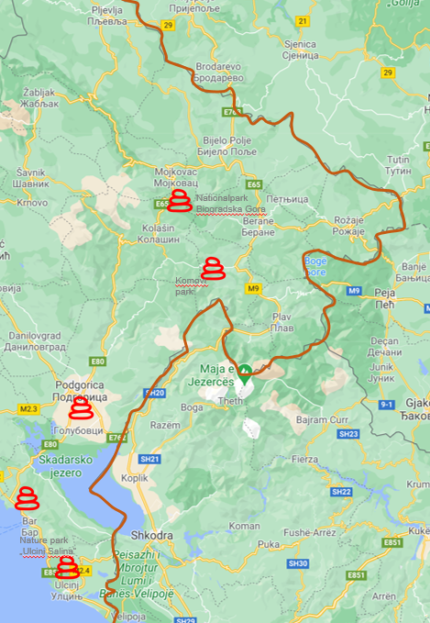
Source: Google maps
The programme area in Kosovo is characterized by a variety of natural and cultural resources. The mountains, protected areas and forests are of great potential, especially for winter and outdoor sports. Lakes and rivers provide an excellent opportunity for resort and adventure tourism. Mirusha regional park which stretches on three municipalities Klina, Malisheva and Rahovec and Mirusha waterfalls possess excellent tourism potential which is yet to be explored. In addition, the thermal waters in Banja offer another destination for domestic and foreign tourists. The well-known Pejë/Peć's surrounding wilderness including Accursed Mountains, Rugova Valley and areas around Lumëbardhi riverbed, Drini i Bardhë could be of great interest to mountain tourists.
Bjeshkët e Nemuna/ Accursed Mountains represent one of the most touristic points, where the highest peak in Kosovo Gjeravica (2656m) can be visited. In addition, the second biggest valley in the Accursed Mountain suitable for hiking is that of Decan. In this area tourists can visit Deçan/Dečane Monastery, dating from the Middle Age and part of UNESCO world heritage list.
Figure 7: Main tourism locations in the programme area (Kosovo)
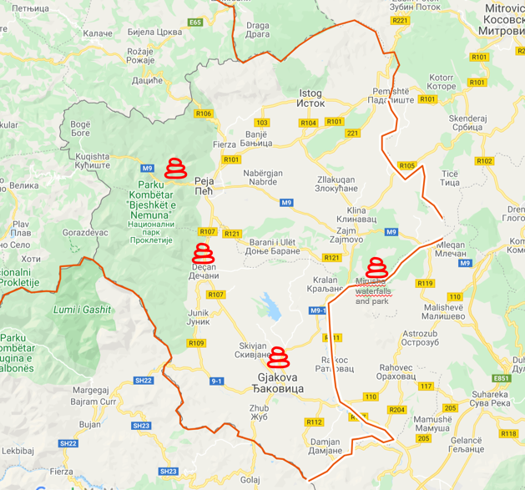
Source: Google maps
In terms of tourist arrivals and overnight stays, the programme area in Montenegro contributed to around 34% of domestic and foreign tourist arrivals in Montenegro in 2019 and 32% of total overnight stays. The coastal region (Bar and Ulcinj) and Podgorica continue to welcome the highest number of domestic and in particular foreign tourists in the programme area, estimated at around 91% of all tourist arrivals and around 96% of overnight stays. Foreign tourists, mainly visiting the coastal region, accounted for over 96% of overnight stays in the area. On the other hand, the northern region reported a small number of domestic and foreign tourists, with the municipality of Kolašin having a slightly higher number (52.818 or nearly 6% of the programme area).
Table 8: Tourism
Country/Programme area | Tourist arrivals 2019 | Overnight stays2019
Montenegro (total) | 2,645,217 | 14,455,920
Montenegro Programme area | 901,872 | 4,658,135
i) Coastal programme area (Bar and Ulcinj) | 636,597 | 4,166,910
ii) Podgorica | 186,207 | 310,593
iii) Other municipalities in the programme area | 79,068 | 180,632
Kosovo (total) | 287,083 | 490, 401
Kosovo Programme area (region of Gjakova/Đakovica region of Peja/Peć) | 73,094 | 163,226
Source: MONSTAT, KAS 2020
In Kosovo, the programme area accounted for nearly 25% of national tourist arrivals in 2019 and around 33% of overnight stays. Municipality of Pejë/Peć remains the most visited municipality in the programme area in Kosovo, followed by Gjakovë/Đakovica and other municipalities. Hospitality industry needs to be particularly strengthened in the region in order to provide better services and to adapt to specific tourist areas. There is lack of infrastructure and well-organized institutional support for the development of eco-tourism and agro-tourism.

Agriculture and rural development
Characterised by a high level of population living in rural areas, agriculture and rural development remain key for the economy of the programme area.
Table 9: Agriculture
Country/Programme area | Share of GVA 2019 (%) | Employment rate in the sector (%) | Used area of agricultural land (ha)
Montenegro (total) | 8% | 8% (2018) | 255,846
Montenegro programme area | NA | NA | NA
Kosovo (total) | 9.5% | 5.2% (2019) | 413, 635 (2014)
Kosovo programme area |  |  | 88, 347 (2014)
EU average | 1.8% | 4.2 % (2016) | 173 million (2016)
Source: MONSTAT (FSS 2016), KAS, Eurostat
In Kosovo, agriculture has the highest contribution to the economy and local employment in rural areas, and around 9.5% of gross value added (GVA). Only 14 municipalities in Kosovo have drafted a working plan on Agriculture and Rural Development, including some municipalities in the programme area, whereas 24 municipalities have not yet drafted one. Based on the latest agriculture census 2014, the programme area covers over 21% of the used area of agricultural land in Kosovo, mainly for meadows and permanent pastures and arable land-fields, and some areas for multiracial crops (fruits, vineyards, etc).
Mostly cultivated cultures in the programme area vegetables, fruits, cereals while sheep and cattle breeding accounts for the largest part of the livestock sector, followed by beekeeping. Unlike other regions in Kosovo, the programme area is in a better position as regards the irrigation of agricultural land, estimated at over 22,685 hectares. However, further expansion of this irrigation network is needed.
Several obstacles hamper the development of this sector including high levels of small farms and land fragmentation, outdated technologies, lack of production diversification, limited capacity to grow and limited provision of technical support. Moreover, land consolidation, protection against transformation and degradation of agricultural land, organisation of the markets and an integrated agriculture information system are needed. Supporting SMEs in the field of processing of agricultural products is necessary to increase the competitiveness of the programme area and create new jobs.
On organic farming, Kosovo adopted a 2018-2021 action plan for organic agriculture, which identifies key areas of work to support and develop the organic sector. This sector is young in Kosovo and mainly focused on wild collection produces, such as non-wood forest products and small area cultivated with medicinal and aromatic plants. There are five zones certified for the organic collection of non-wood forest products, with a total area of 373,488 ha. Despite the fact that the domestic market is at an early stage, exported quantities have increased in the last years, with increased promotional activities at international fairs being one of the main reasons.
Diversification of production remains one of the main challenges since the local producers and consumers are not well informed about organic farming. This indicates the need for projects that focus on promoting organic farming among rural and urban population. In addition, this field is not sufficiently integrated into the educational programmes, and there is a lack of funds to support academic research. It is important to establish open field studies, which will enable the identification of optimal plant varieties and crop management plans adapted to the local conditions.
In Montenegro, agriculture contributed 8% to the country’s GVA and around 8% of employment. Agricultural land in use accounts for 18% of the country’s territory, although 94% of such areas are pastures and meadows. Apart from a few larger agricultural enterprises, agricultural production is fragmented and characterised by small, family-run parcels with high production costs, limited organization, a lack of adequate equipment, as well as limited skills and poor access to credit and markets.
The Montenegrin government is expected to invest EUR 75 million to facilitate progressive modernisation in the next three years, mainly from EU funds (Instrument for Pre-accession Assistance for Rural Development programme - IPARD II). In addition to the support provided to achieve EU standards through investments in the physical capital and manufacturing capacities of farms, the country will focus on the diversification of farms’ economic activities: support to rural tourism and manufacturing of agricultural products directly on farms. As a result, the tourism sector will be stimulated and hence bring about economic and social benefits (e.g. innovative products, opportunities for women and young people, tourism market, ‘craft’ products, export opportunities).
The country and specifically the programme area have great potential for organic production. Organic forest and wild collection remain the dominant area of production of organic agriculture in Montenegro, with more than 143,000 ha in total.
In the programme area, several municipalities have shown high potential in developing this type of agricultural system. For example, a significant number of organic producers are registered in Andrevica and that number is increasing from year to year (from 24 organic producers in 2014 to 37 in 2016). In Podgorica, 2 clusters in agriculture and the food industry were established in 2017. Another step forward in the promotion of organic farming was the establishment of an organic bazaar in Podgorica in 2016, where organic farmers can sell their products once a week, and the start of the project “Caravan of organic and traditional products” aiming at promoting organic and traditional products.
Knowledge generating activities are key priorities for organic farmers in order to comply with certification requirements. Also, associations of organic farmers in the programme area should be strengthened. Further development of organic production will not only support environmental protection and reduction of synthetic chemical products used in food production, but will also contribute to the rural economy and the reduction negative demographic trends (migration and aging farming population).
The structure of agricultural land also shows significant opportunities for the development of livestock, especially in the northern region. Numerous pastures and pastures can be best valorised through the development of sheep and cattle breeding, which remain the most important sector of livestock production throughout Montenegro, and especially in northern Montenegro where more than half of the total bovine population is reared. Beekeeping represent also a predominant sector in organic animal production. There are associations of beekeepers (e.g. in Mojkovac) as well as individual honey producers.
Podgorica is also well-known for its wine production. However, the market of domestic producers, in addition to primary production and processing, should be directed towards products with a higher degree of processing and added value and higher branding.
Promoting agriculture and environmentally friendly and organic farming is important in supporting the sustainable economic development of the population living in the programme area, especially in rural areas. In most cases, agricultural production is a secondary occupation, which slows down the modernization and market orientation of agricultural holdings. Inadequate age structure, as well as the educational and professional profile of agricultural producers to engage in agriculture as a business, additionally have a disincentive effect on its development.
Furthermore, support is needed to align the agri-food and primary production sectors with EU standards for food safety, plant and animal health and welfare (improving livestock farm biosecurity and animal health and disease prevention; upgrading agri-food establishments).

Forestry and wood processing
In Montenegro, forests cover more than 67% of the territory of Montenegro (942 thousand ha) . Based on the forest land value, conservation, organization, diversity, management and the impact on the environment, its forests are considered as among the finest in Europe.
Big areas of municipalities in the northern region are under forests, which is an excellent basis for the development and valorisation of forest resources. The wood processing industry is one of the oldest sectors in the country, with the majority of production focused on primary (lumber and elements) and secondary production (pallets and elements for pallets with the production of briquettes), and less in final production (production of furniture, prefabricated wooden houses, etc.).
The majority of companies are located in the north and north-east part of the country including the municipalities of Mojkovac, Andrevica and Kolašin, among others. Companies that are mainly focused on selling wood raw materials without processing are more vulnerable compared to other companies which represent sent a solid base for further development of the industry and generating new jobs. However, as in other sectors, the trend of migration of the population, especially young people, can affect the perspective of this sector in the future.
In Kosovo, the forest area is estimated at approximately 481,000 ha (45% of total area), which a large area located in southwestern Kosovo in the municipalities of Peja/Peć, Deçan, Istog/Istok, Junik and Gjakova/Dakovica. Compared to Montenegro, the wood industry is not as developed as in Montenegro. In the last years, forests have been exploited beyond a sustainable level to mainly provide heating.
Together with agriculture, forestry and wood industry remain among the most vulnerable sectors in terms of the impact of climate change. Actions will be needed to not only protect the natural resources and related economic sectors (i.e. wood industry, tourism, etc.) but to also adjust to the anticipated effects of climate change.
In both countries, better management and a more balanced use of forest resources are needed and illegal logging shall be stopped. Afforestation and reforestation activities shall be supported, as well as better and improved forest monitoring and protecting tools should be introduced and applied.

Labour market and education

Unemployment
The unemployment rate in Montenegro stood at the level of 15 % in 2019, with still existing gap in the employment of women, youth and vulnerable groups. According to the 2019 Labour Force Survey data, the activity rate improved in 2019, but is still low at 57.4% and is expected to decrease as the COVID-19 crisis unfolds. Long-term unemployment remains a major structural challenge, with 63% of the unemployed being out of work for more than two years. As regards youth unemployment the situation has improved but remains challenging at the level of 29.4% in 2018.
The country is implementing the dual education system, as an important step towards a more labour-market driven provision of skills training. However, more efforts are needed to enhance tracer studies and address the discrepancy between education outcomes and skills.
Table 10: Unemployment
Country  /Programme area | Unemployment rate 2019  (Total) | Unemployment rate 2019  (Female) | Unemployment rate 2019  (Male) | Youth unemployment  rate
Montenegro (total) | 15.1% | 15.7% | 14.7% | 29.4% (2018)
Montenegro Programme area | NA | NA | NA | NA
Kosovo (total) | 25.7 % | 34.4% | 22.6% | 49.4% (2019)
Kosovo Programme area | NA | NA | NA | NA
EU-27 average | 6.7% | 7.0 % | 6.4 % | 15.1% (2019)
Source: MONSTAT, KAS, Eurostat
The overall unemployment rate in Kosovo stood at 25.7 % in 2019, which is slightly lower compared to 2018 (29.6%). Gender gaps in access to economic opportunities remains a challenge, with a persistent gap between male and female unemployment at the rate of 22.6% and 34.4% in 2019, respectively. Unemployment considerably affects women even those with tertiary education.
As highlighted in the Commission´s assessment on the Economic Reform Programme 2020, inactivity has a strong gender dimension. While men are more likely to be inactive for market-related reasons (education or training), more than half of females who are inactive reported family responsibility as being the reason. Women remain still underrepresented in local decision-making and there are currently no female mayors in any of Kosovo's municipalities.
Compared to Montenegro, the youth unemployment in Kosovo is considerably high (2019: 49.4%), revealing the difficulty of the education system to cope with the labour market needs. Active labour market policies and vocational training programmes are inadequate and still to be developed. Also, the capacity of the employment service is not sufficiently developed to ensure matching between workers and vacant jobs and the implementation of labour market policies, including upskilling and on-the-job training, to increase employment of vulnerable groups and improve the transition to informal to formal work.
Kosovo has adopted and is implementing a sector strategy 2018 - 2022 and the youth employment plan 2018 - 2020. The sector strategy identifies five pillars of intervention, one of them aiming at increasing employment, developing market relevant skills and improving labour market administration. In addition, the youth employment plan aims to guide the government´s work in relation to youth employment and education policies. However, effective implementation and monitoring of the action plan should be ensured through stronger political support and better coordination and cooperation among ministries, donors and other bodies involved.
Brain drain of educated and young people is becoming a huge challenge in the programme area, as in the whole Western Balkans. Based on the latest estimation in 2019, Kosovo continues to have negative migration rates with net migration estimated at around -28,845 inhabitants in December 2019. Pejë/Peć and Gjakova/Đakovica had among the highest negative migration balance in the country and the highest in the programme area.
On employment, the programme area in Montenegro accounts for around 65% of employed persons in Montenegro (or around 132,451). 56% of them are men and around 44% women, clearly showing gender differences in the labour market. Podgorica has the highest number of employed persons, estimated at around 93,762 persons, 71% of the programme area and 46% of the whole country in 2019.
Table 11: Employment
Country /Programme area | Total | Male | Female
Montenegro (total) | 203,545 | 112,000 | 91,545
Montenegro Programme area | 132,451 | 73,639 | 58,812
i) Podgorica | 93,762 | 51,161 | 42,601
ii) Bar | 12,673 | 7,178 | 5,495
iii) Bijelo Polje | 8,259 | 4,729 | 3,530
iv) Ulcinj | 5,081 | 3,186 | 1,895
v) Other municipalities | 12,676 | 7,385 | 5,291
Source: JTS
Other municipalities with a relatively high employment rate are the municipality of Bar (9.6% of the programme area or 12,673), Bijelo Polje (6.2% or 8,259) and Ulcinj (3.8% or 5,081 persons), while the other municipalities in the northern region report lower levels of employment.

Education
Both countries have an education system managed at the central level. In Montenegro, there are in total 97 regular primary schools and 31 secondary schools in the programme area. Regarding higher education, there are 33 educational institutions, 30 of which located in Podgorica and 3 in the municipality of Bar. The new structure (3+2+3 years) is being strengthened with the reform of university study programmes, and implementation of on-the-job learning, in order to address the existing mismatch between education outcomes and labour market needs. Regarding vocational schools, there are in total 24 schools in the programme area, mainly located in Podgorica (9), while the other municipalities (excluding Gusinje) have at least one vocational school.
The country has adopted its Strategy for the Development of Vocational Education (2020-2024). The total number of students attending dual form of education during 2019/2020 school year was 834, reflecting an increase compared to 2018/2019 and 2017/2018 school years (570 and 277 respectively). Number of new employers in the 2019/2020 school year is 120, a total of 277 employers from 19 municipalities and 27 schools.
Despite some good measures implemented such as the on - the - job learning, more efforts are needed to enhance tracer studies and address the discrepancy between education outcomes and skills. Based on the Action Plan for 2020, an analysis of existing mechanisms for the participation of relevant partners in the decision-making process is planned to be conducted. Based on these findings, recommendations will be made to strengthen cooperation in the field of vocational education.
In 2021, partners are expected to participate in the financing of vocational education through the fund for support of dual education or in another manner, based on the recommendations derived from the analysis. Other analyses will be carried out with respect to financing of vocational education. By 2024, employers are expected to take over the financing of second-grade dual education fees (now they only finance third-grade fees).
New educational programmes focused on ICT have been included (e.g. “Electrical technician for web and mobile applications in the field of information technology”, “Electrical technician of electronic communications and Electrical technician of computer systems and networks in the field of electrical engineering”, etc.)
Table 12: Primary and secondary education
Country/Programme area | Number of elementary schools | Number of secondary schools
Montenegro Programme area | 97 | 31
Kosovo Programme area | 164 (primary/lower secondary education) | 23 (upper secondary education)
Source: MONSTAT, MoE, MEST.
In Kosovo, the education system is comprised of four levels, primary and lower secondary education, upper secondary education, and Bachelor and Master level. The vocational education reform is still at an early stage, focusing mainly on analysing the situation in vocational education training schools. Half of all upper secondary students (almost 53 % in 2018/2019) choose vocational education (VET) programmes. However, 97.4% of vocational education graduates continue to enrol in higher education.
Referring to the statistics on public education 2017-2018, there are a total of 187 schools in the programme area, 164 of which schools of primary and lower secondary education, and 23 schools of upper secondary education. There is one special school in the municipality of Peja/ Peć. Regular pupils in the programme area accounts for 17% of all pupils attending primary and lower/upper secondary education, with a number of registered male pupils slightly higher that female pupils and over 95% of them are Albanians.
In 2019, investment in educational facilities in the area received the second highest amount of public investments (after construction of local roads), amounting to nearly 19% of total capital investments invested by the government. There are two public universities in Gjakova/Đakovica and Pejë/Peć, and a vocational training centre in Peja/Peć.
The VET system lacks practical and applied courses in most programmes. There are no triangular links between schools, businesses and communities. Teaching and learning methods are mostly theoretical and suffer from a lack of teaching and learning materials. Also, efforts are needed to train young people as workforce applying various forms of alternative education, training programs and innovation, as well as through innovative youth centres.
As regards youth, all municipalities in Montenegro have adopted local youth action plans based on the Law on Youth and all of them are harmonized with the key priorities of the National Youth Strategy. The new Law on Youth was adopted in 2019, prescribing new solutions to improve the creation and implementation of youth policy at the national and local level. In addition, all three bylaws have been already adopted focused on: (1) the criteria and conditions for choosing a space for youth service; (2) on the method of functioning youth services and the performance of the administrative and technical jobs needed for their functioning, followed by the (3rd) legislation in June 2020 on conditions, manner and procedure for election of members of the Council for Youth.
Funding was allocated to reconstruct, adapt, and equip youth clubs, with new clubs expected to open within 2020 in the north of the country. In 2019 and 2020, 11 youth clubs were reconstructed and adapted. Youth clubs are opened in several municipalities in the programme area including in Mojkovac, Plav, Petnjica, Bar and adapted Youth Centre in Podgorica. The country aims to open youth clubs in every municipality.
Additionally, more than 9500 free European youth cards were distributed to young people nationwide. Public financial support is provided for implementing projects on youth mobility, intercultural exchanges, youth participation and non-formal education gathering young people from six Western Balkan counties through Regional Youth Cooperation Office (RYCO).
In Kosovo, most municipalities in the programme area have not yet adopted a local action plan for youth. In 2019, Kosovo chaired the Governing Board of the Regional Youth Cooperation Office (RYCO), a regional initiative which supports intercultural youth exchange programmes and events in the region.
As regards student and academic mobility, since 2015 there have been more than 4,188 participants from Montenegro in student, academic and youth exchanges under the ERASMUS+ programme and over 4,177 participants from Kosovo have benefited from these exchanges during 2015–2019 (EC, 2020).
In Kosovo, most municipalities in the programme area have not yet adopted a local action plan for youth. In 2019, Kosovo chaired the Governing Board of the Regional Youth Cooperation Office (RYCO), a regional initiative which supports intercultural youth exchange programmes and events in the region.
As regards student and academic mobility, since 2015 there have been more than 4,188 participants from Montenegro in student, academic and youth exchanges under the ERASMUS+ programme and over 4,177 participants from Kosovo have benefited from these exchanges during 2015–2019 (EC, 2020).

Social

Population
The population living in the programme area accounts for almost 18% of the total population of Kosovo (321,488 inhabitants) and 63% of Montenegro. Kosovo’s estimated population in the programme area is slightly lower than the population of Montenegro. Kosovo’s population density is higher than in Montenegro, particularly in the mountainous continental region which constitutes more than half of the programme area in Montenegro.
Table 13: Population
Country/Programme area | Population | Density  (Inhabitants/km2)
Montenegro (total) | 622,028 | 45
Montenegro Programme area | 394,622 | 62
Kosovo (total)  Estimation 2019 | 1,782,115 | 163
Kosovo Programme area | 321,488 | 138
Total Programme area | 716,488 | 82
Source: KAS (estimation 2019), JTS

There is a tendency of internal and outward migration in the last years, which negatively affects the growth and structure of the population in the programme area in Kosovo and in the northern region in Montenegro. Based on the latest data for Kosovo, despite the positive natural increase of the population in the last years, Kosovo continues to have negative migration rates. Net migration was estimated to be -28,845 inhabitants in December 2019, while the resident population of Kosovo for the period January - December 2019 was reduced by -13,551 inhabitants. Peja/Peć and Gjakova/Đakovica had among the highest negative migration balance in the country and the highest in the programme area reaching up to -1,560 and -1,735 inhabitants, respectively.
Based on the latest data collected from the 2011 census, the population of the programme area in Montenegro is predominantly urban with almost half of it concentrated in Podgorica. Most of the population in the northern region and in the coastal region lives in rural areas.
The age distribution is similar, with almost half of the population younger than 29 years old. However, in many mountainous localities, the ageing of the inhabitants remains a major constraint for economic development. Most of the population is composed of Montenegrins and Serbs. In the coastal municipalities and in the municipalities of Plav, Tuzi and Gusinje, Albanians form a strong minority community and constitute a majority in Ulcinj. In the northern region the Bosniak population remains also important.
In the programme area in Kosovo, the population is relatively young with over half of population younger than 29. There is a low urbanisation level with most of the population living in rural areas. The population is composed of various ethnicities. Albanians make up most of the total population, and the rest is composed of Serbs, Roma, Ashkali, Egyptians, Bosniaks, Turks, Croats, Gorani, and Montenegrins. Out of 38 mayors in Kosovo, 27 are from the Albanian community, 10 from the Serb community and 1 is from the Turkish community. All municipalities have fulfilled their obligation to appoint deputy mayors from non-majority communities.
In both territories, changes are expected in the urban-rural distribution of the population compared to the previous census in 2011, due to internal and external migration.

Health
The health care in Montenegro is provided in three levels. The first level is the primary health care level that provides around 80-85% of health care needs. The Health Centre has three elementary units: Clinic of a chosen doctor (pediatrician, chosen doctor for adults and chosen gynaecologist), Centre for supporting chosen doctors organized in local and regional level for: lung diseases and TBC, diagnostics, mental health, children with special needs, prevention and similar, and Units for domiciliary care, physical therapy of primary level and medical transportation. The secondary health care level is provided through specialist clinics and hospital wards, as well as tertiary level of health care with the development of sub-specialist clinics.
The country has developed 10 strategic documents in the field of health protection. The Life expectancy slightly rose from 76.1 in 2010 to 76.8 in 2019. However, the health budget decreased compared to 2018 (6.18%), which is insufficient for the implementation of various preventive and public health measures. In 2018, a 2017-2022 action plan on communicable diseases was adopted, and a focal point to participate in the health security meetings was nominated (i.e. on serious cross-border health threats).
Some of the main concerns remain the over-prescription of medicines and insufficient support to tackle antimicrobial resistance due to insufficient communication and actions to improve health literacy. A unit in the Ministry of Health was established to manage the new integral health information system which shall cover all state-owned medical institutions. However, the unit currently has only two staff members, which is insufficient for managing such a complex system. In addition, the system needs to be further improved in order to enable effective provision of quality health services to all patients, better management of the health system and the collection of data necessary for advanced public health reporting.
Access to healthcare services appears to be available for all vulnerable groups. However, referring to the Commission’s country report 2020, treatment options for drug users are limited and almost non-existent for children. Over 95% of domiciled Roma and Egyptian population have medical cards, compared to 75% of displaced Roma and Egyptians.
As highlighted in the 2015-2020 Master Plan, special attention should be paid to the health of elderly, especially in relation to the quality of life and demographic changes considering the expected aging of population. The most frequent health problems of this population group (e.g. chronic non-communicable diseases, injuries, damaging of sight and hearing etc.) requires long-term care and treatment at home. In this context, additional services of care and house treatment of elderly through activities and cooperation between a doctor and a nurse are needed, as well as better cooperation between the health institutions and centres of social work related to provision of care and social services, with a possibility of establishing special institutions for long-term care and treatment of elderly.
In addition, health of disabled persons also requires a special approach in terms of relations between the health workers and the readiness of the system to support the exercising of rights in the area of health care. Due to numerous barriers, these persons have difficulties when exercising health care due to physical availability and the provision of health services.
Some centres for children with special needs and physical therapy, primarily for children with special needs and for disabled persons have been opened in some municipalities in Montenegro and in the eligible area. In Podgorica, special schools are transformed into resource centres focused on supporting inclusive education (early intervention, mobile activities, education, specialized didactic, teaching aids, etc.). There are two resource centres: one for intellectual and autism spectrum disorders and one for physical and visual impairments.
Furthermore, health of socially endangered and marginalized population groups, made of people and families living under the poverty threshold and hardly accessible population groups, is also associated with many aspects of health care problems. Their core problem is ignorance of their rights and methods for exercising health care, for example in Roma population group. In this context, introduction of health mediators per population groups (start with Roma), that provide easier access to health care to endangered and marginalized groups is necessary.
In Kosovo, the overall budget for the health sector has been increased by 6% compared to 2019, including higher allocations for essential pharmaceuticals and for capital expenditures. The public network of primary healthcare consists of 429 institutions and each municipality has the main Family Medicine Centre and Ambulances. As regards the secondary health care, there are two regional hospitals in the programme area: one in Gjakova/Đakovica and one in Peja/Pec. The tertiary health care as the highest specialized medical level, is provided in the capital city Prishtina/Pristina.
The country faces several challenges including a non-functional public health information system and health workers brain drain which is negatively impacting the health system. Kosovo has yet to introduce a universal health coverage scheme and amend the Law on health insurance. Also, little progress has been made on the health sector strategy.
Only 65% of annual public health needs are covered by public spending, which mostly cover fixed costs, leaving less for direct patient costs (diagnosis, treatment and prevention). Health financing continues to be based predominantly on historical expenditure rather than forward-looking needs assessments. Limited incentives have been introduced to improve productivity, efficiency and quality in the health sector.

On access to health services, around 18% of the population do not seek medical services in the event of illness due to economic reasons. Access to basic healthcare is free but spending on diagnostic services and medications is not reimbursed due to inexistent universal health insurance. The high level of private (out-of-pocket) expenditures - estimated at 40 % of total medical costs has been disproportionately affecting the most vulnerable groups. Roma and Ashkali communities have low immunisation levels and limited access to healthcare due to economic reasons. In addition, the distribution of information on public services and the incidence of discrimination requires improvement.
Regarding the response to COVID-19 outbreak, five provisional hospitals for medical treatment of persons suffering from COVID 19 were prepared and equipped in Montenegro. The country received material to control COVID tests, as well as EUR 3 million in EU funding to enabling it to buy urgently needed medical equipment and supplies.
In Kosovo, a new Law on prevention and fight against the COVID-19 pandemic was adopted in August 2020, in order to provide a solid legal framework for the required public health measures. The EU provided EUR 5 million immediate support for medical and protective equipment to strengthen the capacity of the health-care system to fight COVID-19.

Poverty and social issues
In Montenegro, the at-risk-of-poverty rate remained at 23.8% in 2018. The risk of poverty is higher in the northern region; 40% of the population of northern region was at risk of poverty in 2018, while the population of central region had the lowest risk of poverty (UN Montenegro, 2020). The at-risk-of-poverty rate is the lowest for employed people in the country (6.1% in 2018) while almost half of the poor are unemployed (47.5%).
As presented in the table below, the northern region reported the highest number of families (60%) and family members (63%) that received material support in the programme area in 2018 and up to half of the family members at national level (48%).
Table 14: Social assistance in Montenegro
Programme area | Number of families receiving Material support of family  2018 | Number of members receiving (Material support of family)  2018 | Personal disability allowance  2018 | Care and support allowance  2018
Montenegro Programme area | 6,828 | 23,642 | 1,646 | 10,083
i) Podgorica | 30% | 28% | 43% | 43%
ii) Coastal area | 10% | 9% | 14% | 12%
iii) Northern Region | 60% | 63% | 43% | 45%
Montenegro (total) | 9,319 | 31,066 | 2,500 | 15,298
Montenegro Programme area | 6,828 | 23,642 | 1,646 | 10,083
Share of programme area | 73% | 76% | 66% | 66%
Northern Region/ total Montenegro | 44% | 48% | 29% | 30%
Source: MONSTAT
In addition, the programme area receives a large amount of the disability and care and support allowances, reaching up to 66% of the total number of people receiving this support in Montenegro during 2018.

Day care centres for elderly have continued, with several centres opened in Podgorica and Mojkovac, among others. Also, centres have been opened to protect children with disorders and difficulties in development without parental support, and support their socialization and integration into a community. Over 13 day-care centres have been established in: Bijelo Polje, Plav, Ulcinj, Berane, Mojkovac, Rožaje and Podgorica, among others. While there is a trend of development of services of social and child protection in municipalities - mostly day care service, more involvement is needed from other actors apart from public authorities in order to support and improve the system of social and child protection.
In addition, the 2017-2020 social housing programme is being implemented in several municipalities, addressing the housing needs of socially disadvantaged or socially excluded groups, including also projects on housing cooperative of health and education sectors employees (especially in the northern region of Montenegro). In the previous phase housing units were provided in Podgorica, Berane, Bijelo Polje, among others and now other projects are ongoing in Podgorica, in Ulcinj, etc. Funds at national and local level are planned, however, financing remains one of the main challenges for establishing a sustainable social housing system and various forms of support are needed.
Considering the regional disparities in the country, programme planning and implementation need to be focused on the development of projects in the northern region, in order to reduce migration in this area. Also, focus should be placed on the development of projects aimed at addressing the housing needs of persons with disabilities, pensioners – those older than 67, young married couples, and members of the Roma and Egyptian population. Referring to the programme, there is a significant stock of nearly 2,000 housing units in the country, which shall be managed and maintained by the local authorities.
In addition, Montenegro has adopted a Strategy for integration of persons with disabilities 2016-2020 aiming at improving the situation of persons with disabilities and with the need to involve them in all fields of society on an equal basis. Also, a national strategy for social inclusion of Roma and Egyptians 2016 – 2020 is adopted and is being implemented, which aims to address issues related to: housing, education, health care, employment, culture, language & identity, among others. Few municipalities, including Podgorica, Bar and Ulcinj have drafted local plans on Roma.
The lack of education and educational opportunities as well as discrimination and lack of acceptance by non-Roma and employers is one of the biggest obstacles to employment of Roma and Egyptian population. Programs to include children of Roma and Egyptian population are being implemented at all levels of education in Montenegro.
According to the 2011 census on population, 6,251 persons or 1.01% of the total population declared to belong to Roma nationality. Population of Egyptians consists of 2,054 persons, or 0.33% of the population. The largest number of Roma is living in Podgorica (3,988), followed by Berane (531), Niksic (483), Bijelo Polje (334). The majority of Egyptians are in Podgorica (685), Niksic (446), Tivat (335) and in Berane (170). A systematic solution that enables more efficient access to areas in which members of this community are most vulnerable is needed.
As regards poverty rates in Kosovo, the proportion of population living below the poverty line has been decreasing, but it is still high (18% in 2017) with inhabitants living in rural areas and female-led households disproportionately affected. This category has little to no access to health services. Nearly 18% of families receiving social assistance in Kosovo live in the programme area.

Table 15: Social assistance in Kosovo
Country/Programme area | Number of families receiving social assistance  2019 | Number of members receiving social assistance  2019
Kosovo (total) | 24,352 | 98.756
Regions of Gjakova/Đakovica and Pejë/Peć | 4,271 | 17,465
Share of programme area | 18% | 18%
Source: KAS (2020)
Referring to the poverty rate based on the level of education, people with tertiary education have lower chance to live in poverty compared to those with primary and secondary education, emphasizing the importance of education in alleviating poverty.
As regards vulnerable groups, the high level of out-of-pocket expenditures for health care remain one of the main concerns due to their poor economic conditions. Roma and Ashkali communities have low immunisation levels and limited access to healthcare. As regards employment, the situation with employment of these communities is also worse than that of all other communities.
There are some national strategies and action plans developed (mostly at national level) including the National Strategy for Inclusion of Roma and Ashkali Communities in the Kosovo Society 2017-2021 which aims to strengthen the multi-ethnic and multi-cultural character of the society in the country, by focusing on four priority fields that need to be addressed by the national strategies: education, employment and social welfare, health, and housing.

Regional disparities
In Montenegro, the programme area is characterized by regional differences in terms of economic and social development. The average unemployment rate as well as the poverty rate in the northern region are significantly higher than in the central and coastal regions. This region has an unemployment rate up to nine times higher than in the coastal region. While the unemployment in coastal region is estimated at 5.5% (relying heavily on tourism sector and seasonality), the unemployment in the north is estimated at 36.3%.
This situation has led to a constant depopulation of the northern region, which could hamper its development plans. Considering its valuable resources and unique environment, the region has a great economic potential in agriculture and forestry sectors, renewable energy and tourism. Small production activities, mainly related to food and wood processing, are redeveloping and efforts are devoted to develop new tourism products.
The capital city Podgorica has a level of development above the national average. Its economic activities are mainly concentrated on services and industries. In addition, the southern part of the capital possesses favourable conditions for agriculture, being reported to have the largest all-in-one piece vineyard in Europe. The coastal region, apart from the activities related to the port of Bar, is highly depending on tourism. However, investments in tourism sector have been mainly concentrated in the western part of the coast.
Similarly, Kosovo faces significant disparities between municipalities and human and financial resource constraints continue to negatively impact municipalities’ ability to implement their plans. Unlike the programme area in Montenegro, Kosovo´s eligible area is characterized by rural and mountainous areas.
The economic development is highly depended on tourism and related services, trade, agriculture and construction. Pejë/Peć represents the centre of the region in terms of economy and population and is one of the richest cities of Kosovo. Gjakova/Đakovica is the second most important economic centre of the area, being well-known for its work tradition in industry and agriculture as well as for workers in the crafts, trade and services.

Culture and sport
Montenegro has been investing in creative hubs and industries, infrastructure and arts development. There are 9 cinemas in function, 9 theatres (mostly professional theatres), 1,168 sports associations and clubs (2016), 26 museums (2018) and 35 libraries (2016).
Numerous events were organised as part of the 2019 European Heritage days. However, in 2020 many cultural and artistic activities of public interest were affected by the COVID-19 restrictions.
Kosovo has been making efforts to meet the standards of the 2005 UNESCO Convention on the Protection and Promotion of the Diversity of Cultural Expressions. Cultural events are being held in the programme area, mainly at local level. As regards the Creative Europe programme, a Creative Europe desk for Kosovo have been established. In 2019 information sessions were organised to inform larger audiences about co-financing opportunities; however, without any successful project being funded.
In 2018, both countries participated for the first time in the European Week of Sports under the framework of the European Commission’s initiative “European Week of Sport Beyond Borders to promote sport and physical activity throughout Europe. Their active involvement continued in 2019 by organising various sports activities.

Civil society
Civil society has an important role to play, especially in the EU accession process of both countries. In 2018, Montenegro adopted a new Non-Governmental Organisation (NGO) strategy and action plan. The rules for public funding of civil society organisations (CSOs) are in place, with a 0.5% minimum percentage of the state budget to be allocated to civil society under the Law on NGOs.
However, the inclusion of civil society organisations in the policy-making process is yet to be ensured in practice if the new model of CSOs public funding is to reach its full potential. While CSOs can access funds at local level under the law on local self-governments, most municipalities lack transparent procedures.
94% of NGOs in Montenegro are registered in the programme area. Podgorica has the highest number with 2,392 or 60% of NGOs in the programme area, followed by municipalities of Bar (343) and Bijelo Polje (294). Gusinje reports the lowest number of registered NGOs in the region (23) and among the lowest in Montenegro.
Table 16: Number of NGOs
Country /Programme area | Number of registered NGOs | Share (%)
Montenegro (total) | 5,932 | 100%
Montenegro Programme area | 4,011 | 94%
i) Podgorica (as % of the programme area) | 2,392 | 60%
ii) Gusinje (as % of the programme area) | 23 | 1%
Source: JTS 2020
In 2019, Kosovo adopted the Government Strategy for Cooperation with Civil Society 2019-2023, which aims to improve the enabling environment for development of civil society and increase its participation in policymaking. Based on this strategy, a new Government Council for Cooperation with Civil Society was set up and started work in July 2019.
In addition, the Law on freedom of association was approved in 2019, aligning the legal framework for CSOs to the best international standards and practices. While the environment in which civil society operates has been improving, more efforts are needed to enhance transparency of public funding for CSOs which remains at risk of corruption and conflicts of interest due to limited capacity of local and central authorities to properly implement new transparency and accountability standards.

Infrastructure
Appropriate infrastructure and developed transport systems remain of high importance for the economic development of the programme area. The good geographic location of both countries allows them to connect with other parts of the region and Europe.

Road infrastructure
In Montenegro, the length of roads in 2019 amounted to 9,249 km. Based on the type of road, the highest share had an asphalt surface whose length was 6,333 km (68.5%), followed by gravel with 1 839 km (19.9%) and earthen roads with 1 077 km (11.6%).
As regards road infrastructure investment, the construction of the priority section of the Bar-Boljare highway suffered delays and high costs, which points to the need for a proper environment and social impact assessment and a sound cost-benefit analysis when building further sections. Preliminary studies are underway for building the Adriatic-Ionian highway, which would be the second highway parallel to the coast, improving connectivity in the country and in the region.
In Kosovo, the length of the regional road is 1,313.9 km or 63% of total road in the country, while the length of national roads and motorway length are respectively 641.7 km (or 31%) and 119.1 km (6%). Some progress is made in improving roads including the highway to Peja/Peć and the completed Route 6-highway on the border crossing point linking the capital city Pristina with North Macedonia. In the programme area, construction of local roads receives the highest amount of public investments, consisting of around 60% of public investments made by the central government in 2019. Construction of local roads, water supply and sidewalks were also the most invested sectors by local authorities in the programme area.

Railway infrastructure
The length of the railway line in Montenegro amounted to 250 km in 2019, with a number of passengers carried by rail at the level of 984,000 passengers. While some national and regional roads have been upgraded in Montenegro, rail infrastructure requires further upgrading, which will especially help the country and the programme area to fully unlock the potential of the port of Bar. In addition, a new railway law is yet to be adopted.
In addition, public transport and compliance with passengers’ rights remain a concern. Implementing legislation for the interoperability of rail systems in line with the EU acquis was amended in 2019, including new technical specifications on safety in railway tunnels. Rail transport services for passenger and freight have been liberalised at domestic level, but further efforts are required to ensure the full opening of the rail market. In 2019, Montenegro signed the Declaration on European Railway Safety Culture, which aims to raise awareness and promote a positive safety culture throughout the industry.
As regards railway infrastructure in Kosovo, the country has a total of 333 km of railway tracks for transport. In 2019, the number of passengers who used the train as a means of transport was about 181,000. The Railway Route 10 rehabilitation works, aimed at linking Kosovo with the wider European railway network have started but little progressed has been made due to the lack of administrative capacity for project implementation.
National legislation on rail transport needs to be updated, in particular in relation to accident investigation. No progress has been made on the adoption of a 5-year rail maintenance plan. Significant efforts are needed to rehabilitate and extend rail transport for freight and passengers.
As in Montenegro, railway authorities signed in 2019 the Declaration on European Railway Safety Culture to raise awareness and promote a positive safety culture throughout the industry.

Air and water transport
One international airport is located in the programme area: Podgorica airport (TGD), situated 11km south of central Podgorica in Montenegro. It is one of the two international airports in Montenegro offering services to commercial airlines. The air transport is dominated by the movements of tourists, mainly originating from neighbouring countries and European countries. The total number of passengers using this airport was 1.21 million in 2018, representing 49% of all passengers in Montenegro. Traffic is largely driven by summer season tourism with the June-September period representing 50% of the annual traffic for Podgorica airport. In addition, there are two other old airfields in Montenegro -Berane airport and Ulcinj airport which are currently not operational.
In addition, Montenegro's main port is located in the municipality of Bar. It is an important transport connection which serves as a key entry and exit point for large amounts of goods for Montenegro and its neighbouring countries.
In Kosovo, air travel of the programme area is mainly performed by air routes through Pristina international airport, which is situated 90 km away from Decani and offers all services for passengers, and goods transport. Activation of Gjakova/Đakovica airport, which is currently not operational could offer a great potential for the economic development of the programme area.

Water supply
Bigger urban centres in the programme have in general higher rates of connectedness to the water supply and wastewater treatment than smaller towns and rural areas. In Montenegro, in order to align with EU environmental standards, water distribution networks and waste treatment plants are being constructed in several municipalities.
In Kosovo, in 2018 about 86.31% of the population was supplied with drinking water through public systems, managed by Regional Water Companies. Whereas 13.69% of the population did not have access to public water services. The country has adopted a 2017- 2036 water strategy, but the level of alignment with EU legislation is low. In addition, more needs to be done to ensure the implementation of the Law on water.

Energy supply
In Montenegro new energy supply capacities have been enhanced with the launch of a windmill farm at Možura with 46MW of installed capacity which was put into operation in November 2019, the issuing of licences for solar power plants, including a large 250 MW solar plant at Briska Gora in the programme area, and the interconnection of the electricity network with Italy, while others with Serbia and Bosnia and Herzegovina are planned. In 2018, 38.8% of the country’s electricity came from renewable sources, mostly hydropower and biomass. However, the reliability of the electric power supply in rural areas still needs to be improved.
Unreliable energy supply remains a key bottleneck for Kosovo’s economic development. Little progress is made in securing a stable energy supply and losses in the electricity sector remain very high. An outdated production capacity, a non-liberalised energy market and an adequate tariff system remain significant problems in Kosovo. Also, the internal energy market continues to be undermined by insufficient regional economic integration.
The construction of a new 500 MW power plant was planned to start in 2019. However, its construction plan is yet unclear, after the company selected to build the new plant withdrew from the project in 2020. Several aspects of the project were questionable, including its potential impact on public finances, electricity prices for consumers, biodiversity, climate change and the environment, as well as its compatibility with state aid rules.
Although investments in renewables are increasing, Kosovo remains highly depended on a coal-based, outdated and unreliable energy production system. The electricity produced from renewable sources was only 3.2% of total production in 2018. Competitive bidding procedures for renewable energy projects are undermined by the use of excessive fixed feed in tariffs by the Energy Regulatory Office. While the legislation is partially aligned with the EU acquis, the electricity market should be restructured to facilitate the integration of renewable energy generation. There was no progress on meeting the requirements for the use of biofuels in transport. An administrative instruction on biofuels and the adoption of a new Law on trade in petroleum products and renewable fuels are still pending.

Digitalisation
In Montenegro, the 2019 action plan implementing the information society development strategy has been adopted. The developments of telecommunication networks rely mainly on the private sector. Fixed broadband services, and in particular the optical fibre sector, has shown strong growth, although mainly in key municipalities.
In the first nine months of 2019, the number of fibre connections has increased by 24%, totalling 34% of all fixed broadband connections. The process of mapping existing telecommunication infrastructure is continuing since 2018 and expected to be completed in 2020. In 2019, 25% of households had no internet access, increasing up to 37% in rural areas. Although 98.6% of Montenegrin enterprises use computers, only 18% of them have internet connections. In 2018, 80% of companies with internet access had a website; however only 8% of SMEs sold online, compared to the EU average of 17%.
Table 17: Internet access at home
Regions | % of households who have internet access at home in 2018
Montenegro (total) | 72.2%
Montenegro programme area | NA
Kosovo (total) | 93.2%.
Kosovo programme area
EU average | 88 %
Source: EC (2020) & Eurostat
Regarding e-services, the government’s electronic portal (eUprava) currently provides 249 e-services, most of them informational and it is underway the development of the e-cadastre, as some procedures are yet to be completed online.
As regards the digitalisation of the economy in Kosovo, the country achieved the mid-term targets in the 2013 - 2020 digital agenda for Kosovo by mid-2018. Access to internet at home was 93.2% in 2018 and the number of mobile phone users stood at 115.7% of the population. Since 2018, the country has been implementing a 5-year project, aiming to bridge the urban-rural digital infrastructure divide, and investing in the rural areas which are not normally attractive for private investors.
As regards e-services in Kosovo, stronger efforts are required to formalise data sharing arrangements across agencies (Kosovo Tax Administration, Business Registration and Cadastre Agencies and the Credit Registry of the Central Bank). The Tax Administration has developed a good taxpayer service focus, in particular with the widespread use of e-filing and e-payment. Also, all complaints related to procurement are now handled only electronically on the e-procurement platform.
In the context of developing a Regional Economic Area in the Western Balkans, a regional agreement on roaming fees was signed in 2019 enabling Roam like at Home as of July 2021.

Innovation and research
In Montenegro, the level of investment in research and development (R&D) has been rising since 2017 amounted to 0.5% of GDP in 2018, which is however below its 2020 target of 0.6% and EU average. Most of the investment comes from the public sector, while only 2.2% of SMEs invest in R&D.
Table 18: Innovation and research
Country/Programme area | R&D expenditure 2018  (% of GDP)
Montenegro (total) | 0.5%
Montenegro programme area | NA
Kosovo (total) | 0.1%
Kosovo programme area | NA
EU average: EU- 28/EU - 27 | 2.11% / 2.18%
Source: EC 2020, Eurostat
In 2019 the Smart Specialisation Strategy (S3) 2019-2024 was adopted, which is an important step towards developing an innovation ecosystem by concentrating and linking research and innovation resources to key priority areas (agriculture, energy, health, tourism and ICT).
In 2020, Montenegro was included in the European Innovation Scoreboard as a modest innovator, which will help the country to improve its statistical system and monitor the implementation of its Smart Specialisation Strategy.
As regards innovation support infrastructure, a new science and technology park is being established in Podgorica, while the one in Niksic (Techno-polis) is already operational. Soft activities related to training, mentoring, intellectual property, etc., are also organized, and are mainly financed by the EU. In 2020, two new centres of excellence covering food science and biomedical science started operating.
On country’s participation in Horizon 2020, Montenegro received EUR 3.2 million of direct EU contribution in 2019 and reached a success rate of 13,9% for the overall Horizon 2020 programme. The country is also engaged with international bodies such as COST, CERN, IAEA and EUREKA in order to support business-academia cooperation.
Research is carried out by scientific research institutions including: Montenegrin Academy of Sciences and Arts (CANU) and institutions that have been granted a license to carry out research activities in certain fields of science (universities, institutes, faculties and enterprises). University of Montenegro is the most important actor in R&D in terms of international cooperation in scientific publications and in R&D projects financed by EU programmes, mainly in ICT, agriculture, manufacturing industry and materials and in electrical and electronic technologies. In 2020, the University was awarded the ‘HR Excellence in Research Award’, acknowledging its compliance with some human resources principles set out in the European charter and code for researchers. Other important actors are the Clinical Centre of Montenegro and the Public Health Institute of Montenegro.
Kosovo has made efforts to develop its research and innovation policy. However, its research, development and innovation system is yet underdeveloped and underfinanced. R&D spending as share of GDP, amounted to only 0.1%, despite a 0.7% target mandated by law. The public funding and efforts are mainly focused on providing scholarships for student mobility and only very few opportunities for PhD/postgraduate research.
There is no strategic approach to the development, prioritisation and promotion of research activities. Its legal base on research and innovation consists of a Law on scientific research activities and a Law on scientific innovation, transfer of knowledge and technology. However, many key provisions of these laws are yet to be implemented, including the requirement to develop a national-wide research programme. A Smart Specialisation Strategy is being developed but it is still at an early drafting stage.
Regarding research infrastructure, Kosovo has started to establish links to GÉANT (Europe’s leading collaboration on network and e-infrastructure services), and a support project to better integrate the country in the activities of this research infrastructure is ongoing. Work has started to develop an R&D infrastructure map that collects national data on laboratories and researchers.
In 2018, a new Ministry of Innovation was established and EUR 1.1 million was allocated for specific labs and equipment at two regional innovation centres. In the programme area, Jakova Innovation Centre has been established in Gjakova to promote and support young entrepreneurs.
Horizon 2020 is the main international cooperation programme. Kosovo entities have participated in 18 collaborative actions, Marie Skłodowska Curie actions and European Research Council actions, receiving EUR 2.5 million. The country also participates in the European Cooperation in Science and Technology, which enables researchers to participate more easily in research and innovation meetings across Europe.

Environment

Environment protection
The programme area is rich on environmental resources and biodiversity. Montenegro has five national parks and four regional nature parks. The national parks cover approximately 10% of the territory. Four of the national parks and two important nature parks (Komovi, Ulcinj) are located in the programme area. Parks are managed by the National Parks of Montenegro government agency.
Komovi is a mountain and mountain range in eastern Montenegro, located between the Montenegrin-Albanian mountain range Prokletije bordering them from the south and east, Bjelasica mountain in the north, and Tara river in the west. Komovi mountain range is divided between Kolašin and Andrijevica municipalities. Since 2018, Komovi is classified as a nature park, i.e. as a protected natural area, for their ecological significance and abundance of the flora and fauna.
In 2019, the municipality of Ulcinj proclaimed Ulcinj Salina as a nature park and in September 2019 was also included on the Ramsar list, declaring it a wetland of international importance.

Figure 8: Protected areas in Montenegro
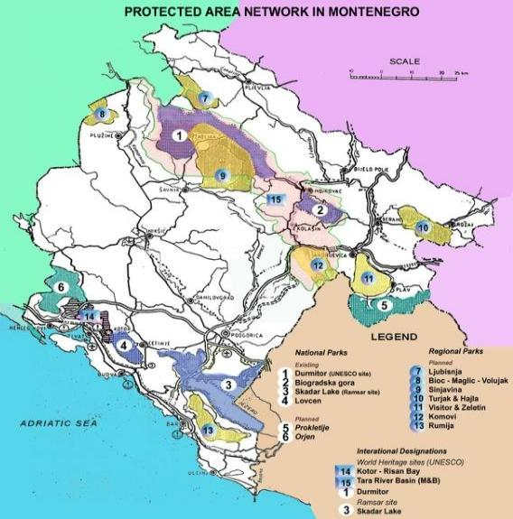
Source: Spatial Plan of Montenegro until 2020
Kosovo has currently 2 national parks (one in the programme area), 11 nature reserves, 99 natural monuments and 3 protected landscapes. The total area of all protected areas in the country is 118,913 hectares. The national policy for governing and management of the national parks is implemented by the Ministry of Environment and Spatial Planning. Kosovo has also adopted the 2016-2020 action plan on biodiversity.
Steps have been taken to start the inventory and mapping of natural habitats types and of biodiversity, but the designation of Natura 2000 sites is still at an early stage, due to a lack of technical and staff capacities in relevant institutions. Spatial planning documents and infrastructure plans need to ensure that nature protection obligations are respected, mainly in protected areas such as national and regional parks, and potential Natura 2000 sites.

Figure 9: Protected area in Kosovo
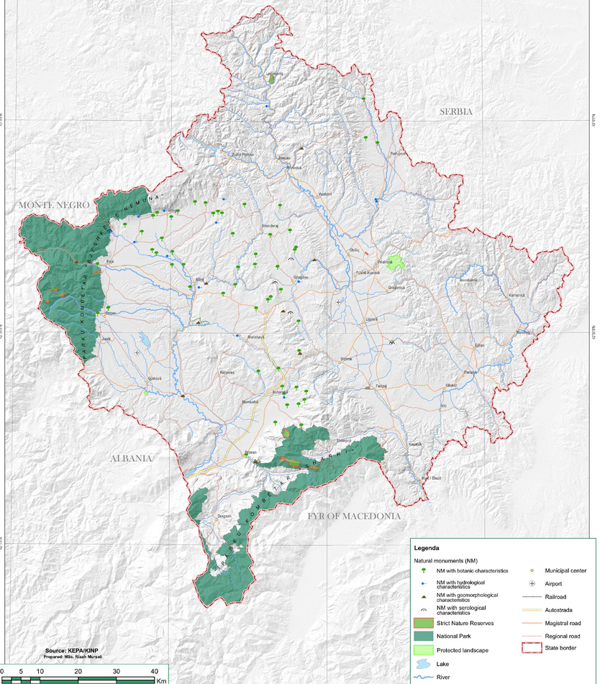
Source: KEPA/KINP 2015
Considering the environmental resources and biodiversity that the programme area offers, environmental protection and preservation is key for a sustainable development. In some areas, the environment is negatively affected by poor water and sewage management, uncontrolled waste disposal, unregulated urbanization, and industrial pollution. Also, there is a risk of deforestation due to uncontrolled logging, rivers and lakes locally risk pollution from illegal landfills and poor waste management. Moreover, the intensive use of pesticides that harms agriculture should be avoided.

In 2019, Montenegro developed a new action plan to better prioritise alignment with and implementation of the EU acquis on the environment and climate change (Chapter 27). In December 2019, the government adopted the third report on the implementation of the previous action plan for the 2018-2020 period, showing slow implementation in most of the policy areas especially on waste management and climate change. Urgent issues such as the lack of sufficient administrative capacities at central and local level and inspection bodies, insufficient inter-institutional coordination and lack of a sustainable financial framework should be further addressed. However, progress is being made to meet the final criteria for Chapter 27, which will be adopted by the end of 2020. Montenegro has also established the Fund for Environmental Protection and adopted the Law on environmental impact assessment, aligning with the EU Environmental Impact Assessment Directive.
While some mitigation measures are taken to monitor and improve the state of the environment in some sensitive areas at Skadar Lake and the Tara River, potential negative environmental impacts of building construction in the Skadar Lake national park and on Tara River due to the Bar-Boljare highway development need to be assessed and prevented. Likewise, potential investments in hydropower and touristic developments need to comply with nature protection and water management requirements. The lack of sufficient administrative capacities at central and local level and inspection bodies, insufficient inter-institutional coordination and lack of a sustainable financial framework should also be addressed.
Control of industrial pollution is predominantly regulated by the Law on Environment (“OG of ME” 52/16) and the Law on Industrial emission (“OG of ME” 17/19) adopted in March 2019. Montenegro is aligned with the EU acquis on industrial pollution control and risk management. The Law on industrial emissions was adopted in March 2019, followed by relevant secondary legislation. The Industrial Waste Management and Clean-up Project (IWMCP) has been implemented to remediate 5 selected industrial waste disposal sites and to manage the ongoing disposal of industrial hazardous waste.
Pursuant to the new Law on Industrial Emissions and article 26, the Nature and Environment Protection Agency of Montenegro (NEPA), ex officio initiated the procedure of revision of integrated permits, informing all 5 operators of the reasons for initiating. Documentation for revision was submitted by 4 operators ("Možura" doo Bar; Landfill “Livade” doo Podgorica; Elektroprivreda CG for the plant "Termoelektrana Pljevlja" and "TOSCELIK Alloyed Engineering Steel d.o.o.", Nikšić). In this way, all plants will harmonise their operations, especially in the part related to the possibility of conducting coordinated inspections, which are regulated for the first time by the new Law on Industrial Emissions.
On chemicals, the Montenegro has adopted the 2019-2022 national chemical management strategy and action plan. A national helpdesk has been established in 2018 as first point of contact for questions related to the Biocidal Products, REACH and CLP regulations.
Kosovo is at an early stage of preparation on environment and climate change. While the country has adopted some relevant strategies, serious environmental problems persist. The environment strategy has still not been updated and implemented. Insufficient funding and a lack of administrative capacity and technical skills continue to undermine the implementation of priority measures. At local level, municipalities are facing with many difficulties in the field of environment, waste collection, air pollution and illegal landfills.

The 2016-2020 action plan for biodiversity is only partially implemented and there is no progress in the area of nature protection. Kosovo became a member of the International Union for Conservation of Nature and extended protected area status to more of its territory, which is yet polluted and poorly maintained. Mapping of natural habitats and biodiversity has started, but the designation of Natura 2000 sites is still at a very early stage due to a lack of administrative capacity. Deforestation and illegal logging remain problematic, although some progress on forestry was made on planning and management, with the adoption of relevant acts.
As regards industrial pollution and risk management in Kosovo, no progress is made to align with the EU acquis. Insufficient enforcement of legislation and polluter accountability is hampering the establishment of a system for preventing industrial and chemical accidents. Hazardous mine waste, industrial discharge into rivers and industrial dumpsites continue to pose serious threats to soil and water and no location is yet established for the future hazardous waste storage facility.

Climate change adaptation and mitigation
A Climate Change Strategy is in place in Montenegro, but more work is needed to ensure consistency with the EU 2030 climate and energy policy framework and to ensure that the strategy is integrated into all relevant sectoral policies and strategies.
In 2019, the framework law on climate change was adopted followed by the adoption of a decree which ensures the establishment of a national carbon dioxide emissions trading system. However, incorporation of the remaining elements of the EU Emissions Trading System (ETS), the Effort Sharing Regulation and the Monitoring and Reporting Mechanism (MMR) is yet to be completed.
As for the UN Framework Convention on Climate Change (UNFCCC), Montenegro has submitted two national communications and submitted its second bi-annual report on climate change in 2019 and a third national report is being prepared.
In Kosovo, the 2019-2028 strategy and action plan on climate change has been approved but are not properly implemented. Due to its economic dependency on coal, the country is not complying with the emission ceilings established under its National Emission Reduction Plan (NERP).
Progress is needed in aligning the legislation and mainstream climate action and in public awareness. There is a lack of climate change adaptation strategy, of concrete measures to mainstream climate action and raise public awareness, and there is little alignment of policies with climate change objectives. Administrative capacity and awareness-raising need to be strengthened at all levels. In 2019, awareness-raising campaigns on environmental protection were undertaken in 23 municipalities, including in some of the municipalities of the programme area.
Although Kosovo is not a signatory to the UN Framework Convention on Climate Change and therefore does not have nationally determined contribution to the Paris Agreement, implementation of its climate change strategy shall help the country reach the low emissions and climate-resilient objectives of the agreement. As regards the transparency of climate action, the compiling of greenhouse gas inventory and reporting has stopped since 2015.

Waste management
In Montenegro, more efforts are needed in terms of strategic planning and investments in order to implement the national strategy for waste management and the 2015-2020 national waste management plan. Some progress is achieved on managing municipal waste and decisions on separate waste collection were adopted in the municipalities of Berane, Plav, Rozaje, Kolasin, Gusinje, Andrijevica, Ulcinj and Petnjica, among others. However, illegal waste disposal and the use of temporary waste disposal in all municipalities remain issues that need to be addressed. Furthermore, infrastructure for separate waste collection and recycling is yet to be established in all municipalities.
In Kosovo, the solid waste management system is not yet sustainable. The Law on waste needs to be further aligned with the Waste Framework Directive. Most waste generated in the municipalities ends up in illegal or not effectively managed landfills. Despite efforts to remove illegal dumpsites, the number of illegal landfills reached 2,529 in 2019 (more than 60% compared to 2017), posing a serious public health risk, in particular due to hazardous waste and groundwater contamination.
In the programme area, Junik is among the few municipalities in Kosovo with no illegal landfills, while Peja/Peć reports the highest number, according to a report published by the Ministry of Local Government Administration.
In addition, waste prevention and monitoring remain a challenge. The collection rate is 70% and less than 40% of solid waste is disposed of in managed facilities. Measures to reduce waste and increase recycling and recovery in line with circular economy principles are needed. Municipal waste management plans have not been adopted by all municipalities and the 2013-2022 waste management strategy and action plan are only partly reflected in local plans. In 2019, 31 municipalities in Kosovo have approved the local waste management plan, including some of the municipalities in the eligible area.

Water management
In Montenegro, the national strategy for water management 2020 - 2035 is being implemented to address the issue of untreated wastewater, being the largest source of pollution of surface and groundwater. The network of hydrological surface stations for monitoring the quantity of surface waters and a network of stations for groundwater monitoring were set up, including a software for processing the collected hydrological data.
Water management plans for the Danube and Adriatic basins are yet to be finalised. A new law on marine environment protection was adopted in 2019 to enable alignment with the Marine Strategy Framework Directive. While hydropower is seen as an important energy source, compliance of investments with national and international nature protection and water management obligations as well as public participation and consultation should be ensured. In addition, they need to guarantee high quality environmental impact assessment that include cumulative impacts on nature and biodiversity.
In Kosovo, the river basin district authority has become operational. No progress was achieved in preparing management plans for all river basins. There was some progress on cooperation with neighbouring countries on integrated water management and flood protection. In addition, waste water treatment plants are being constructed in seven regional centers and are under different phases of construction. Tariff collection needs to be improved and water losses to be reduced. According to Kosovo Agency of Statistics, in 2018 there was only one plant for the treatment of urban wastewater in the municipality of Skenderaj in the central part of Kosovo (outside the programme area), which has been operating since 2011.
In addition, identification of agglomerations and sensitive areas, in line with the Urban Wastewater Treatment Directive is needed. Water reservoir dam management requires improvement to meet water demand. Moreover, the construction of numerous small hydroelectric power plants that harms the environment needs careful monitoring and assessment. Water resource monitoring networks are incomplete, in particular for groundwater, and water protection zones are not being monitored or properly managed. Lack of proper wastewater treatment poses a serious risk to the ground and drinking water and to nature in general.

Renewable energy sources
In Montenegro, 38.8% of gross final consumption of energy in 2018 came from renewable sources, mainly hydropower and biomass. This exceeded the national 2020 target of 33% (even above the EU average of 31.8% in 2017). While the share remains high, it marks a downward trend, being the lowest figure since 2008. In 2019, the government adopted a regulation on incentives for electricity production from renewable sources and high-efficiency cogeneration.
In 2019, Montenegro awarded a tender for the long-term lease of state-owned land for the construction of a wind farm on the site of Brajići in Budva and Bar municipalities. The Možura wind farm with 46MW of installed capacity is now operational.
Montenegro is yet to adopt rules for auctions granting support to renewable energy producers compliant with the 2014-2020 guidelines on State aid for environmental protection and energy. A regulation to facilitate individual investment in small-scale generation facilities is also lacking.
In Kosovo, the outdated power system, which relies on old, inefficient and highly polluting lignite thermal power plants is causing serious air pollution. A technical upgrade to reduce the environmental impact of one of the lignite-fired generation TPP is expected to start within 2020. Although investments in renewables are increasing, Kosovo remains highly depended on a coal-based, outdated and unreliable energy production system. There were some new investments in wind and solar. However, the electricity produced from renewable sources is only 3.2% of total production (EC 2019). The development of small hydropower plants has faced strong resistance from the community due to concerns over their environmental impact.

ANNEX 2: SWOT
SWOT 1 - TP1: Employment, labour mobility and social and cultural inclusion across borders
Strengths | Weaknesses | Opportunities | Threats
Labour market
Relatively young population | High unemployment rate | European Integration process of both countries aligning national legislation with EU acquis | Outflow of educated population (brain drain)
Low labour costs | High level of informality (non-registered workers) | IPA Cross-border cooperation and other European funds supporting labour market development | Depopulation of rural areas
Existence of some active employment policy programs (e.g. trainings) | Depopulation and outflow of educated and skilled people, mostly in mountain and rural areas | Cooperation between education and business community in the programme area | COVID-19 pandemic
Existing business support infrastructure for skills upgrading (e.g. business incubator in Podgorica) | Mismatch of supply and demand in the labour market | Increased awareness for social inclusion of marginalised groups | Ageing of the population due to low natural increase compared to migration
Good practice in the implementation of lifelong learning (in Montenegro) | Lack of jobs and opportunity for young people to acquire practical skills | Increased awareness of the necessity to support vocational education in view of better serving the labour-market situation
Multi-ethnic and multicultural landscape of the programme area | Language barriers | Regional initiatives
Increased life expectancy | Gender employment gap
 | Low level of cooperation between businesses and education institutions
Public health
Existence of primary healthcare in each municipality | Insufficient budget on health | EU funded projects supporting health projects | Brain drain of healthcare professionals
Existence of secondary healthcare in some main municipalities | Lack of a universal health coverage scheme (in KS) | EU Integration process that enables alignment with EU acquis | COVID-19 pandemic
Well-established integral health information system in Montenegro | Uneven access to health care due to economic reasons | Health as a priority of Smart Specialisation Strategy in ME
Social disparities
Multi-ethnic and multicultural landscape of the programme area | Uneven development of urban and rural areas | Relatively large diaspora which contributes to economic development | Unfavourable business environment and unstable macroeconomic environment
Existence of social assistance for low-income families at local level | Disproportionate unemployment and poverty rates |  | Internal and outward migration
Existence of a local plan for Roma in some municipalities | Poor social position of marginalized groups |  | COVID-19 negative economic and social impact
Existence of housing programme in ME including some municipalities in the programme area | Low level of education of vulnerable groups
 | Human and financial resource constraints
 | Low access to the health and education system in Kosovo
 | Majority of the municipalities do not have a local action plan for Romas
 | Lack of preparedness to manage refugee sheltering and management
Culture and Sport
Good cultural and sports tradition | Insufficient number of cultural events | Strong demand for cultural and sports activities | Insufficient funds for the implementation of projects and plans
Multi-ethnic and multicultural landscape of the programme area | Lack of space capacity and poor condition of facilities in the field of culture and sports | International and regional events (e.g. European Week of Sports) | COVID-19 restrictions
Civil Society
Adopted NGO strategy and action plan | Limited inclusion of civil society organisations in the policy-making process in practice | EU Integration process, which enables alignment of legislation with EU acquis | Brain drain of educated people
Existence of a number of NGOs at national and local level | Lack of transparency on public funding for CSOs | Increasing awareness on the importance of civil society | Political instability and lack of transparency
 |  |  | Failure to implement the adopted strategies and plans on Civil Society (e.g. lack of capacity, change of government, lack of resources)
SWOT 2 - TP 2: Environmental protection, climate change adaptation and mitigation, risk prevention and management
Strengths | Weaknesses | Opportunities | Threats
Protection of natural areas
Rich and varied biodiversity and nature | Lack of administrative capacity and financial resources at local level to deal with environmental issues | International treaties/initiatives on environment issues | Increasing pressure on protected or natural areas: (e.g. unprofessional and uncontrolled exploitation of natural resources; Illegal construction or infrastructure investments potentially adversely affecting the environment, illegal landfills)
Progress in legal and policy framework for environmental protection | Limited recognition of the potential of historical and cultural heritage as a source of income through tourism and culture activities | Increasing pressure at international level | Excessive use of chemicals in agriculture
Existence of a local environmental development plan in some municipalities in the programme area | Insufficient inspection bodies | Increasing awareness of society | Low awareness on environmental issues
Existence of some certified organic fruit producers | Insufficient inter-institutional coordination | Increasing natural tourism in Montenegro | Natural disasters
Existence of civil society organizations in the area of environmental protection and improvement (e.g. in Ulcinj in ME) | Lack of education on environmental protection and on the importance of recycling in primary and secondary schools | European Integration process of both countries aligning national legislation with EU acquis | Unsustainable economic development and uncontrolled pollution which can deteriorate air, water and soil quality
Proclamation of some natural parks as protected areas (e.g. Ulcinj; Komovi Regional Nature Park) | Lack of monitoring and reporting system to better manage protected sides |  | Failure to implement planned plans and activities on environment
Climate change adaptation and mitigation
Good climate conditions | Low capacity of adaptability to climate change and insufficient measures to tackle this challenge | Increasing awareness of the society | Programme area vulnerable to climate change
Some progress in legal and policy framework | Lack of administrative capacity and financial resources at local level to implement climate change adaptation and mitigation measures | Legal pressure from EU side | Failure to implement planned plans and activities
 | Lack of standardised monitoring and reporting system | International Treaties/Agreements (European Green Deal) | Increasing droughts and floods due to climate change
 | Lack of cooperation between regions and institutions |  | Increasing weather extremes
Waste management
Existence of a Waste Management plan in the majority of municipalities in the programme area | High number of unregulated landfills | European Integration process of both countries aligning national legislation with EU acquis | Increasing urban sprawl and thus increase of generated waste
Existence of some good practices in waste management (e.g. landfill in Bar and Ulcinj; temporary waste storage and landfill in Berane) | Lack of capacity for waste recycling | IPA CBC programme supporting investment in waste management | Failure to implement plans and activities
 | Not sufficient regulation of the disposal of solid waste and wastewater
 | Lack of appropriate measures to attract and implement green and brownfield development

SWOT 3 - TP 3: Sustainable transport and improving public infrastructure
Strengths | Weaknesses | Opportunities |  | Threats
Road and rail infrastructure
Existence of road infrastructure projects (Bar-Boljare highway, highway to Peja / Peć) | Poor quality of local roads in rural areas and poor connection of rural areas with the city centre | Increasing foreign and domestic investment |  | Lack of funds for the implementation of infrastructure projects
Existent (albeit old) rail infrastructure | Poor and outdated rail infrastructure | International infrastructure projects (funded by EU and other partners) |  | High cost of road infrastructure project in mountainous terrain
Potential Adriatic-Ionian highway, which will be the second highway parallel to the coast (Montenegro) | Lack of interest for investment in rural and mountain areas | Increase pressure to cross the border by trade and tourist transports |  | Natural disasters
Strategic geographic location between Eastern and Western Europe | Lack of sufficient road and rail crossing of the border Kosovo-Montenegro, existence of only one functional cross-border point | Bilateral agreement on international transport of passengers and cargo (2019) |  | Unresolved property issues, restitution issues
Relatively small area in km2 | Lack of proper environment and social impact assessment and a sound cost-benefit analysis | Signature of the Declaration on European Railway Safety Culture, to raise awareness on rail infrastructure and promote a positive safety culture
Relatively good network of regional and main roads (Montenegro) | Unclear practical safety and regulatory tasks | Improved mobility through better infrastructure and new/ reopened cross–border points
 | Low use of rail transport for both freight and passengers
 | High maintenance cost and limited budgets
 | Difficult terrain in mountain areas which increases maintenance and construction costs of transport infrastructure
 | Lack of skills and education in terms of transport
 | Lack of cooperation
Air and water transport
Existence of one international airport (Podgorica airport) including low-cost airlines | Pollution issues | Foreign and domestic investment |  | Lack of funds for the implementation of infrastructure projects
Existence of the largest port (port of Bar) | High investment cost to upgrade aviation and port infrastructure | International infrastructure projects (funded by EU and other partners) |  | COVID-19 pandemic negative impact on tourism and trade industry
Existence of some old non-operational airport facilities that can be activated (e.g. in Gjakova/Đakovica, Ulcinj) | Seasonality (mainly during summer period) | Growth of tourism and trade industry
Geographic position (close to EU) |  | Relatively large diaspora travelling to their homeland
Availability of market (tourism and trade industry) |  | Bilateral agreement on international transport of passengers and cargo
 |  | Old airport facilities available
Water supply
Relatively rich in water resources | Insufficiently developed water supply network especially in small towns and rural areas | EU Integration process which enables alignment with EU environmental standards |  | Illegal construction
Good accessibility of the water supply and wastewater treatment in urban areas | Lack of wastewater drainage systems | Foreign and domestic investment |  | Lack of funds for the implementation of infrastructure projects
 | Poor and outdated infrastructure | International infrastructure projects (funded by EU and other partners) |  | Environmental and sea pollution by the lack of wastewater treatment systems
 | Lack of wastewater treatment systems |  | Availability of knowledge and technology on efficient use of water in agriculture Europe wide | Increasing urban sprawl
 | Inadequate system of protection and regulation of watercourses from floods, landslides and landslides |  | Increased awareness of the population | Water pollution by excessive use of chemicals
 | Lack of sufficient monitoring and reporting systems according to common standards |  | Pressure to implement the Water Framework Directive | Lack of investment in infrastructure due to the economic crisis (wastewater treatment plants)
 |  |  |  | Flood risks, droughts and other influencing weather extremes
Energy supply
Relatively good electricity infrastructure in the urban area | Unreliable energy supply (especially in KS) | Creation of the regional energy market supported by the EU |  | Illegal construction
Increasing energy production from renewable sources | Outdated energy production system | EU Integration process which enables alignment with EU standards |  | Uncontrolled use of energy inefficient heating materials
Existing renewable energy infrastructure | Lack of appropriate legal framework for development of renewable energy | Foreign and domestic investment |  | Economic impact reduced speed of implementation
Availability of renewable energy sources (hydropower, wind power, solar energy and biomass) | Lack of awareness on climate change and the environment impact | Energy as priority area of Smart Specialisation Strategy (S3) 2019-2024 in ME
 | Complicated procedure for development and implementation of renewable energy sources | New technology and foreign investment in renewable energy (e.g. hydropower)
 | High level of air pollution and ozone concentration, mainly caused by industries
 | Inability to attract funds for the development of renewable energy sources
 | Low energy efficiency; slow implementation of renewable energy strategies and action plans

SWOT 4 - TP4: Digital economy and society
Strengths | Weaknesses | Opportunities | Threats
Digitalisation
Developed telecommunication network | Lack of internet access in rural areas | Regional agreement on roaming fees | Lack of funds for the implementation of infrastructure projects
Relatively high internet access at home | Lack of investment in rural areas | High use of Ecommerce | Economic crises reduced the access to financial sources
High number of mobile phone users | Unreliable energy supply (especially in Kosovo) | Application of the Smart City concept in Podgorica
Existing business and innovation support organisations improving ICT skills |  | Foreign and domestic investment
Increased ICT use by individuals and businesses |  | CBC and other funding opportunities
 |  | ICT as priority area of Smart Specialisation Strategy (S3) 2019-2024 in ME
 |  | Increasing interest on digital economy and society due to COVID-19 pandemic

SWOT 5 - TP5: Tourism and cultural and natural heritage
Strengths | Weaknesses | Opportunities | Threats
Natural resources as potential for development of different types of tourism | Partly insufficient tourist infrastructure (hotels, tour providers, even management, restaurants, etc.) compared to EU standards. Especially in the mountain area. Poor tourism service quality | Cross-border cooperation funds that prioritize the development of joint tourist offer | Depopulation of rural areas to support tourism development
Rich cultural heritage (history, tradition and folklore) | Undeveloped capacities for developing joint offer and providing services in tourism | Increasing interest of Europeans in traveling in this region. | Effect of the COVID-19 pandemic
Geographical position and climate | Infrastructure problems, especially in rural areas (bad roads, lack of electricity, etc.) | Relatively large diaspora (diaspora tourism) | Unsustainable use of natural resources
Reputation of some tourist destinations in the programme area (e.g. Ulcinj, Podgorica, Peja/Peć) | Lack of a clearer strategy for the development of mountain tourism | Foreign and domestic investment | Illegal construction
Existence of relatively good infrastructure (e.g. Port of Bar, Podgorica international airport) | Insufficiently trained workforce | Tourism as priority area of Smart Specialisation Strategy (S3) 2019-2024 in ME | High level of informality
Relatively good network of regional and main roads | Inadequate promotion of the CB area at international level | Demand for more sustainable tourism | Lack of capacity for waste recycling
Easily accessible coastal region | Insufficient connection between agricultural production and tourism |  | Global climate change influencing tourism
Experience in cross-border projects in tourism | Seasonality (mainly summer tourism)
Existence of a tourism development plan in some municipalities in the programme area

SWOT 6 - TP6: Youth, education and skills
Strengths | Weaknesses | Opportunities | Threats
Relatively young population | High youth unemployment rate | European Integration process of both countries aligning national legislation with EU acquis | Depopulation of rural areas
Existence of primary, secondary, higher education institutions and vocational schools | Depopulation and outflow of youth, mostly in rural areas | Cross-border cooperation and other European funds supporting labour market development | Migration of young people and brain drain
Some experience in cross-border cooperation projects | Mismatch of supply and demand in the labour market | Cooperation between education and business community in the programme area | Insufficient funds for the implementation of projects and plans
Existing business support infrastructure (e.g. business incubator) for skills upgrading | Limited access to funds for entrepreneurial activities (grants, VC etc.) | Smart specialisation strategy supports new labour market skill development | COVID-19 pandemic restrictions
Implementation of lifelong learning (in Montenegro) | Lack of jobs and opportunity for young people in rural areas to acquire practical skills | Existence of a Regional Youth Cooperation Office (RYCO) | Effects of the COVID-19 pandemic, which could prolong the school to work transition for youth
 | Low level of cooperation between businesses and educational institutions | Student and academic mobility opportunities (Erasmus + programme)
 | Inadequate equipment of school facilities in rural areas | Increased awareness on the necessity of vocational education in view of better serving the labour-market situation
 | Curricula not always aligned with market needs | Digitalisation positively improves teaching
 | Low level of education of the rural population and socially marginalized groups such as Roma, etc.
 | Limited of access to education of the rural population and socially marginalized groups during the pandemic
SWOT 7 - TP7: Governance, planning and administration capacity of local and regional authorities
Strengths | Weaknesses | Opportunities | Threats
Adopted national and local strategies and plans | Insufficient communication and coordination between different levels of government and regional authorities | Cross-border cooperation and other European funds that support capacity building and cooperation | Failure to implement adopted strategic plans
Some experience with EU project (e.g. IPA CBC programme) | Different administrative procedures in both countries | European Integration process, which enables alignment with EU acquis | Political changes and staff rotation and nepotism
Adequate professional equipment of the municipal administration and services for performing functions | Lack of inter-sectoral cooperation (associations, institutions, local self-government) | Ongoing decentralisation process | Slow decentralization process
 | Insufficiently trained people at local level in projects, especially in EU programmes |  | Outflow of educated people (brain drain)
 | Unfriendly customs procedures |  | Insufficient financial resources to implement strategies, policies and projects
 | Language barriers |  | Regional differences and turmoil
 | Low fiscal capacity of municipalities

SWOT 8 - TP 8: Competitiveness, business environment and SME development, trade and investment
Strengths | Weaknesses | Opportunities | Threats
Economic overview
Existence of relatively good infrastructure (e.g. Port of Bar, Podgorica international airport) | High level of informality | Bilateral and free trade agreement (e.g. CEFTA) | Outflow of educated and skilled population (brain drain)
Affordable cost labour force | Insufficient economic activity and lack of medium and large enterprises for local development | European integration process that supports economic reforms | Unfavourable business environment and unstable macroeconomic environment due to the current crises
Positive GDP growth | High level of unemployment |  | Difficulties of SMEs due to recurring lockdown
Existence of a local economic development plan in the majority of municipalities of the programme area | Limited access to funds for entrepreneurial activities (grants, forms of equity financing, VC etc.)
Sectoral and enterprise structure
Existing business infrastructure (e.g. business zone in Berane) | Insufficiently equipped infrastructure in the economic/business zones | Bilateral and free trade agreement (e.g. Central European Free Trade Agreement - CEFTA) | Outflow of educated and skilled population (brain drain)
Existing business support infrastructure (e.g. in Bar, Podgorica) | Low level of cooperation between existing companies and research institutes | EU Programmes (e.g. COSME) to support growth and competitiveness | Effect of the COVID-19 pandemic
A relatively developed wood processing industry in ME | Limited access to funds and lack of various forms of financial instruments for business growth and development | Increasing aim to develop a regional market | Slow adoption of EU technical and quality standards
 | Lack of a SMEs development plan for the majority of municipalities
 | Lack of important statistical data at municipality level
 | Low level of information on foreign markets
 | Unreliable energy supply
 | Language barriers that hinders cross-border cooperation between local authorities and business community
Agriculture and rural development
Geographical position and climate | Existence of small farms and high level of land fragmentation | Cross-border cooperation funds that supports agriculture and rural development | Depopulation of rural areas, especially young workforce
Existence of some certified organic fruit producers (e.g. in Andrijevica) | Lack of modern technologies (e.g. for agricultural production and processing) | EU programme – IPARD II | Excessive use of chemicals in agriculture
Existence of some associations of agricultural producers | Lack of production diversification | Agriculture as priority area of Smart Specialisation Strategy (S3) 2019-2024 in ME | Degradation of the environment
Existence of an Agriculture and Rural Development plan in some municipalities in the programme area | Unresolved property issues | Investment in wastewater treatment and drainage systems | Natural disasters
Adopted/planned measures on developing organic farming | Limited access to finance
Experience in beekeeping and honey production (mainly in ME) | Limited skills on innovative practices to support agriculture and rural development
Available natural resources, pastures, meadows for cattle and sheep breeding | Small production volume at most agricultural producers and lack of organized purchase of agricultural products
 | Product standardization and certification for exporting

SWOT 9 - TP 9: Research, technological development, innovation and digital technologies
Strengths | Weaknesses | Opportunities | Threats
Existing scientific research institutions in the programme area (mainly in Podgorica) | Low public investment in R&D | EU programmes focused on Research and Innovation (e.g., Horizon Europe) | Insufficient public and private funding
Existing business and innovation support organisations in the programme area (mainly in Podgorica) | Very low private investment in R&D | Smart Specialisation Strategies (adopted or to be adopted) | Fragmented approaches on entrepreneurship support
Some experience in participation in EU Innovation Programmes (e.g. Horizon 2020) | Poor quality of research programmes | Increased networking of the innovation community (clusters and networks) | Brain drain
Increasing use of ICT by individuals and businesses | Lack of cooperation between education and research institutes and business community
Developed telecommunication network | Significant differences among regions regarding research innovation activities and potentials
 | Low level of research in small municipalities and rural areas
 | Weak innovation system and small number of patents
 | Limited access to broadband in rural areas
 | Lack of breakthrough innovation
 | Lack of various forms of financial resources for business growth and development (grants, venture capital etc.)

ANNEX 3: Key lessons learned from the current period
Referring to the latest evaluation of the previous IPA I CBC programme 2013-2017, there is a need to improve the situation analysis with respect to more in-depth rather than superficial analysis using adequate data at the level of border regions.
In this context, secondary data at national, regional and local level was used to prepare the analysis. Some of the main data sources include: national statistical offices (i.e. Kosovo Agency of Statistics and Statistical Office of Montenegro), government and international organizations and the European Commission. The data collection process was also facilitated by the project team and the Joint Technical Secretariat (JTS) of the programme.
Considering that many statistics are only available at national level, questionnaires were used as an effective method to collect primary data and gather insights from local authorities and legal entities in the programme area. There are 38 responses received from stakeholders: 22 responses from legal entities other than local authorities (i.e. professional or business associations, NGOs, development agencies, etc.) and 16 from local authorities. All municipalities in the eligible area in Kosovo responded to the questionnaire, whereas in Montenegro 10 out of 13 municipalities of the programme area fulfilled the questionnaire.
20 (out of 22) legal entities other than local authorities consider that multi-country networking could improve the region image, economic development and placement of products and services on the international market. Multi-country cooperation through networks or specific initiatives provides a great opportunity for public institutions and civil society organizations (CSOs) in their development through sharing of experiences and know-how, as well as through development of joint projects that foster long-term cooperation and benefit the communities on both sides of the border.
However, as highlighted in the Results Oriented Monitoring (ROM) reports prepared for various projects under the first and second round of calls of the IPA II CBC programme ME – KS 2014 - 2020, the cross-border dimension should be better emphasized and added when designing and implementing projects under the IPA III CBC programme. In some cases, the main EU added value lies in developing a project under a specific thematic priority (e.g. environment), rather than as a CBC project, with the only cross-border activities as such being the opening and closing events.
In the frame of cross-border cooperation programmes, EU value is being added within a CBC context through, among others, the sharing of cross-border experiences and the facilitation of partnerships/networks via cross-border exchanges and study visits between various stakeholders in both areas. By combining the efforts and views of many different actors, participatory and inclusive approaches towards local development in the border areas are more effectively promoted. In addition, future projects shall build on the outcomes and impacts achieved by previous projects in order to avoid repetition and ensure effective and efficient use of local and EU funds.
Finally, the COVID-19 pandemic impact points to the need to develop a good risk management plan when designing the projects and update it during project implementation in order to mitigate the risks and avoid delays arising from potential restrictions or other major forces.

ANNEX 4: Questionnaires - Main findings
Table 19: Number of responses
Stakeholders | Legal Entities other than Local Authorities | Local Authorities | TOTAL
Montenegro (ME) | 11 | 10 | 21
Kosovo (KS) | 11 | 6 | 17
TOTAL | 22 | 16 | 38

Figure 10: Number of responses
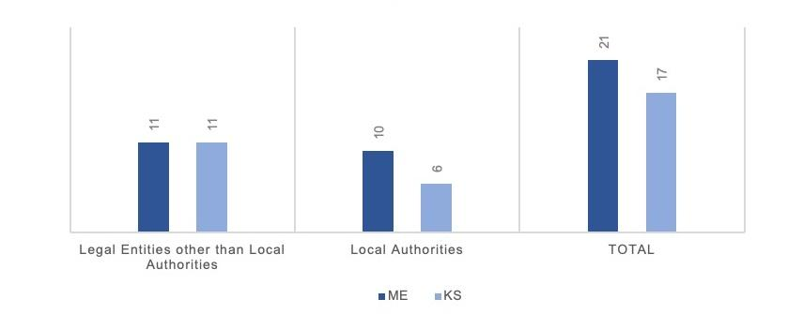

Figure 11: Multi-country networking

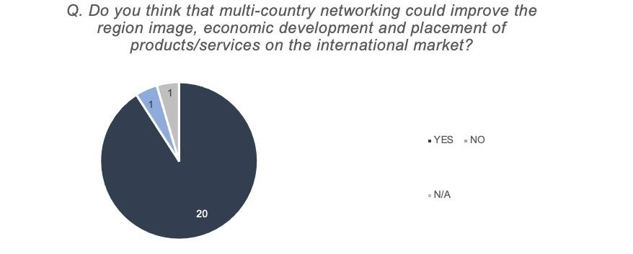
No. of responses: 22 legal entities other than local authorities

Figure 12: Existing cross-border cooperation

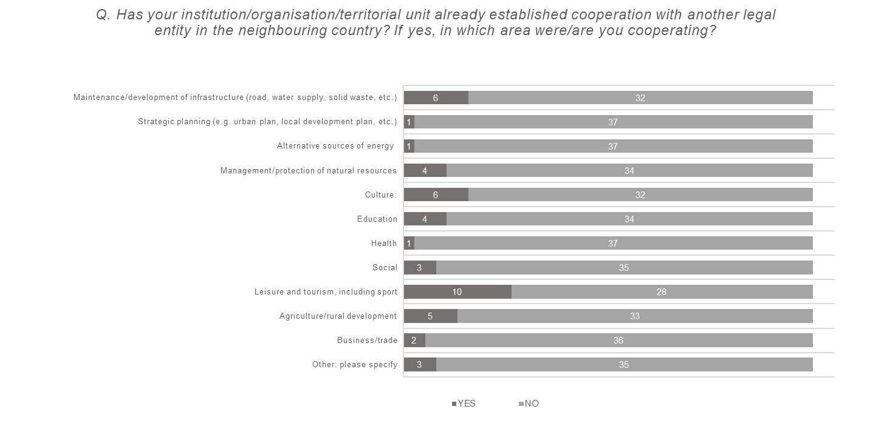

No. of responses: 16 local authorities and 22 legal entities other than local authorities
Figure 13: SWOT - Strengths and Weaknesses
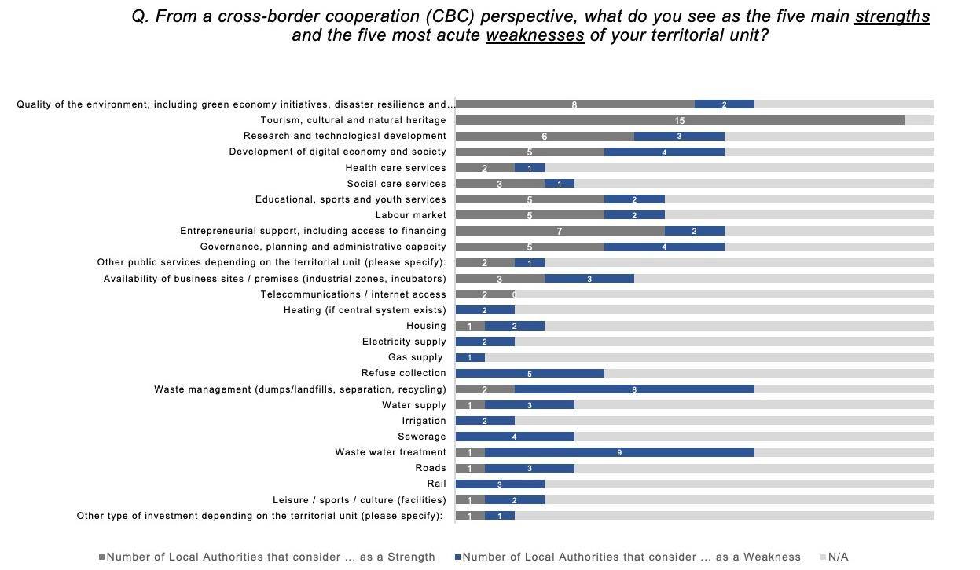
No. of responses: 16 local authorities
Figure 14: SWOT – Opportunities
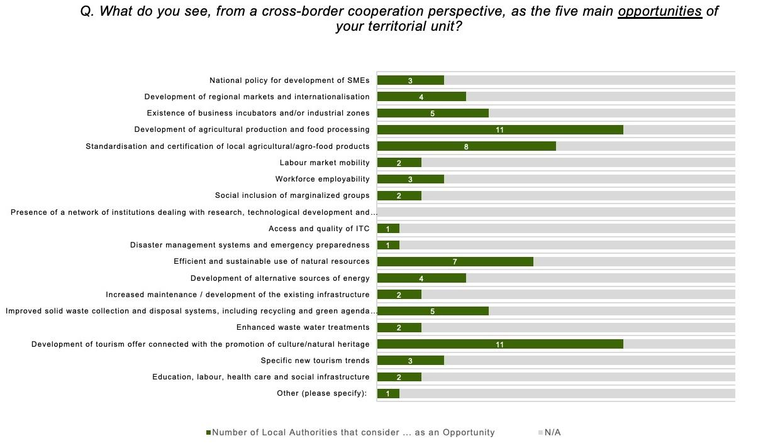
No. of responses: 16 local authorities

Figure 15: SWOT – Threats

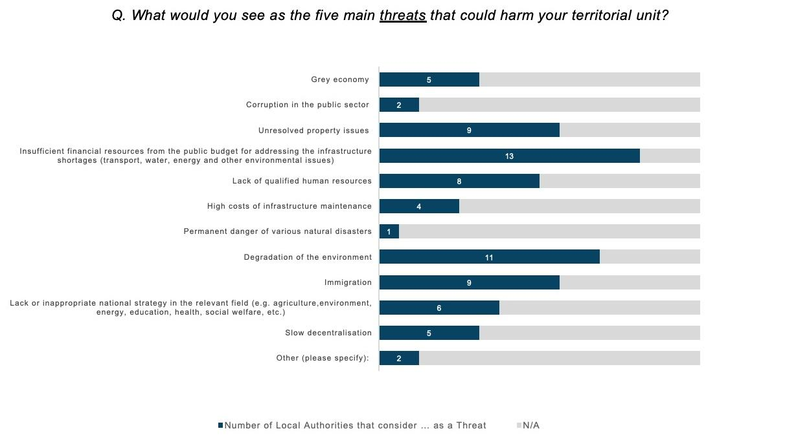
No. of responses: 16 local authorities
Figure 16: Main difficulties for cross-border cooperation
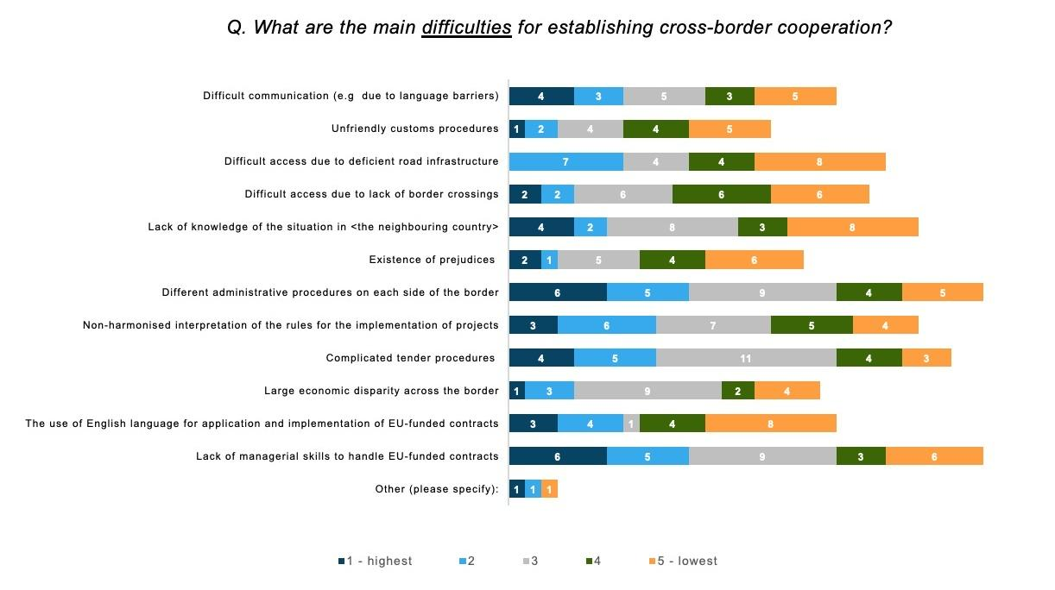
No. of responses: 16 local authorities and 22 legal entities other than local authorities

Figure 17: Thematic Clusters/Priority areas
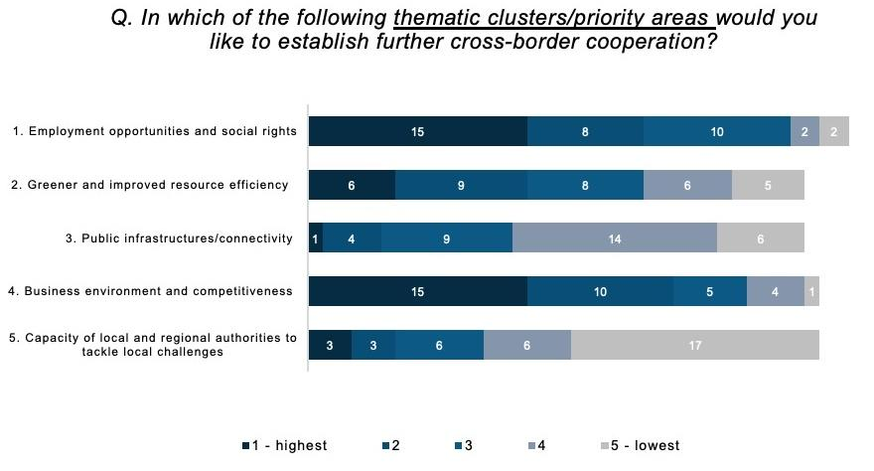
No. of responses: 16 local authorities and 22 legal entities other than local authorities
Figure 18: Existing local documents, strategies, plans or studies
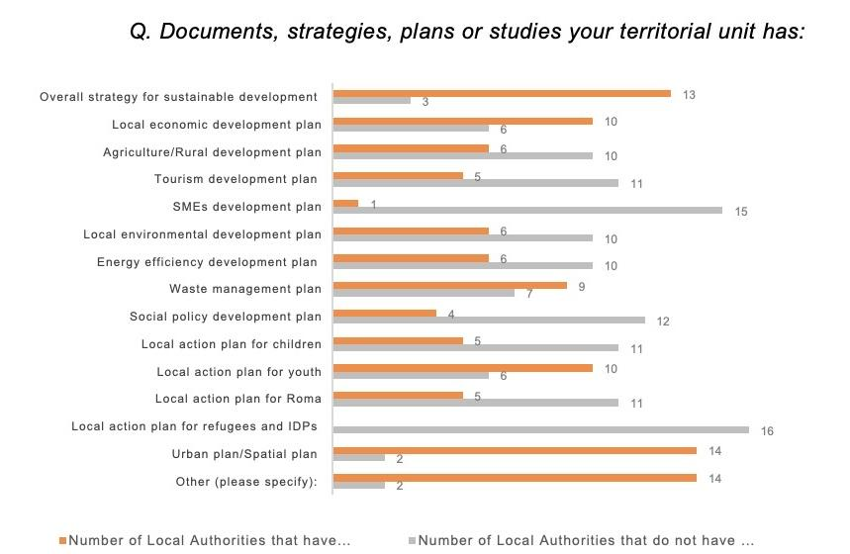
No. of responses: 16 local authorities

ANNEX 5: Political maps
Figure 19: Political map of Montenegro
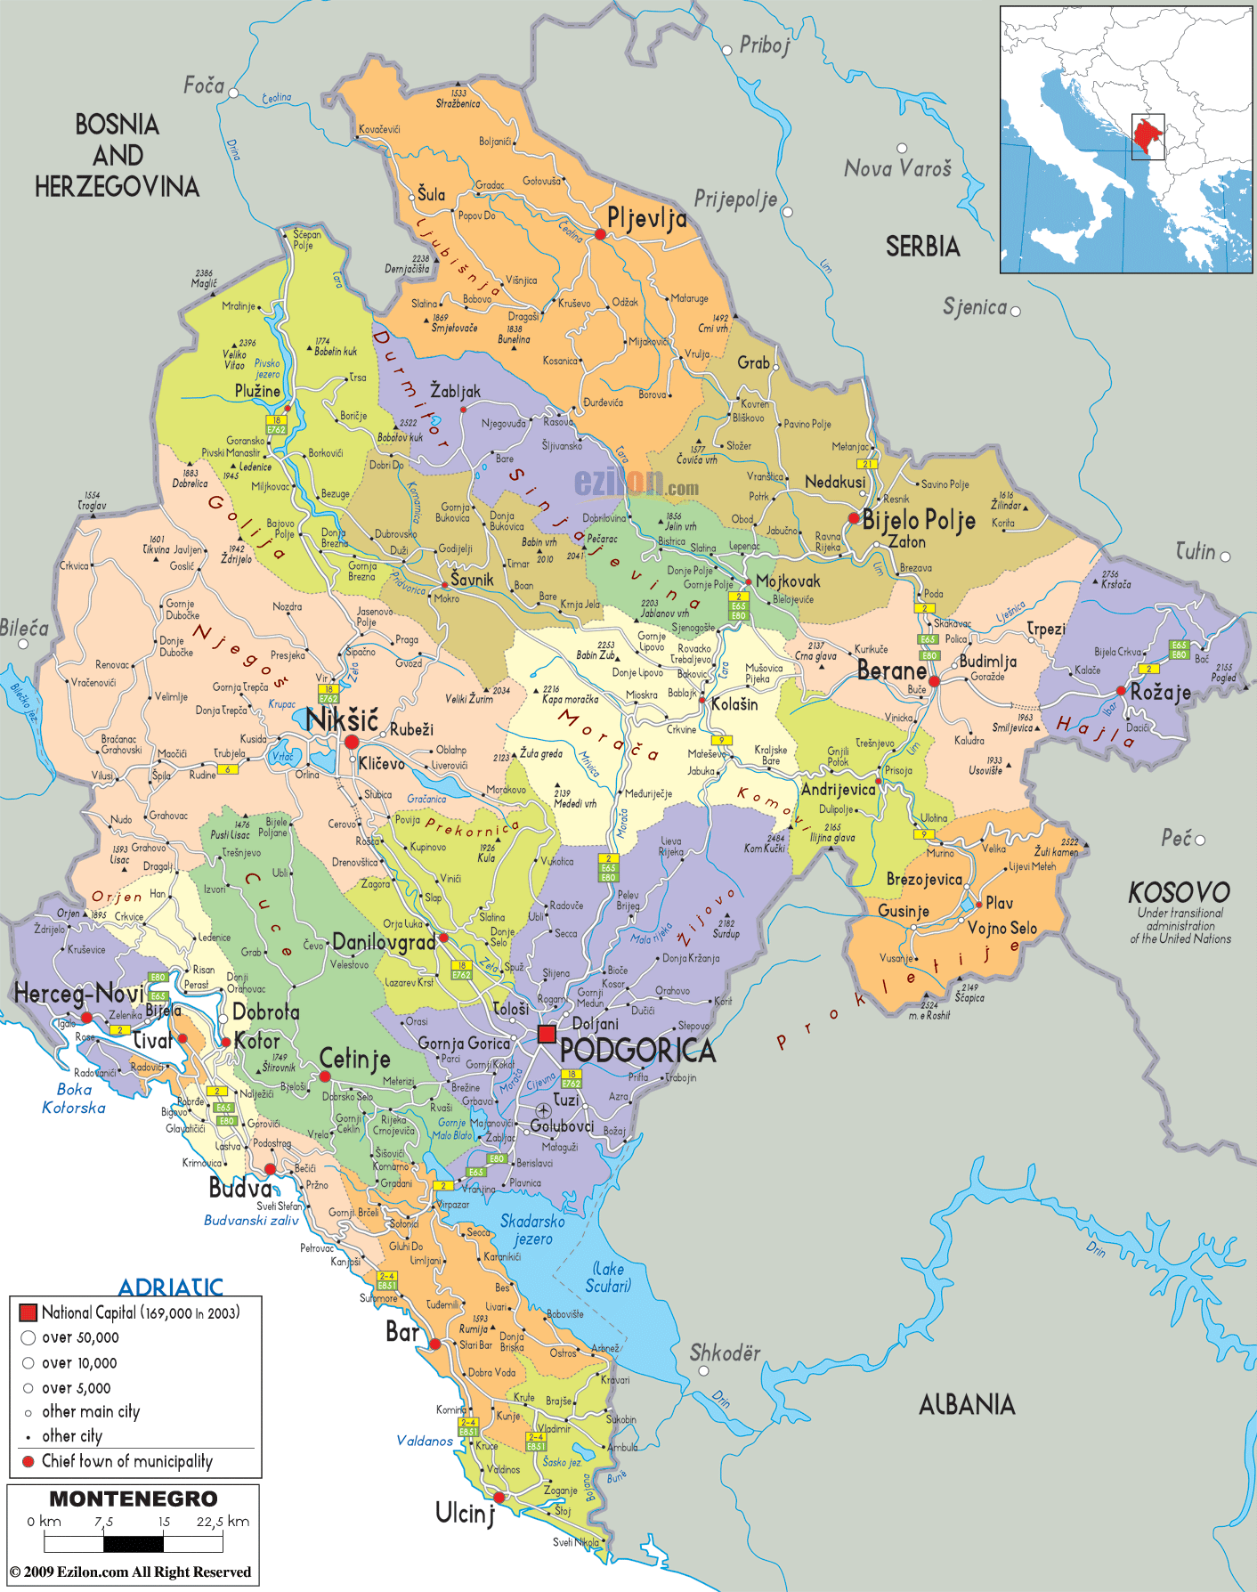
Source: ezilon.com

Figure 20: Political map of Kosovo
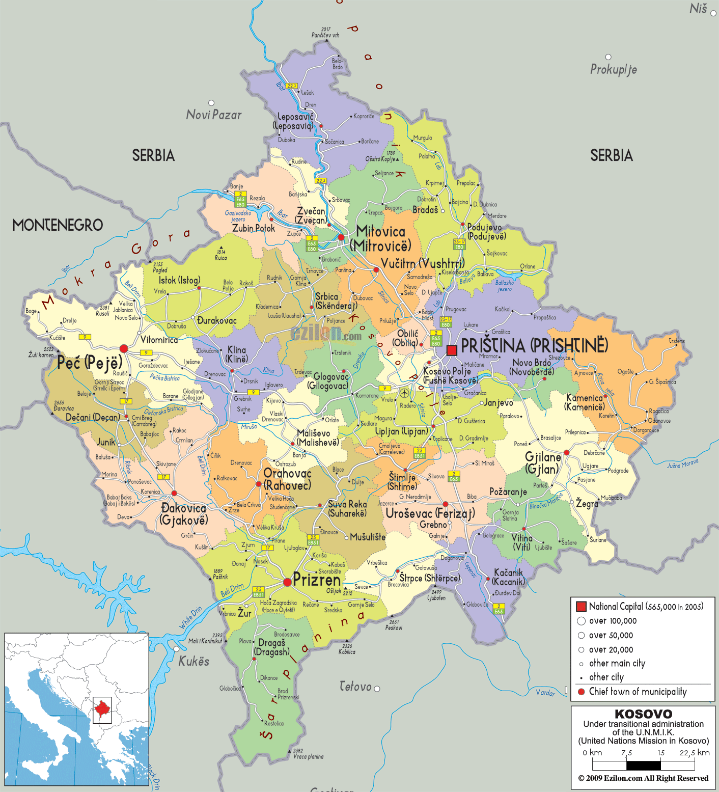
Source: ezilon.com

ANNEX 6: Bilateral agreements between Montenegro – Kosovo
No | Date of signing | Agreements
1 | 21-Mar-19 | Agreement on Cooperation between the Government of Montenegro and the Government of the Republic of Kosovo in the Context of the Accession to the European Union
2 | 21-Mar-19 | Memorandum of Cooperation between the Ministry of Economy of Montenegro and the Ministry of Trade and Industry of the Republic of Kosovo relating to the control of Strategic Goods
3 | 1-Aug-18 | Agreement between the Government of Montenegro and the Government of the Republic of Kosovo on International Road Transport of Passengers and Goods
4 | 30-May-17 | Protocol on the Establishment and Functioning of the Joint Center for Police Cooperation between the Ministry of Interior of Montenegro, the Ministry of Interior of the Republic of Albania and the Ministry of Interior of the Republic of Kosovo (Multilateral agreement)
5 | 28-Apr-17 | Agreement between the Government of Montenegro and the Government of the Republic of Kosovo on Cooperation in the Field of Culture
6 | 10-Feb-17 | Bilateral agreement between Montenegro and the Republic of Kosovo relating to the cross-border cooperation program between Montenegro and the Republic of Kosovo under IPE II 2014-2020 Montenegro-Kosovo cross-border cooperation program
7 | 10-Feb-17 | Partnership Agreement between the Ministry of European Affairs of Montenegro, Lead Partner and the Ministry of Local Self-Government Administration of the Republic of Kosovo, a partner on the management of technical support under the IPA cross-border cooperation program within the Western Balkans
8 | 4-Mar-16 | Memorandum on Cooperation between the Ministry of Foreign Affairs and European Integration of Montenegro and the Ministry of Foreign Affairs of the Republic of Kosovo
9 | 26-Aug-15 | Agreement on the state border between Montenegro and the Republic of Kosovo
10 | 13-Jun-14 | Memorandum of Understanding between the Central Bank of Montenegro and the Central Bank of Kosovo
11 | 25-Apr-14 | Protocol between the Secretariat General of the Government of Montenegro-Office for Fight Against Trafficking in Human Beings and the Ministry of Interior of the Republic of Kosovo-National Coordinator's Office for Fight Against Trafficking in Human Beings on Cooperation in Combating Trafficking in Human Beings
12 | 15-Apr-14 | Program of Cooperation between the Diplomatic Academy of Montenegro and the Diplomatic Academy of the Republic of Kosovo
13 | 26-Mar-14 | Agreement between the Government of Montenegro and the Government of the Republic of Kosovo on Regulating Border Traffic Regime
14 | 26-Mar-14 | Agreement between the Government of Montenegro and the Government of the Republic of Kosovo on Police Cooperation
15 | 26-Mar-14 | Agreement between the Government of Montenegro and the Government of the Republic of Kosovo on Opening of Common Border Crossing Kotlovi-Kućište for International Passenger Road Traffic
16 | 26-Mar-14 | Agreement between the Government of Montenegro and the Government of the Republic of Kosovo on International Road Border Crossing Point Kula-Savine Vode
17 | 26-Mar-14 | Protocol between the Ministry of Interior of Montenegro and the Ministry of the Republic of Kosovo on the Forming of Joint Patrols along the Common State Border
18 | 26-Mar-14 | Protocol between the Ministry of the Interior of Montenegro and the Ministry of the Interior of the Republic of Kosovo on performing joint activities of the border control and the payment of costs arising from the activities at the common border crossing point Kotlovi-Kućište
19 | 26-Mar-14 | Protocol between the Ministry of Interior of Montenegro-Police Directorate and the Ministry of Interior of Republic of Kosovo-Police on holding regular border police meetings at all managerial levels
20 | 27-Feb-14 | Agreement on Cooperation between the Government of Montenegro and the Government of the Republic of Kosovo in the Process of the European Integration

ANNEX 7: Local and national strategies
Thematic Cluster  (TC) | Topics | Country | Regions covering the topic in their local strategies (name the actions described in the regional strategies) | Example of actions (taken from current projects and examples from the regional strategies) | Main responsibility (local, national authorities) Difference between ME and KS
TC I | Employment | KS | - KS Strategy for Local Economic Development 2019-2023  - Commission Country report (Kosovo)  - Kosovo has adopted a sector strategy 2018 - 2022 and youth employment plan 2018 – 2020. | - promoting the creation of new jobs through national and foreign investments  - develop active measures for increasing employment and female labour market participation and employment  - increase employment, develop market relevant skills and improve labour market administration | Local supported by national authorities
 |  | ME | - Local Strategies in ME (aiming at increasing the employment rate of the population) | - Improving information on self-employment opportunities (e.g in  - Kolašin)  - Support for retraining and training programs for the unemployed  - Promotion of women's entrepreneurship (e.g. in Kolašin)  - Implement educational programs for the unemployed  - Increase awareness of employment opportunities for persons who are not registered with the Labor Office  - Entrepreneurship support through business ideas in Bar (increasing business cooperation/female entrepreneurship) | Local supported by national authorities
TC I | Labour mobility | KS | - KS Strategy for Local Economic Development 2019-2023/Investing in Human Capital  - Employment Action Plan in Peja/Pec, KS | - Development of vocational training through the advancement of vocational school;  - Increasing the knowledge and skills of vocational school teachers and providing support materials to create successful partnerships with enterprises.  - Professional capacity building of teachers;  - Expanding new profiles within vocational schools;  - Analysis regarding the review of opportunities for creating new spaces for vocational training;  - Promotion of vocational schools;  - Opening/improvement of education and vocational schools that meet labour market needs  - Identification of the skills that are used by modern businesses;  - Organization of training for the development of personal skills for career management  - Cooperation between municipalities in KS and between other countries | National, supported by local and donors
 |  | ME | Local strategies  Rožaje and Ulcinj | - Improving the education system according to the needs of the labor market (Rožaje)  - Development of employment programs for certain categories of unemployed in the field of agriculture (in Ulcinj the strategy is relatively old 2016 – 2020) | National, local, supported by business community
TC I | Social inclusion of vulnerable groups | ME | - A strategy for social inclusion of Roma and Egyptians in ME 2016 – 2020 and employment is one of main areas. Lack of education and educational opportunities as well as discrimination and lack of acceptance by non-Roma and employers is one of the biggest obstacles to employment of Roma and Egyptian population.  - A large number of unemployed who are considered more difficult to employ (such as older unemployed people, people with different forms and levels of disability, ie, health risks, etc.)  - Local Action Plan on Roma in Podgorica and few other municipalities  - Social policy development plan 2020-2023 in Podgorica  - Other local strategies in ME | - Programs to include children of Roma and Egyptian population are being implemented at all levels of education in ME;  - In Podgorica, special schools have been transformed into resource centres focused on supporting inclusive education (early intervention, mobile activities, education, specialized didactic and teaching aids, assistive cabinets, etc.). There are 2 resource centres: one for intellectual and autism spectrum disorders and one for physical and visual impairments;  - Construction of a facility for children with developmental disabilities (in Bar);  - Regional housing program in Berane (in the final phase);  - Building a home for the elderly and vulnerable groups in Berane, Podgorica;  - Organizing a day care centre for the elderly in Podgorica (2020- 2023)  - Providing continuous work and increased coverage of home help and care services for the elderly and infirm (geronto housewives).  - Establishment and operation of services for the protection of the elderly from violence and psycho-social support (SOS telephone services for the elderly)  - Construction of a building for persons with disabilities in Berane;  - Establishment of a database of citizens in need of social assistance in Podgorica (not implemented until 2019)  - Introduce new customized educational programs to increase qualification and skills levels;  - Opening of youth club or centre: accessible to young people from the Roma and Egyptian community;  - Organizing a campaign to inform the public about the Roma identity in Podgorica (2020)  - Launching initiatives for making documentaries and propaganda films on Roma and Egyptians (2020 – 2023);  - Ensure the development of innovative community life support services, at the local level in Podgorica (2020 – 2023)  - Work to eliminate discrimination against people with mental disorders, through education and sensitization of the general public, with the strong support and participation of local and national media (2020- 2023);  - Support programs for people with mental disabilities and their families, with an emphasis on particularly vulnerable categories (2020 – 2023);  - Trainings on starting small businesses and social entrepreneurship;  - Making tactile paths for blind people in public areas in Podgorica (2020 – 2023);  - Temporary accommodation service for street children  - Development of Action Plan for social inclusion of persons with disabilities | National and local
 |  | KS | - In KS, there is a national level that focused on Roma and Ashkali 2017 – 2021 |  | National level
TC I | Culture and sports | ME | - Local strategies in ME  - Improving conditions for the development of cultural and sports activities | - Art studios in the old part of Bar– creative hub  - Reconstruction of the archaeological museum Bar– Archbishopric palace  - Restoration and conservation of the Ottoman cemetery in Bar  - Construction of a new building centre for culture and reconstruction of the existing one in Berane  - Construction of cites centres with zoo in Berane  - City Theater in Podgorica (2019)  - Development of projects for the needs of sports facilities in Podgorica, Berane  - Reconstruction of the House of Culture in Podgorica (not implemented until 2019)  - Revitalization of cultural, religious and other buildings in the old town partially realized in Podgorica  - Establishment of the Office for Cooperation with the Civil Sector in the Municipality of Ulcinj  - Support for the Development of Cultural Events  - Education of young people with local elements of culture and production of audio-visual material "Record of cultural heritage" in Gusinje (2020 – 2021)  - Development of the Sports Development Program in Kolašin  - Formation of a database of all entities in local self-government in charge of sports as well as sports facilities in the territories of local self-government with defining the needs of citizens related to sports and sports infrastructure at local level | Local (in some cases supported by national authorities)
 | Health services | ME | - Local strategies improving education, social and health care | - Support for people with disabilities in employment (2017 – 2019)  - Construction of a children's playground near the building of the Cultural Center (Andrijevica 2017 – 2018)  - Construction of stands at the city stadium (Andrijevica)  - Improving healthcare services through investment in health infrastructure (laboratories etc) in Bar  - Daily centre for the elderly in Bar  - Construction and upgrade of health centres in Podrogica (partly implemented)  - Providing counselling, psychological and social educational support to all children with experience of domestic violence (2020 – 2023)  - Developing the professional capacities of professionals working with child victims of domestic violence from all sectors (2020 – 2023)  - Increase awareness of HIV and sexually transmitted infections (STIs) awareness among young people in educational institutions and the general population (Podrogica 2020 – 2023)  - Establish institutional mechanisms to combat HIV / AIDS at the local level (2020 – 2021)  - Promote and support local, national and regional activities to prevent and reduce the harmful effects of alcohol and drugs (in Kolašin)  - Establishment of the Festival on Healthy Lifestyles (Kolašin) | Local
TC I | Youth education and Lifelong learning | ME | - Improving education in the local community  - ME is implementing the dual education system, for more labour-market driven provision of skills training | - Investment in kindergarten and schools’ facilities in Berane;  - Construction and modernization of city schools due to the growing number of students in the city:  - Promoting career orientation in schools, awakening the entrepreneurial spirit, training for acquiring key skills as well as promoting lifelong learning;  - Promote involvement of youth in agriculture (2018 – 2019), Petnjica  - Reconstruction of the Student Dormitory in Kolašin;  - Development of the Local Youth Action Plan (LPAM)  - Establishment and operation of entrepreneurial clubs in secondary vocational schools;  - Promoting learning in a real work environment;  - Establishment and operation of entrepreneurial clubs in secondary vocational schools | National and local
TC II | Environmental protection | ME | - Preserve the environment;  - Development of local planning documents in the field of environmental protection (in some strategies) | - Raising the ecological awareness of citizens;  - Development of programs of protected areas with unique natural characteristics in Berane;  - Development and implementation of educational programs in environmental protection (done in Podgorica);  - Preparation of a Feasibility Study for construction and equipping of a plant for briquetting, ie composting of plant waste in Podgorica (not done until 2018)  - Establishment of a local monitoring network - monitoring of individual segments of the environment (air, water, land, biodiversity (done in Podgorica)  - Establishment of protected natural assets on sites with unique natural features and protection of natural values in Podgorica (2020 – 2023)  - Development of the Cadastre of Green Areas in Podgorica (2020 - 2023)  - Biodiversity protection in recognized localities in Podgorica (until 2024)  - Improve the quality of forests, increasing the area under high forests, maintaining and strengthening the generally useful functions or functions of forest welfare  - Raise the level of physical protection of forests  - Improving the technique for the exploitation of commercial forests  - Organization of cleaning of riverbeds and wild dumps through the organization "Day of pure nature"  - Analysis of potential areas for protection  - Development of the Local Aquatic Biodiversity Protection Plan (LAB) in Kolašin | Local, supported by national
 |  | KS | Environment Protection Strategy 2013-2022 | - Development of projects in protected areas with unique natural characteristics Deçan and Istog;  - Raising the ecological awareness of citizens | National/Local
TC II | Climate change adaptation and mitigation | ME | Local strategies in ME | - Encouraging forestation;  - Improving bicycle transport;  - Construction of several roundabouts;  - Educational and information campaigns on climate change;  - Early Warning System for Forest Fires;  - Increasing green areas in the urban area | Local, supported by national
 |  | KS | Air Quality Strategy 2013-2022 | - Educational and information campaigns on climate change;  - Increasing green areas in the urban area | National
 | Waste management  Water supply and treatment | ME | Local Strategies in ME  - Establishment of a sustainable waste management system  - Improved wastewater management  - Improvement of water supply on the territory of the municipalities | - Construction of a transfer station (Andrijevica 2017 - 2018)  - Reconstruction of existing and construction of a new sewerage network; construction of a wastewater treatment plant (e.g Andrijevica 2018 – 2021; in Berane in progress in 2018)  - Reconstruction of the city water supply (And. 2017 – 2018);  - Construction and maintenance of rural water supply systems (Andrijevica 2017 – 2020);  - Water supply study of Bar;  - Expansion and reconstruction of the existing water supply network in Berane  - Sanitation of waste landfill in BAR;  - Construction of a recycling yard in Bar (implemented in Podgorica)  - Installation of semi-underground containers in the centre of Bar  - Arrangement of one-like container places for disposal in Bar;  - Construction of landfills and rehabilitation of uncontrolled landfills in the area (e.g. in Berane in progress in 2018)  - Green Islands Project in Berane (ongoing in 2018, IPA CBC 2 with Albania)  - Construction of water supply in rural areas  - Wastewater collection and treatment in Podgorica (2019)  - Construction of a plant for processing municipal waste in order to obtain biodiesel, biogas and hot water (not implemented until 2019)  - Preparation of the Report on the state of the environment for the territory of Podgorica (until 2023)  - Construction of a new wastewater treatment system for Podgorica and treatment of sewage sludge (2022)  - Improving the maintenance of the existing and construction of new sewerage infrastructure  - Educating citizens on the importance of sustainable resource management with an emphasis on primary selection according to the concept of "dry" and "wet" fractions in order to ensure sustainable waste management in Podgorica (until 2022)  - Establishment of a plant waste management system in Podgorica (until 2022)  - Establishment of a waste disposal system for recycling in public institutions in Podgorica (continuously)  - Monitoring of waste collection activities from the use of plant protection products in Podgorica (continuously) | Local supported by national
 |  | KS | - Waste Management Strategy 2013-2022 (The final draft of new draft strategy is prepared and is in the process of approval);  - Kosovo National Water Strategy 2017-2036 | - Closure of illegal landfield in Istog | National
TC II | Risk prevention and risk management | ME | Local strategies in ME | - Construction of fortress coasts on the river to protect from flood;  - Construction of new and upgrading and regular maintenance of existing coastal fortifications (not done until 2019 in Podgorica );  - Implementation of preventive measures in order to protect against the harmful effects of water in the Skadar Lake basin in Podgorica (continuously);  - Construction of a bank fortification on the river in Gusnje (2019 – 2020)  - Regulation of river and pond watercourses in Gusinje (2020 – 2024) | Local
TC II | Energy efficiency | ME | Local strategies ME aiming at improving energy efficiency in the local community | - Green island "- construction of energy efficient system for supply of sports hall" with electricity in BAR  - Construction of small hydropower plants on the city water supply in Berane  - Increasing energy efficiency and use of renewable energy sources by establishing a city heating system in Berane  - Production of electricity and hot water from biogas in Podgorica (not done until 2019)  - Raising awareness and educating citizens on energy efficiency (implemented in Podgorica)  - Construction of a plant for the production of electricity from landfill gas in Podgorica (2022)  - Development of the Energy Efficiency Improvement Program with the Energy Efficiency Improvement Plan in Podgorica (until 2023)  - Implementation of the Media Campaign for Rational and Efficient Use of Resources and Energy in Podgorica (continuously)  - Construction and reconstruction of electrical network and lighting | Local
 |  | KS | Commission Country report (Kosovo): | - improve energy efficiency incentives for firms and households  - make the support schemes for renewable energy projects more cost efficient, by introducing competitive bidding for renewable support | Local
TC II | Circular economy
TC III | Local public mobility | ME | Local strategies in ME | - Increasing telephone and internet coverage of the municipality of Gusinje (2020 – 2021) | Local supported from national authorities
TC III | Regional connectivity | KS | KS | - Opening of the border crossing on the road Murino-Čakor-Peć with Kosovo  - Construction of the main road Plav-Decani | National authorities
TC III | Road transport | KS | Strategy for Local Economic Development 2019-2023 | - Infrastructure improvement in function of businesses | Local supported by national
 |  | ME | Local Strategies in ME | - Expanding of local infrastructure  - Investment maintenance of local roads in urban and rural areas  - Introduction of modern technologies in public lighting  - Construction and reconstruction of the road network  - Continuation of the reconstruction of the town square (Andrijevica 2017 - 2018) | Local supported by national
TC III | Rail transport |  |  |  | National authorities
TC III | Air and water transport | ME | Local Strategies in ME (Berane municipality) | - Airport reactivation in Berane | National
TC IV | Tourism and cultural heritage | KS | Local strategies in ME,  Strategy for Local Economic Development 2019-2023  Municipal profiles of the Republic of Kosovo | - Special emphasis placed on connecting tourism, agriculture, and the development of agro tourism, where potentials are identified in Northern region in ME and in KS.  - Some municipalities have potential for dealing with outdoor sports (mountain biking, hiking and mountaineering, paragliding, kayaking, etc.)  - Stronger connection between local and state authorities, Tourist Organizations, cross-border cooperation and greater funds to promote the capital | Local, supported by national and tourist organisations
 |  | KS | KS Strategy for Local Economic Development 2019-2023  Improving the conditions of Local Tourism development through investments and capacity building. | - Identification of new areas for development of tourism;  - Improvement of local infrastructure in tourist areas;  - Identification of important cultural heritage sites and their functionalization for tourist visits;  - Creating information points for the promotion of local tourism;  - Promotion of cultural and natural heritage in municipalities;  - Organization of trainings and other activities for capacity building and quality increase in services;  - Development and promotion of tourism through creating of tourist packages developed in cooperation with tour operators, and the creation of conditions for promotion of local tourism through fairs;  - Organization of fairs for the promotion of tourism;  - Preparation of a study for the construction of winter centres and the necessary tourist infrastructure | Local
 |  | ME | All local strategies in ME  - Improve the tourist offer of the municipalities  - Strengthening the capacity of employees in the tourism sector  - Promotion of tourist potentials and possibilities of municipalities  - Protection and promotion of cultural heritage | - In 2016, Andrijevica in ME through a CBC project with KS, began the reconstruction of the old military barracks in the village of Josanica to put this facility in the function of developing this rural area. The facility, which was reconstructed and equipped in 2017.  - Some infrastructure has been built: a network of local bicycle and hiking trails, the national bike trail, the national hiking trail, the fishing lodge etc.  - Valorization of archaeological sites (e.g. Old Town in Bar)  - Protection, revitalization and valorization of natural resources (e.g. Lake Plav)  - Putting into operation the Mojan Adventure Center (Andrijevica 2017- 2018)  - Development of the offer in rural tourism and inclusion of new households in the network (Andrijevica 2017 – 2020)  - Strengthening the capacity of the Andrijevica tourist cluster for project preparation and implementation (2017- 2020)  - Organization of annual promotional events (Andr. 2017 – 2020)  - Reconstruction of the coastal zone in the vehicle- arrangement of a functional beach beach (Bar)  - Digitalization of the old Bar  - Development of program (strategy) of tourism development of BAR until 2026  - Completion of construction and exhibition of functions of olive houses in old Bar  - Improvement of traffic and tourist signaling in Bar  - Revitalization of rural areas, development of tourist eco-ethno villages in Berane  - Inclusion of domestic agricultural products in the tourist offer  - Connecting cultural and tourist offer  - Preparation of a study of protection of cultural goods in Berane  - Investment in museums  - Introduction of game into hunting grounds for the needs of hunting tourism in Podgorica (done)  - Encouragement of construction and promotion of capacity and quality of private accommodation in Podgorica (done)  - Activation of certain insufficiently affirmed areas of Podgorica for the development of sustainable tourism (2020 – 2023)  - Creating conditions for the development and promotion of sports tourism in Ulcinj - a bit old the strategy  - Creating conditions for development and promotion of rural tourism - model of diffuse hotels in Ulcinj  - Revitalization of olive groves in Ulcinj (a bit old the strategy)  - Valorization and development cultural-historical and religious tourism/Promotion and protection of underwater archaeological and cultural heritage  - Development of new types of tourism through the exploitation of tourist potentials in Ulcinj  - Improvement of virtual marketing in Ulcinj  - Investment in Alipaša's springs in Gusnje (2020, 2021)  - Construction of the Tourist Organization facility, trail mapping and installation of info tourist counters in Gusinje (2021)  - Development of paragliding in Gusinje, Trim track "Rahine Forests" (2020 – 2022)  - Preparation of the Study of diversification of the tourist offer in Kolašin  - Support for existing and introduction of new tourist events (e.g. Work with local tourism professionals to organize new events, esp.in winter,  - Identification of needs of existing tourist events (camps etc.)  - Protection and promotion of cultural and architectural identity of Kolašin  - Mapping of cultural, historical, religious buildings and sites in the function of tourism development and tourist visits; Improving the condition of religious buildings on the tourist route in Kolašin  - Quality tourist product requires additional facilities to enrich the offer along the marked trails (accommodation, food, lookouts, horseback riding, arranged facilities for food tasting, etc.). It is also necessary to expand the network of trails to parts that are not sufficiently represented in the tourist offer. | Mostly Local
TC IV | Competitiveness, business environment and SME development | ME | Local Strategies in ME  Support agriculture, rural development:  - Organic production is gaining importance.  - Untapped potentials of rural areas for agriculture and organic production  - Improve agricultural production  Commission Document on Economic Reform Programme of ME (2020-2022)  - implement the measures entrusted to it under the IPARD II programme and seek to be entrusted with budget implementation tasks for other measures of the programme  - implement the action plan for EU acquis alignment on agriculture and rural development, in particular by further developing the Integrated Administration and Control System | - 2 clusters in agriculture and the food industry established in Podgorica;  - Since 2007, a company for control and certification in organic production, has been conducting certification of organic production.  - Over 13 producers are registered as Organic Farmers in Podgorica  - Initiation of capacities for processing of agricultural products (And. 2018 – 2019)  - Incentive measures to agricultural producers  - Support for the establishment and functioning of clusters  - Support for the development of viticulture and wine-making in Bar and agriculture production  - Construct Regional Livestock Market in Berane (in progress in 2018)  - Analysis of needs and possibilities for building irrigation systems in agriculture in Berane  - Support the production of organic products and food products in Berane, Podgorica  - Promotion of "Wine Roads" (implemented in Podgorica)  - Organizing a wine salon (implemented in Podgorica)  - Organization of agricultural fairs  - Expansion of assortment and placement of agricultural products (done in Podgorica)  - Formation of clusters of agricultural producers in order to jointly appear on the market  - Preparation of a study for standardization of ecological agricultural products according to international standards (ISO…)  - Development of a study to support organic agriculture  - Development of a project for organized harvesting of forest fruits  - Preparation of a study for plantations of forest fruits, etc  - Branding of agricultural and food products | Local
 |  | ME | - Local strategies in ME  (Support to the forestry and wood processing industry) | - Support in the procurement of a dryer for the wood processing sector (Andrijevica 2017 – 2020)  - Support in the preparation of project applications for the wood processing (Andrijevica 2017)  - Development of wood processing industry and creation of products with higher processing in Berane  - Preparation of planning documentation for forests and forest land in Podgorica (not until 2019)  - Stimulation of agroforestry  - Preparation of a study for joint performance of producers of wood products;  - Preparation of a study for the analysis of the potential for the production of finished wood products  - Preparation of a study for the production of pellets in order to reduce sawdust waste;  - Preparation of a study for the production of official tourist souvenirs from wood
 |  | KS | - Commission Document on Economic Reform Programme of Kosovo (2020-2022) | - More holistic approach to developing value chains and integrating agricultural products in export markets  - The protection of the agricultural land, environment and less favoured areas with reduced productivity should also be supported | Local, supported by national
 | Infrastructure improvement in function of businesses | KS | - KS Strategy for Local Economic Development 2019-2023  - Commission Country report (Kosovo) | - Promoting Local Businesses  - Construction and establishment of a business incubator  - Construction and establishment of a business zones  - improve further the access to finance for SMEs by addressing the underlying legal and institutional factors | Local and national
 |  | ME | - Local Strategies in ME | - Determining business zones in Gusinje  - Construction of infrastructure in the business zone in Kolašin  - Reconstruction of the administrative and business centre building (Andrijevica)  - Works on arrangement of the business zone in Berane (2019)  - Cluster support and development and promotion of business zones in Berane  - Definition of institutional measures for investors in development activities in free zones in Bar  - Cluster development in Gusinje | Local, supported by national
TC IV | Trade and investment | KS | - KS Strategy for Local Development 2019 – 2023 | - Planned activities Inventory of municipal immovable property;  - Promotion of policies on properties granted for use for local economic development;  - Identification of potential economic areas;  - Developing economic areas by supporting the development of the private sector  - Creating more favorable conditions for foreign investors, private sector  - Full functionalization of balanced economic zones | Local and national
TC IV | Research and Innovation | ME | It was not specifically and largely addressed in the local strategies | Promotion and introduction to new technologies;  Promotion of research and development;  Identification of new business ideas
TC V | Cooperation of local and regional public authorities | KS | - KS Strategy for Local Development 2019 - 2023  - Kosovo National Program for the Implementation of the Stabilization and Association Agreement (SAA), | - Updating of municipal websites;  - Publication of information about the granting of property in use;  - The analysis regarding the review of possibilities for collecting revenues from the use of natural resources within the territory of the municipality  - Analysis regarding the review of the possibilities of dividing a percentage of VAT for municipalities.  - Increase of municipal transparency to create conditions for foreign investments.  - Reduction of municipal budget dependency from the central level through review of the financing formula  - Establish a special mechanism for coordinating the investment financing process from the central level to the local level.  - Promotion of development through inter-municipal, cross-border and transnational cooperation programs,  - strengthening of local administration capacities  - Strengthening the capacity for absorption of IPA funds  - Encouraging the involvement of citizens in the decision-making process | National supported by local and Civil society
 |  | ME | Local strategies in ME | - Education of local self-government employees in Berane  - Adoption of local action plans (lap for culture, lap for youth,etc) –  - Forming commissions for drafting action plans; development of action plans; adoption of action plans in Berane  - Strengthening the administrative capacity of Kolašin to support investors  - Establishment of a system of sustainable management of municipal property in Kolašin | Local

ANNEX 8: References

Documents
- EC (2020). Commission Staff Working Document Kosovo Report 2020
- EC (2020). Commission Staff Working Document Montenegro Report 2020
- EC (2020). Commission Staff Working Document: Economic Reform Programme of Kosovo (2020-2022)
- EC (2020). Commission Staff Working Document: Economic Reform Programme of Montenegro (2020-2022)
- EC (2020). European Neighbourhood Policy and Enlargement Negotiations Montenegro: Overview of chapters opened/closed
- United Nations Kosovo (2020). Socio-Economic Response Plan to COVID-19
- United Nations Montenegro (2020). The UN Socio-economic response plan to COVID-19 in Montenegro
- Municipality of Gjakova/Đakovica (2020). Environmental Situation Analysis in Gjakova/Đakovica (produced under the IPA II CBC 2014 – 2020 ME – KS programme)
- Administration (2020). Report on Fulfilment of Municipal Obligations deriving from European Agenda for the period January – December 2019
- Ministry of Regional Development (2020). Analysis of capital investments made by development regions in Kosovo in 2019
- Jashari Sekiraqa Sh. et al. (2020). Further support to the development of trade in Kosovo
- EC (2019). Commission Staff Working Document Kosovo Report 2019
- EC (2019). Commission Staff Working Document Montenegro Report 2019
- Kosovo Office of the Prime Minister (2019). Government strategy for cooperation with civil society
- Kosovo Government (2019). Economic Reform Programme (ERP) 2019-2021
- Montenegro Ministry of Science (2019). Smart Specialisation Strategy of Montenegro 2019 – 2024
- CIHEAM Bari (2019). Mediterranean Organic Agriculture Network report 2019 (incl. Kosovo Ministry of Agriculture, Forestry and Rural Development; Montenegro Ministry of Agriculture and Rural Development
- IFC (2019). Montenegro airports concession: information memorandum
- Kosovo Ministry of Local Government Administration (2018). Strategy for Local Economic Development 2019-2023
- International Labour Organization (2018). Perspectives of Roma, Ashkali and Egyptian youth on decent work opportunities and challenges in Kosovo
- Office of the Prime Minister (2017). Strategy for Inclusion of Roma and Ashkali Communities in the Kosovo Society 2017-2021;
- Kosovo Ministry of Local Governance (2017). Municipal profiles of the Republic of Kosovo
- Ministry of Labour and Social Welfare the Action Plan for increasing Youth Employment 2018 - 2020
- EC (2017). Evaluation of IPA Cross Border Cooperation Programmes 2007-2013
- Montenegro Ministry of Finance (2017). Montenegro development directions 2018-2021
- Montenegro Ministry for Sustainable Development and Tourism (2017). The 2017-2020 Social Housing Programme
- The Montenegrin Investment Promotion Agency (2017). Country report
- Vladan Jovanović for the Ministry of Labour and Social Welfare of Montenegro (2017). The analysis of implementation of the strategy for development of the social protection system for elderly persons 2013‒2017
- Montenegro Ministry of Sustainable Development and Tourism (2016). National Strategy for Sustainable Development of Montenegro by 2030
- Montenegro Ministry of Human and Minority Rights (2016). The strategy for social inclusion of Roma and Egyptians in Montenegro 2016 – 2020
- Montenegro Ministry of Health (2015). Master plan of the development of health system in Montenegro 2015-2020
- Montenegro Ministry of Agriculture and Rural Development (2015). Strategy for the development of agriculture and rural areas 2015-2020
- Montenegro Ministry of Agriculture and Rural Development (2015). Programme for the development of agriculture and rural areas in Montenegro under IPARD II 2014-2020
- Montenegro Ministry of Economy (2014). Regional Development Strategy 2014-2020
- EC (2014). IPA II CBC PROGRAMME 2014 – 2020 Montenegro – Kosovo
- Kosovo Ministry of Agriculture, Forestry and Rural Development (2013). National Forest Inventory 2012
- Montenegro Ministry of Economic Development (2008). Spatial plan of Montenegro until 2020
- Other strategic documents and action plans of municipalities (i.e. Andrijevica, Bar, Berane, Bijelo Polje, Gusinje, Kolašin, Mojkovac, Petnjica, Plav, Podgorica, Rozaje, Ulcinj, Gjakova, Peja/Pec, among others)

Sources of Statistics
- KAS (2020). Series 4: Economic Statistics, Gross Domestic Product 2008 – 2019
- KAS (2020): Estimation Kosovo Population in 2019
- KAS (2020). Water statistics 2018 – 2019
- KAS (2020). Transport and Telecommunication Statistics 2019
- KAS (2020). Statistical Yearbook 2020, p.191
- KAS (2020). Series 5: Social Statistics Labour Force Survey 2019
- KBRA (2020). Report on Basic Performance Indicators Report on Business Registration in Kosovo 2019
- KBRA (2020). Report on Basic Performance Indicators Report on Business Registration in Kosovo April – June 2020.
- KAS (2019). Economic Statistics Transport and Telecommunication Statistics Q3 2019
- KAS & World Bank Group (2019). Consumption Poverty in Kosovo
- Kosovo Ministry of Regional Development (2019). Regional development profiles
- Kosovo Ministry of Education, Science and technology (2018). Education statistics in Kosovo
- KAS (2015). Agriculture census 2014
- Eurostat (2020). Main GDP aggregates per capita 2019
- Eurostat (2020). National accounts and GDP
- Eurostat (2020). Youth unemployment 2019
- Eurostat (2020). Gross domestic expenditure on R&D by sector 2018
- Eurostat (2018). Farmers and the agricultural labour force – statistics 2016
- Montenegro Ministry of Education 2020. Number of schools in Montenegro (Link: http://www.skolskamreza.edu.me/)
- MONSTAT (2020). Gross domestic product of Montenegro in 2019
- MONSTAT (2020). Survey on arrivals and overnight stays of tourists, total 2019
- MONSTAT (2020). Annual statistic of transport storage and communications 2019
- MONSTAT (2019). Statistical Yearbook of Montenegro 2019
- MONSTAT (2019). Annual statistic of transport storage and communications 2019
- MONSTAT (2017). Farm structure survey (FSS) in 2016
- MONSTAT (2011): Population census 2011

Montenegro Ministry of Human and Minority Rights (2016). The strategy for social inclusion of Roma and Egyptians in Montenegro 2016 - 2020
The indicators will be disaggregated by category and also by gender in the monitoring system
A tourism product is a combination of tangible and intangible elements, such as natural, cultural and man-made resources, attractions, facilities, services and activities around a specific centre of interest which represents the core of the destination marketing mix and creates an overall visitor experience including emotional aspects for the potential customers. A tourism product is priced and sold through distribution channels and it has a life-cycle”, Source: UNWTO. In that respect as the new or improved CB tourist product should be considered any combination of tangible and intangible elements, such as natural, cultural and man-made resources, attractions, facilities, services and activities from both sides of the border around a specific centre of interest, developed or improved by beneficiaries of this programme and offered in the market
EC. European Neighbourhood Policy and Enlargement Negotiations Montenegro: Overview of chapters opened/closed
EC (2020). Commission Staff Working Document Kosovo Report 2020
Montenegro Ministry of Sustainable Development and Tourism (2016). National Strategy for Sustainable Development of Montenegro by 2030
EC (2020). Commission Staff Working Document Kosovo Report 2020
Note: Other bilateral agreements signed between Montenegro and Kosovo are provided in Annex 6
Note: Central European Free Trade Agreement (CEFTA) is an international trade agreement between countries mostly located in South-eastern Europe
EC (2019). Commission Staff Working Document Kosovo Report 2019
Eurostat (2020). Main GDP aggregates per capita 2019
MONSTAT (2020). Release No.159
EC (2020). Commission Staff Working Document: Economic Reform Programme of Montenegro (2020-2022)
EC (2020). Commission Staff Working Document: Economic Reform Programme of Montenegro (2020-2022)
KAS (2020) Series 4: Economic Statistics, Gross Domestic Product 2008 - 2019
EC (2020). Commission Staff Working Document Economic Reform Programme of Kosovo (2020-2022)
EC (2019). Commission Staff Working Documents Kosovo Report 2019 and Montenegro Report 2019
MONSTAT (2020). Gross domestic product of Montenegro in 2019
KAS (2020). Series 4: Economic Statistics Gross Domestic Product 2008-2019 MONSTAT (2020). Gross domestic product of Montenegro in 2019 Eurostat (2020). National accounts and GDP
Data collection on the number of businesses have been supported by the JTS of the programme
Note: Montenegro - Number of total active businesses 2019; Kosovo - Number of total registered businesses 2017
Jashari Sekiraqa Sh. et al. (2020). Further support to the development of trade in Kosovo
Source: Primary data collected from local authorities of the eligible area
Kosovo Business Registration Agency (2020). Report on Basic Performance Indicators Report on Business Registration in Kosovo 2019
KAS (2020). Statistical Yearbook 2020, p.191
Kosovo Ministry of Regional Development (2019). Regional development profiles
EC (2020). Commission Staff Working Document Economic Reform Programme of Montenegro (2020-2022)
Jashari Sekiraqa Sh. et al. (2020). Further support to the development of trade in Kosovo
Source: List of Ramsar wetlands of international importance: rsis.ramsar.org
MONSTAT (2019). Statistical Yearbook of Montenegro 2019
Note: Available data only at regional level
KAS (2015). Agriculture census 2014
Ministry of Local Government Administration of Kosovo (2020). Report on Fulfilment of Municipal Obligations deriving from European Agenda for the period January – December 2019
Kosovo Ministry of Regional Development (2019). Regional development profiles
CIHEAM Bari (2019). Mediterranean Organic Agriculture Network report 2019 (incl. Kosovo Ministry of Agriculture, Forestry and Rural Development)
EC (2020). Commission Staff Working Document Economic Reform Programme of Montenegro (2020-2022)
CIHEAM Bari (2019). Mediterranean Organic Agriculture Network report 2019 (incl. Montenegro Ministry of Agriculture and Rural Development)
Municipality of Andrijevica. Strategic Development Plan 2017-2022
Montenegro Ministry of Agriculture and Rural Development (2015). Strategy for the development of agriculture and rural areas 2015-2020, CIHEAM Bari (2019). Mediterranean Organic Agriculture Network report 2019 (incl. Montenegro Ministry of Agriculture and Rural Development)
The Montenegrin Investment Promotion Agency (2017). Country report
Montenegro Ministry of Agriculture and Rural Development (2015). Strategy for the development of agriculture and rural areas 2015-2020, Forests and Forestry Strategy with Development Plan – National Forest Strategy 2013
Kosovo Ministry of Agriculture, Forestry and Rural Development (2013). National Forest Inventory 2012
EC (2020). Commission Staff Working Document Montenegro Report 2020
Recent official statistics as regards employment in the programme area in Kosovo were not found
Source: Ministry of Education of Montenegro 2020 2019/ 2020: 834 - 308 students in the first grade, 387 in the second and 139 students in the third grade 2018/2019: 570 - 324 students in the first grade, 193 in the second, 53 in the third 2017/2018: 277 - 192 students in the first grade, 79 in the second, 6 in the third
Kosovo Ministry of Education, Science and Technology (2018). Education statistics in Kosovo Montenegro Ministry of Education 2020. http://www.skolskamreza.edu.me/
Ministry of Local Government Administration (2018). Strategy for Local Economic Development 2019-2023
Source: Ministry of Sports and Youth (Montenegro)
Note: Total Montenegro (excluding Budva and Cetinje municipalities)
KAS (2020): Estimation of Kosovo´s Population in 2019
Montenegro Ministry of Health (2015). Master plan of the development of health system in Montenegro 2015-2020
Intersectoral Working Group (2017). Strategy for the development of the social and child protection system for the period from 2018 to 2022
Montenegro Ministry for Sustainable Development and Tourism (2017). The 2017-2020 Social Housing Programme
Montenegro Ministry of Human and Minority Rights (2016). The strategy for social inclusion of Roma and Egyptians in Montenegro 2016 - 2020
KAS World Bank Group (2019). Consumption Poverty in Kosovo
The figures are available only at regional level.
KAS (2020). Statistical Yearbook 2020
Office of the Prime Minister (2017). Strategy for Inclusion of Roma and Ashkali Communities in the Kosovo Society 2017-2021; International Labour Organization (2018). Perspectives of Roma, Ashkali and Egyptian youth on decent work opportunities and challenges in Kosovo
EC (2020). Commission Staff Working Document Economic Reform Programme of Montenegro (2020-2022)
EC (2020). Commission Staff Working Document Montenegro Report 2020
No official statistics were available for the programme area in Kosovo.
Office of the Prime Minister (2019). Government strategy for cooperation with civil society
EC (2020). Commission Staff Working Document Kosovo Report 2020
MONSTAT (2020). Annual statistic of transport storage and communications 2019
KAS (2019). Economic Statistics Transport and Telecommunication Statistics Q3 2019
Ministry of Regional Development (2020). Analysis of capital investments made by development regions in Kosovo in 2019
MONSTAT (2020). Annual statistic of transport storage and communications 2019
KAS (2020). Transport and Telecommunication Statistics 2019
IFC (2019). Montenegro airports concession: information memorandum
KAS (2020). Water statistics 2018 - 2019
EC (2020). Commission Staff Working Document Montenegro Report 2020
EC (2020). Commission Staff Working Document Economic Reform Programme of Montenegro (2020-2022)
EC (2020). Commission Staff Working Document Economic Reform Programme of Montenegro (2020-2022)
Overview of Nature Protection Progress in Kosovo - www.ammk-rks.net
EC (2020). Commission Staff Working Document Montenegro Report 2020
Montenegro Ministry of Sustainable Development and Tourism: The National environmental approximation strategy has been almost fully implemented, only the area of waste management has not been implemented due to the delay in the adoption of the new Law on Waste. The country has adopted the Negotiation position for Chapter 27, which has been opened. Montenegro is currently working on the development of an AP for meeting the final criteria for Chapter 27, which will be adopted by the end of 2020.
Source: Montenegro Ministry of Sustainable Development and Tourism
Ministry of Local Government Administration (2020). Report on Fulfilment of Municipal Obligations deriving from European Agenda for the period January – December 2019
KAS (2020). Water Statistics 2018 - 2019
EC (2020). Commission Staff Working Document Economic Reform Programme of Kosovo (2020-2022)
Note: The questionnaires were dispatched by the Operating Structures of the programme. The main findings are provided in Annex 4 (next page)
Note: Not all 38 stakeholders allocated points for each thematic cluster. Therefore, there is a difference in the total number of responses (n/a)

