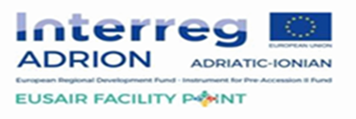

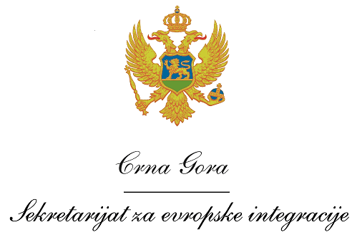
Montenegro
Ministry of European Affairs

Terms of Reference – Project officer for the ADRION strategic project –“Facility Point – Supporting the governance of the EUSAIR”

Position: Project officer for the ADRION strategic project – “Facility Point – Supporting the governance of the EUSAIR”

Location: Ministry of European Affairs, Podgorica (full time in office).

Duration: Until 31 August 2023 (with possibility of extension).

Overall objective

The main tasks of the Project officer is to assist MEA and the Project Leader - Government Office for Development and European Cohesion Policy of the Republic of Slovenia in the Project implementation, to contribute to the Facility Point and EUSAIR information and publicity within Montenegro and to serve as technical support to partners and stakeholders at national level by providing assistance for the project implementation.

Selected Project Officer will perform following duties:

- Technical assistance for the implementation of the Project;
- Conducts publicity and visibility activities related to the Facility Point and EUSAIR;
- Project management and coordination at national level;
- Project reporting (content, financial);
- Technical and administrative support (minutes/conclusions);
- Organisation of travels and events;
- Technical support to the activities of the Working Group for Implementation of the Adriatic - Ionian Strategy (JS) and the Strategic Project "Support Unit - Support to the Management of the European Union Strategy for the Adriatic - Ionian Region (EUSAIR) - Facility Point";
- Support in organization of any activity and event linked to TWG 1- Blue Growth;
- Support to the activities related to all four thematic pillars of EUSAIR;
- Support in identification of Pillars related financial sources at country level;
- Support in stakeholder consultations and other activities;
- Support in activities related to the Stakeholder platform;
- Support in procurement process;
- Monitoring of project implementation;
- Participates in preparation of reports on Project implementation;
- Participates in programme documents updating;
- Cooperates with other project partners on the implementation of the Facility Point;
- Support organisation of the Facility Point and EUSAIR events;
- Other tasks ordered by the superiors.

