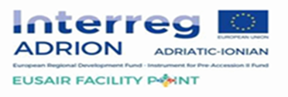

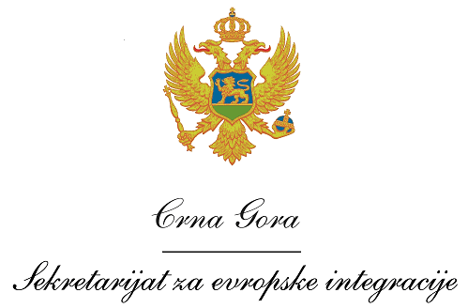
Montenegro
Ministry of European Affairs

Vacancy announcement

The Ministry of European Affairs (MEA) of Montenegro, as the National Partner of the – Strategic project »FACILITY POINT – Supporting the governance of the EUSAIR«, funded under the INTERREG V-B Adriatic-Ionian Cooperation Programme 2014-2020 by the European Regional Development Fund (ERDF), the Instrument for Pre-Accession Assistance (IPA II) and national funds, invites interested candidates to apply for the following position:

Project officer for the ADRION strategic project– “Facility Point – Supporting the governance of the EUSAIR”

Professional requirements
Qualifications and skills
- University degree;
- Fluency in both written and spoken English and the official language in Montenegro;
- Good communication, organizational and presentation skills;
- Computer literacy.

General professional experience
- At least 3 years of professional experience following the University degree.

Specific professional experience
- At least 1 year of experience in programme/project management;
- Experience in at least one EU-funded project;
- Knowledge of PRAG rules.

Application procedure

Interested candidates have to submit following application documents:

- A curriculum vitae (CV) in Europass format;
- A motivation letter in English;
- Photocopy of University degree.

The Terms of Reference is available on the MAE’s web-site: https://www.gov.me/cyr/mep Interested candidates should send application documents by 29 July 2022 until 15.00h to the following e-mail address: gordana.djekic@gsv.gov.me, specifying in the Subject: Project officer for the ADRION strategic project – “Facility Point – Supporting the governance of the EUSAIR”

Only short-listed candidates shall be contacted for an interview.

